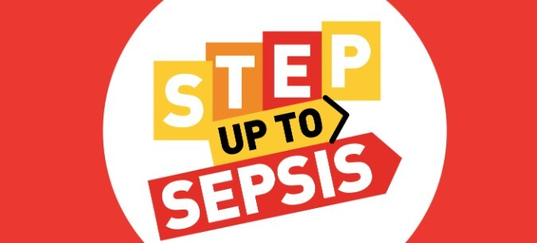

Sepsis: Know the Signs, Save a Life
As part of Sepsis Awareness Month this September, we are highlighting the importance of recognising the symptoms of sepsis.
In the UK alone, there are at least 245,000 cases and up to 48,000 deaths of sepsis every year. That’s more deaths than breast, bowel and prostate cancer combined.
There is no single sign or diagnostic test, and sepsis is indiscriminate: while it primarily affects very young children, older adults, and people with underlying health conditions, it can sometimes be triggered in those who are otherwise fit and healthy.
Sepsis is a life-threatening condition.
How to spot sepsis in adults:
- Slurred speech or confusion
- Extreme shivering or muscle pain
- Passing no urine (in a day)
- Severe breathlessness
- It feels like you’re going to die
- Skin mottled or discoloured
A child may have sepsis if they:
- Are breathing very fast
- Have a ‘fit’ or convulsion
- Look mottled, bluish, or pale – on darker pigmented skin, colour changes may show on the inside of the forearms or palms
- Have a rash that does not fade when you press it
- Are very lethargic or difficult to wake
- Feel abnormally cold to touch
A child under 5 may have sepsis if they:
- Are not feeding
- Are vomiting repeatedly
- Have not passed urine for 12 hours
If you or another adult or child develop any of these signs, it is important to seek urgent medical attention.
Call 111 or contact your GP if you are worried about an infection.
Call 999 or visit A&E if you or another adult or child has one of the sepsis symptoms.
Just Ask: Could it be Sepsis?
For further information on sepsis please click on this link: FAQs – The UK Sepsis Trust

