Education Prospectus 2024 – 25

We offer a range of courses to support education & training needs for both clinical, working in health and social care settings.
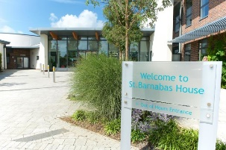

Barnabas Hospices
St Barnabas House
Education Dept
Titnore Lane
Worthing
West Sussex BN12 6NZ

To join us at one of our education events, please visit www.stbh.org.uk/education and complete an online booking. Alternatively, telephone 01903 706356 or email education@stbh,org.uk to speak to one of our team.

- Weds 4th September 24 – Recognising Dying at 09:30 – 13:00 FULLY FUNDED (JUST A FEW SPACES LEFT)

- Tues 18th September 24 – Symptom Management in the Last Days of Life (via Teams) at 09:30 – 13:00 £50

- Thurs 26th September 24 – Bereavement, Loss & Grief in Adults at 09:30 – 13:00 FULLY FUNDED

- Weds 16th October 24 – Introduction to Supporting Children who are Bereaved at 13:00 – 16:30 £50

- Tues 12th November 24 – Introduction to the Management of Syringe Drivers at 09:30 – 13:00 £50

- Thurs 21st & Fri 22nd November 24 – An Overview of Palliative & EOL Care for HCAs 2 Day course at 09:30 – 16:30 £200 (for both days)

- Tues 26th November 24 – Palliative & End of Life Care & Long Term Conditions at 09:30 – 16:30 FULLY FUNDED

