**For further information about this service, please talk to your child’s key-carer, class teacher or Special Educational Needs Co-ordinator (SENCO).**

**Who are we?**

We are qualified teachers with extensive experience working with children with Special Educational Needs and Disabilities (SEND). We are known as Specialist Advisory Teachers (EYSAT’s)

 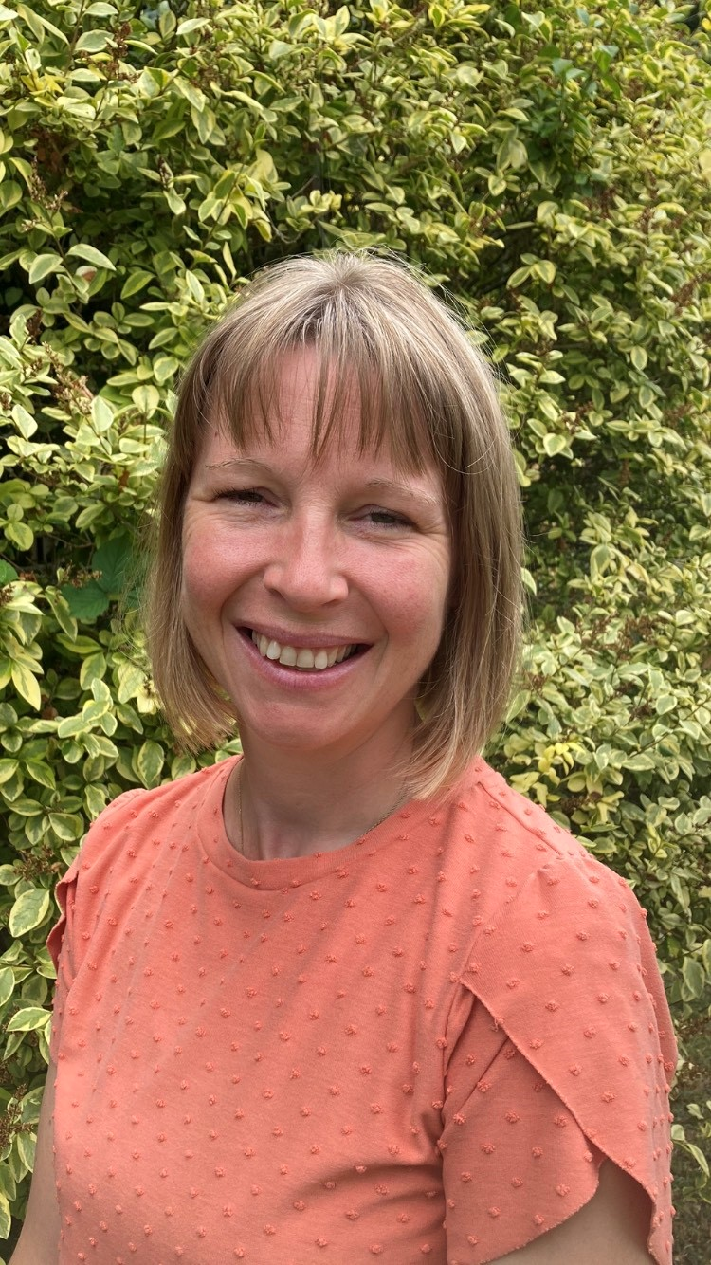  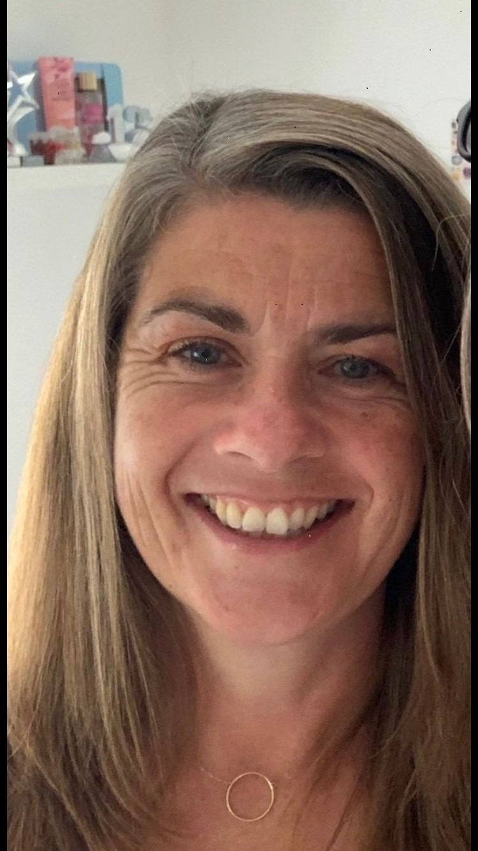

Tracy Swaffer Marianne Allen Tori Healy Emma Spurle

**What do we do?**

We work with parents, schools, early years settings, and other agencies to plan and enable a positive experience for children with additional needs as they transition from home and/or pre-school to Reception.

**What does this look like?**

In the summer term before a child starts school, we can meet with parents, staff from Early Years settings, and schools to plan a supported transition for individual children. In addition, we can visit early years settings and schools to help co-ordinate adaptations to the environment and suggest training and/or approaches that will enable the children to have a positive transition.

In the following autumn and spring term, we can visit children in their new reception classes to review their progress and help teachers and support staff to implement strategies that build on the children’s starting points.

**How can we be contacted?**

Staff from early years settings and schools can refer children into our service, after consultation with parents. We expect settings and schools to fully involve parents with the referral process and share all reports with them. Referral forms are available on our dedicated page on the West Sussex County Council Services for Schools website. [Specialist Advisory Teachers for Early Years SEND Transition | West Sussex Services for Schools](https://schools.westsussex.gov.uk/Page/27515)

**Specialist Advisory Teachers**

**Early Years SEND Transition**

