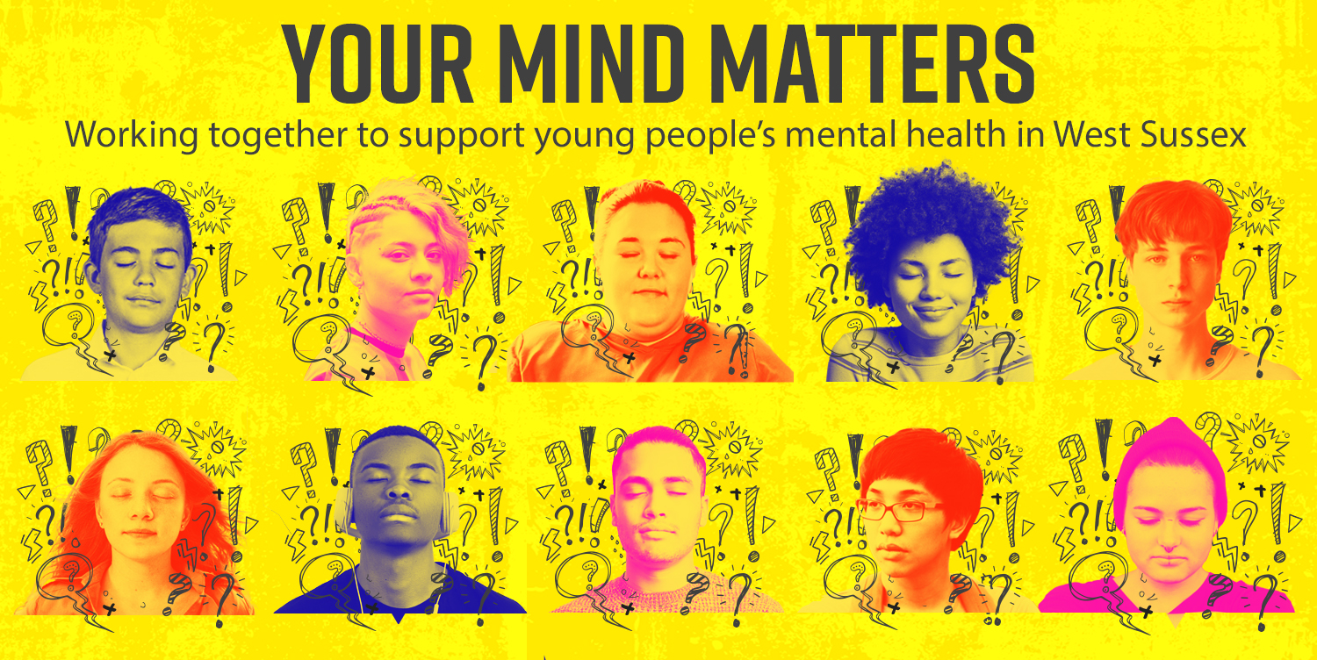
Emotional wellbeing and mental health support during the summer

The end of school term, the summer holidays and exam results days are approaching. Now is a good time to talk about our children’s wellbeing and mental health.

We hope the summer holidays will be a time to relax. Some young people may find the holidays more difficult.
Being active and staying in touch with friends is a good way to support one another. If you need extra help with your or your child’s mental health, support is available and there are people you can talk with.

Your Mind Matters
www.westsussex.gov.uk/yourmindmatters has details of lots of local and national resources. This includes:
- toolkits and guides on looking after your child’s mental health
- support for LGBT+ young people from Allsorts Youth Project
- details of free training and networking events.

Self-care plan
Young people can create a self-care plan and explore things to promote wellbeing https://www.annafreud.org/schools-and-colleges/self-care-summer/

Careers advice
For those who have finished their education and may be looking for advice on what to do next.
The careers advice team supports 16–24-year-olds with free 1-2-1 career advice.
Find out more at: www.westsussex.gov.uk/careers 0330 222 7175 careersadvice@westsussex.gov.uk

E-Wellbeing is a digital wellbeing service for young people who live in Sussex. It aims to help young people understand how to be mentally healthy and how to connect to support across Sussex.
It includes links to crisis support. It also hosts the West Sussex Single Point of Access, a simple way to ask for specialist emotional wellbeing and mental health support. Anyone can make a referral. They’ll help direct you to the right service. www.ewellbeing.co.uk/support.
Please continue to look after yourselves and each other, talk about how you are feeling, and reach out if you need extra help.

Further support information for families:


Free summer holiday clubs and food
Eligible families can sign up for free summer holiday clubs near them to help keep children entertained over the school break. Families can now search and book places near them on our Family Information Service webpages.

West Sussex County Council has again teamed up with over 40 clubs across the county to offer an exciting range of sports, kids camps, swimming, crafts and more – all with a nutritious hot meal provided.
Places are free-of-charge for West Sussex children aged 4 to 16 who receive benefits-related free school meals, subject to availability. www.westsussex.gov.uk/HAF

Community Hub support
The West Sussex Community Hub continues to operate seven days a week, providing food and essentials to people who need support, including those not eligible for free school meals.
The Community Hub can be contacted on 0330 222 7980 and is open 9am to 5pm, seven days a week.

