How to access a MS Teams meeting will depend on the equipment being used.

If you are accessing a meeting via a desktop or laptop, you simply need to click on the invite link and it will open MS teams in a web browser. You will be able to sign in as a guest.

How to access the meeting via a mobile device
You will need to download the app before you can join the meeting.

Installing on iOS/iPhone/iPad
- To install the Teams mobile app on your iPhone or iPad:
- Open the Apple App Store on your iOS device.
- Tap the Search icon in the store and type Microsoft Teams. Make sure you choose the Microsoft app, as shown.
- Tap the download link to install the app on your device.
- Once the app has finished downloading and installing, tap the Open button

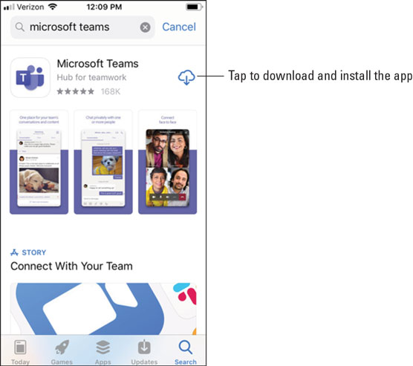

Installing on Android
- To install the Teams mobile app on your Android phone or tablet:
- Open the Google Play Store on your Android device.
- Tap the Search icon in the store and type Microsoft Teams. Make sure you choose the Microsoft app, as shown.
- Tap the Install button to install the app on your device.
- Once the app has finished downloading and installing, tap the Open button

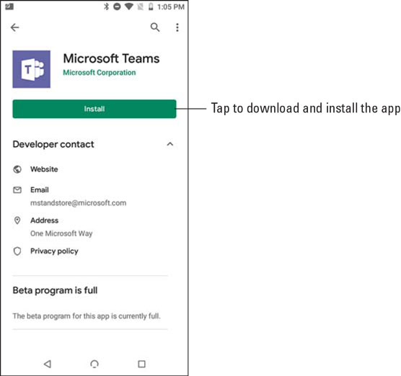

- When you first open the Teams mobile app, you are presented with a sign-in screen where you can choose to sign in to Teams, as shown. Tap the Sign In button and then enter your Office 365 credentials that you created when you signed up for the Office 365 trial in Chapter 1. Teams loads and walks you through some tips on using the app. Once you get through the tips, you can start working with Teams, as you will see in the next section.

- If you have already signed in to any other Office 365 app on your mobile device, such as Outlook, you can just select that account and Teams will automatically log you in using the credentials that are already cached on the device.

- If you want to skip signing up for Office 365, you can also sign up for a free account just by downloading the app on your mobile device and then tapping the Sign Up for Free button shown.
