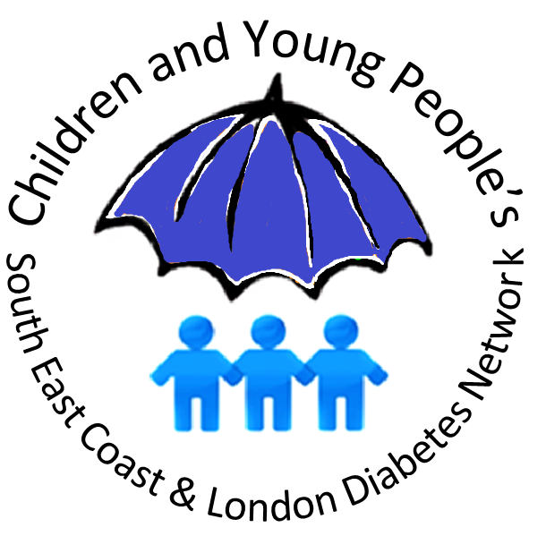

South East Coast & London Paediatric Diabetes Network
3rd July 2020
Network Manager: Usha Parkash
Usha.parkash@nhs.net Tel. 07432598896
Dear School Lead,
I am contacting you to request that an important health message is cascaded to all families through your schools’ communication systems.
Hospitals in London and SEC wish to inform the public that despite the Coronavirus situation, services are still ‘open for business’. NHS services are very well equipped to look after patients safely if they are unwell. We know that in other regions there have been cases where parents didn’t contact health services until it was too late.

It is important for all parents to know the signs and symptoms of undiagnosed Type 1 diabetes in children, which is a medical emergency. If parents notice ANY of the key symptoms of Type 1 diabetes, they need to make an urgent GP appointment, or contact their Out of Hours service.
The main symptoms of Type 1 diabetes are called the 4 Ts:
THIRST (often all the time)
TOILET (needing to urinate more often)
TIREDNESS
THINNER (losing weight)
On the following page we have included a pre-prepared message which we would greatly appreciate all schools, both primary and secondary, to communicate urgently to parents.
Information about the signs and symptoms of all types of diabetes can be found here: https://www.diabetes.org.uk/diabetes-the-basics/diabetes-symptoms

Many thanks in advance.

Professor Peter Hindmarsh
Chair of SEC & London Paediatric Diabetes Network

Dr Martha Ford-Adams
Chair of SEC & London Paediatric Diabetes Network
Dr Alok Gupta
Co-chair SEC & London Paediatric Diabetes Network

South East Coast & London Paediatric Diabetes Network
3rd July 2020
Network Manager: Usha Parkash
Usha.parkash@nhs.net Tel. 07432598896

Dear Parents,
The NHS has asked for this message to be sent out to you.
Undiagnosed Type 1 diabetes in children requires urgent medical attention.
If your child has ANY of the main symptoms of Type 1 diabetes please make an urgent GP appointment or contact the Out of Hours service. The main symptoms are known as the 4 Ts – Thirst, Toilet, Tiredness, Thinner. If you notice your child is thirsty or using the toilet more frequently, is always feeling tired, or has lost weight recently, seek immediate medical advice.
NHS services are very well equipped to look after children safely if they are unwell. Please do not delay seeking medical advice because of Covid-19.
There is more information available here:
https://www.diabetes.org.uk/diabetes-the-basics/diabetes-symptoms

