Swab test

How it works
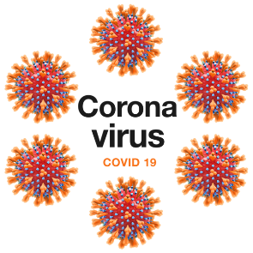 | We need to check if you have the new illness called coronavirus.
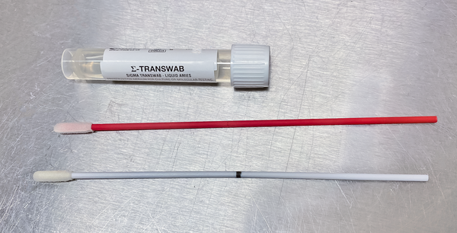 | To check we will do a swab test.  A swab is like a big cotton bud.
 | This test is nothing to be frightened of.  The swab dose not hurt but they might feel uncomfortable.
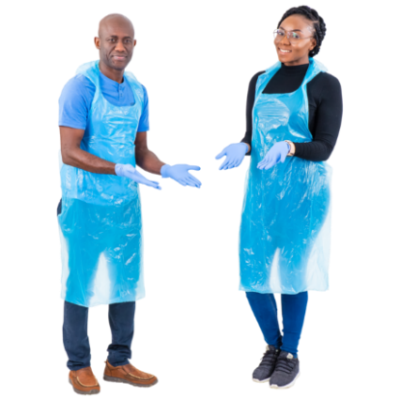 | Staff (name) at your home or a nurse may do the test.  You could insert a photo of a staff member doing the test
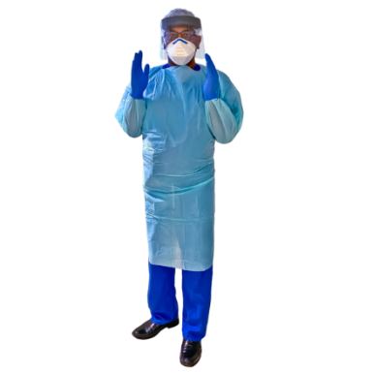 | Staff will be wearing special clothes to keep you and them safe. Insert staff photos  They may be wearing a mask on their face.
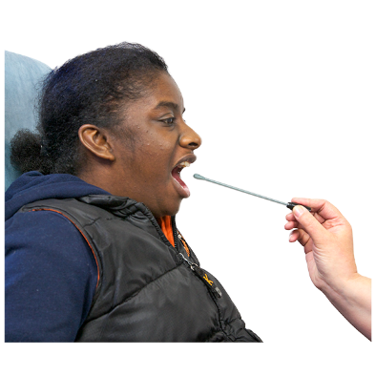 | We will put the swab into your mouth and rub it at the back of your throat.
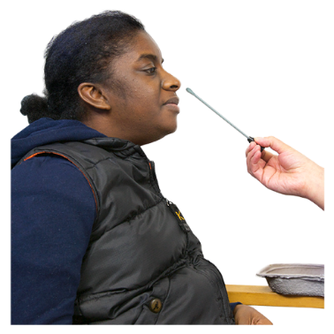 | We put the swab into your nose and rub it around a bit.
 | We will put the swabs in a special container to go and be tested.
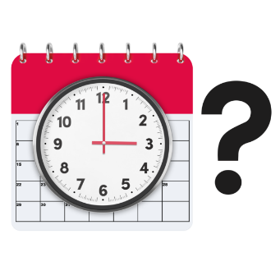 | We will tell you how long it will take to get the results.
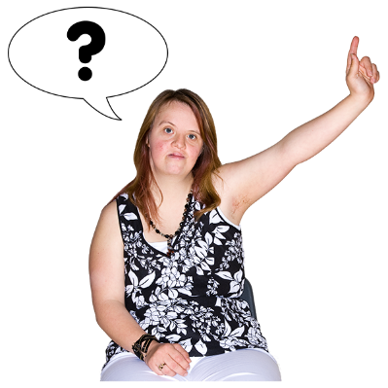 | Ask us any questions.  We will try our best to answer them.
Adapted from: James Padget University Hospitals NHS Foundation Trust  By: Brighton & Hove Health Facilitation – June 2020 |  | 

