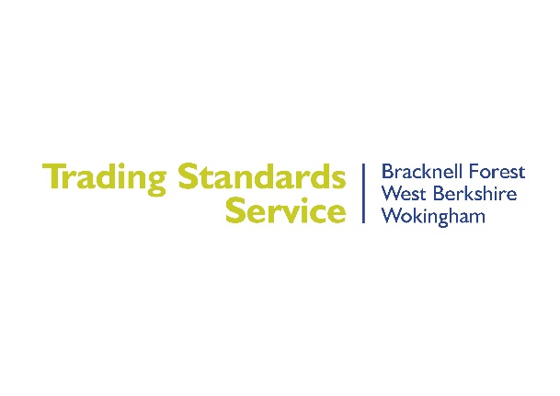
Fake Scam Parking Messages
Trading Standards Officers are warning residents about an increase in scam parking charge text messages. These messages tell consumers that they have an outstanding parking charge, and sometimes threaten that if they do not pay it in time, they will be banned from driving or be taken to court.
The messages include a link to a very convincing copycat Government website, but any payments made end up with the fraudsters.
If you receive a text message informing you of a parking fine, be aware of the following:
- We will never text you about parking fines.
- All real parking fines contains details on the back of how to pay or appeal.
- Never visit links that you receive via text from unknown numbers.
- Never scan QR codes that you receive from unknown sources.
- Any scam text should be forwarded to the number 7726.
- You can get consumer advice applying to England and Wales from Citizens Advice helpline on 0808 223 1133
