Applying to pursue an NPQ with ConnectEd Partnership.

Applications
When completing your NPQ application form please ensure you nominate ConnectEd Partnership as your chosen Delivery Partner from the drop-down list e.g.
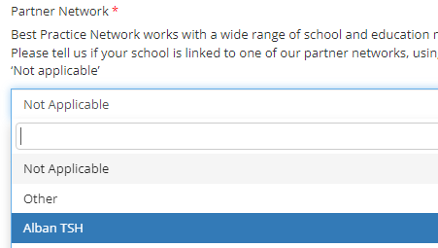
Programme information and application links
- National Professional Qualification for Leading Teaching (NPQLT)
- National Professional Qualification for Leading Teacher Development (NPQLTD)
- National Professional Qualification for Leading Behaviour & Culture (NPQLBC)
- National Professional Qualification for Leading Literacy (NPQLL)
- National Professional Qualification for Senior Leadership (NPQSL)
- National Professional Qualification for Headship (NPQH)
- Early Headship Coaching Offer (EHCO)
- NPQ for SENCOs *new*
- National Professional Qualification for Executive Leadership (NPQEL)
- National Professional Qualification for Early Years Leadership (NPQEYL)
As always, if you have any questions or need any further information, please do not hesitate to contact Harinder Jandu Harinder.jandu@connectedpartnership.com

