


working in partnership

Domestic Abuse

Manager’s Guide

This Manager’s Guide should be used in conjunction with the
Domestic Abuse Policy document

Created June 2023

Adopted by: [School/Academy name]
On: [date]
Signed (Chair of Governors/Trust):
Minute number:

Domestic Abuse: Manager’s Guide

This guide has been developed to assist Schools/Academies with the application of the Domestic Abuse Policy within the workplace, by setting out expectations and supplementary advice with regards to each area listed in the contents below.

City of Wolverhampton Council is committed to tackling domestic violence through both its role as an employer and as a partner in the Wolverhampton Domestic Violence Forum (WDVF).

For further support please contact your HR provider.

Contents

Section | Contents | Page Number
1.0 | The impact of domestic abuse | 2
2.0 | Recognising Problems | 2
3.0 | Responding to disclosures  3.1 Confidential Discussion  3.2 SafeLives Dash Risk Assessment & MARAC Referral | 3  3  4
4.0 | Signposting to additional help | 6
5.0 | Silent Solution System | 7
6.0 | If the employee is deaf or can’t verbally communicate | 7
7.0 | Domestic Violence Disclosure Scheme or “Clare’s Law” | 7
8.0 | Assistance Needed Immediately or “Ask For Ani” Scheme | 8
9.0 | External Links – Statistics and Information | 8
 | Appendices
Appendix 1 | Flow Chart for managing a disclosure of Domestic Abuse | 10
Appendix 2 | Confidential Discussion Record – Template | 11
Appendix 3 | Sources of help and advice: Local and National | 12

1.0 The impact of domestic abuse

Domestic abuse impacts all sectors of society in differing ways; however, some sectors are more prevalent than other. Domestic abuse is an under-reported crime, and victims may never report their abuse; however, evidence suggests that 1 in 3 women are likely to be impacted by domestic abuse in their lifetime, whilst 1 in 6 men are also likely to be affected. Those most affected are those aged 16 -24 years old. Two women a week are killed by a current or ex-partner. In 2019 1.6 million women experienced Domestic abuse (www.refuge.org.uk).

Domestic abuse can be experienced by both men and women and is an issue that can impact on the workplace. Domestic abuse can affect the morale, health, wellbeing, and self-confidence of an employee, which in turn can impact on their performance at work and their wider team.

The effects of domestic abuse do not remain at home when the victim goes to work, and perpetrators can continue to harass victims while they are at work. Domestic abuse in the workplace includes all behaviour that affects an employee's capacity to safely perform their duties. As well as harassing emails, phone calls or the perpetrator attending the workplace / route to work, a victim's ability to do their job can also be affected by sleep deprivation, anxiety, depression, fear, reduced confidence, injury, unplanned absences etc.

Avoid victim blaming: It is important that managers are able to provide a non-judgemental and supportive environment. Respecting the employee’s boundaries and privacy is essential.

Even if managers disagree with the decisions being made regarding an employee’s relationship, it is important to understand that abuse is never the fault of the victim and often victims will make a number of attempts to leave their partner before they are finally able to do so.

Managers also need to be aware that the victim is most at risk of life threatening or fatal abuse when they are attempting to leave or have recently left their violent partner.

2.0 Recognising Problems

Employees may experience domestic abuse at any time, including whilst they are social distancing and self-isolating. COVID-19 will have serious impacts on the lives of people who are experiencing domestic abuse. Isolation is a key tactic of abusers; it will increase the risk to victims.

If there is an immediate danger the guidance is to dial 999.

Employers should be aware of the following potential signs of domestic abuse:
Every year at
least
3

million
women
and 786
thousand men
experience

Domestic Abuse
in the UK

- Sudden changes in behaviour or demeanour.
- A usually engaged employee not being communicative.
- Reduced quantity or quality of work.
- Regularly being unavailable to answer calls or attend virtual meetings with no explanation.
- Consistently refusing to turn video on for virtual meetings.
- Expressing a need to log off early or log on late.

3.0 Responding to disclosures

3.1 Confidential Discussion

A Flow Chart for managing a disclosure of domestic abuse can be found at Appendix 1.

A template Confidential Discussion Record can be found at Appendix 2.

When responding to a disclosure of domestic abuse the following actions should be considered:

Confidential Discussion

Safe Lives Dash Risk Assessment

MARAC Referral

If an employee ever finds the courage to disclose that they are experiencing domestic abuse to you, please believe them, support them, and signpost them to available services and the necessary authorities.
One in three women and one in six men will experience domestic abuse in their lives.

One in three women and one in six men will experience domestic abuse in their lives.
Do not ask for evidence or proof.

Reassure your employee that you are aware of the impact that domestic abuse may have on their performance and let them know what support is available.
- Maintain communication with the employee by means that are safe for the them.

75
% of
Abused
Women are
targeted at
work

- Have open, supportive conversations with employees about what arrangements to make if they feel unsafe.
- Devise a safe word to use in case of emergencies.
- Check in regularly with your employee, set out company policy of employees contacting managers when they start and finish work.

- Retain both a work contact and an emergency contact of a family member (not the abuser).

- Ask employees to keep a mobile phone with them at all times, if possible. If not seek to obtain a work mobile phone for the employee.

- Keep up to date with specialist services and emergency numbers.

- HR and managers to familiarise themselves with The Silent Solution system to pass on to employees (refer to section 6.0 for further information).

3.2 SafeLives Dash Risk Assessment & MARAC Referral

Where a disclosure is made, a risk assessment should be conducted to determine if it is safe for the employee to return home. If you cannot safely say ‘yes’ then it is important to act on this professionally and appropriately. If you suspect that your employee is at high risk of harm or homicide, then you must act on this information. Managers need to complete the SafeLives Dash Risk Checklist (savelives.org.uk), a copy of which can be accessed via this link: https://safelives.org.uk/sites/default/files/resources/Dash%20without%20guidance.pdf

Before completing the form for the first time we recommend that you read the full guidance and FAQs, which can be downloaded from the following link: http://safelives.org.uk/sites/default/files/resources/FAQs%20about%20Dash%20FINAL.pdf

The SafeLives Dash Risk Checklist should be introduced to the victim within the framework of the School/Academy’s:
• Domestic Abuse Policy.
• Information sharing policy and protocols.
• MARAC referral policies and protocols:
If identified as required, a Multi-Agency Risk Assessment Conference (MARAC) is a meeting where agencies talk about the risk of future harm to people experiencing domestic abuse and if necessary their children, and draw up an action plan to help manage that risk.

Before you begin to ask the questions in the SafeLives Dash Risk Checklist:
• Establish how much time the victim has to talk to you: is it safe to talk now? What are safe contact details?
• Establish the whereabouts of the perpetrator and children
• Explain why you are asking these questions

While you are asking the questions in the SafeLives Dash Risk Checklist:
• Identify early on who the victim is frightened of – ex-partner/partner/family member
• Use gender neutral terms such as partner/ex-partner. By creating a safe, accessible environment, LGBT victims accessing the service will feel able to disclose both domestic abuse and their sexual orientation or gender identity.

High Risk
Upon completion of the SafeLives Dash Risk Checklist, if the assessment comes out as high risk you should advise the employee that you need to refer them to someone who is professionally qualified to assist with their situation; as you cannot ignore what you have been told and need to act on this for their own safety.

For all high-risk assessments, you should complete a MARAC Referral Form which can be accessed via this link:
https://safelives.org.uk/sites/default/files/resources/Marac%20referral%20form%202019%20-%20England%20%26%20Wales%20%20version.doc

Upon completion, the MARAC referral form should be emailed to:
marac_referrals@west-midlands.pnn.police.uk
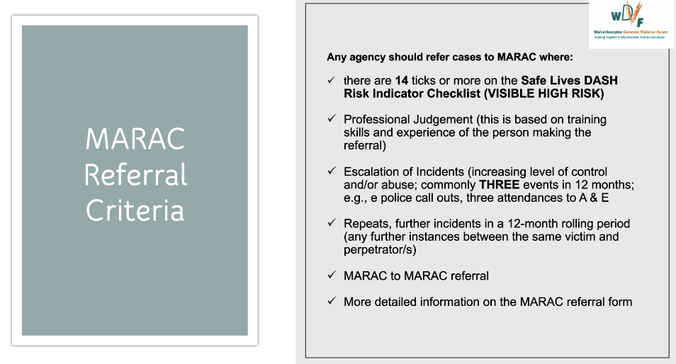

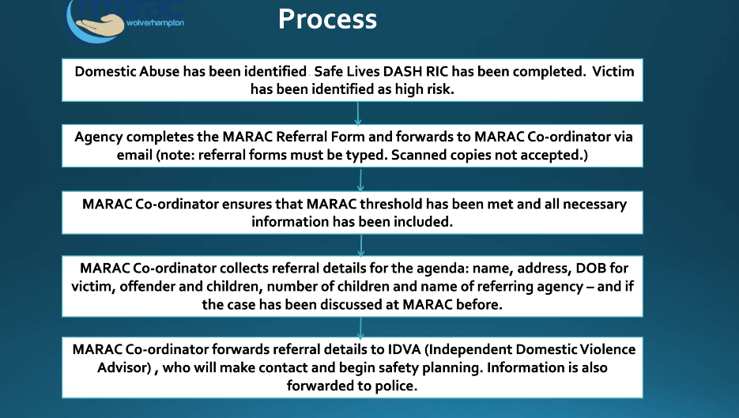

NB: When making a MARAC referral managers need to be mindful that the referring agency will be required to attend MARAC to present the case, or if unable a representative will be asked to attend.

Medium/Low Risk
Equally, identifying that someone is not currently high risk needs to be managed carefully to ensure that the person doesn’t feel that their situation is being minimised and that they don’t feel embarrassed about asking for help. Explain that these factors are linked to homicide and serious harm and that if they experience any of them in future, that they should get back in touch with your manager or professional service provider or with the emergency services on 999 in an immediate crisis.

As the manager it is important to revisit the SafeLives Dash Risk Checklist intermittently as situations that begin as low risk can escalate to high risk quickly and as the manager it is advised that you do address these concerns whilst your employee is in a vulnerable position and potentially at risk of harm.

4.0 Signposting to additional help

- Make sure you share the list of support services offered in the area (Appendix 3).

- Encourage the employee to contact organisations and or support services local to them, via the safest mode of communication.

- The Haven offer a 24-hour helpline (08000 194 400) as well as a live chat service that is available Monday to Friday from 9am to 5pm. You can also contact them via email through their website - this could be a safer way to access support, if an abuser might also be in the property.

5.0 Silent Solution System

This is a system for victims of domestic abuse who might be afraid of further harm and danger if they are overheard when calling the emergency services. When they call 999, an operator will ask which service is required.

If the caller is unable to audibly signal to the operator, the call will be forwarded to an operating system. If 55 is pressed by the caller, the system will detect this. The operator will then transfer the call to the relevant police force as an emergency.

6.0 If the employee is deaf or can’t verbally communicate

The employee can register with the emergency SMS service where users can send a text message to the UK 999 service which will be passed to the police, ambulance, fire rescue, or coastguard. To do this, they will need to text ‘REGISTER’ to 999. A response will then be sent with instructions on what to do next.

50% of stalking victims have ceased or curtailed work due to being stalked

7.0 Domestic Violence Disclosure Scheme or “Clare’s Law”

Clare’s Law designates several ways for police officers to disclose a person's history of abusive behaviour to those who be at risk from such behaviour. It is intended to reduce intimate partner abuse. There are two main elements: a 'right to ask', which allows members of the public, including a domestic partner, to request information from the police about a potential abuser; and a 'right to know', which, in certain circumstances, permits police to disclose such information to the public on their own initiative. Information could arise from a criminal investigation, through statutory or third sector agency involvement, or from another source of police intelligence.

How can employees make a Clare's Law request?

They will need to visit their local police website and complete an online form or they can visit their local police station. If the ‘person’ lives outside of the employees local policing area, they will need to find the nearest police force to them using the National Police Website.

8.0 Assistance Needed Immediately or “Ask For Ani” Scheme

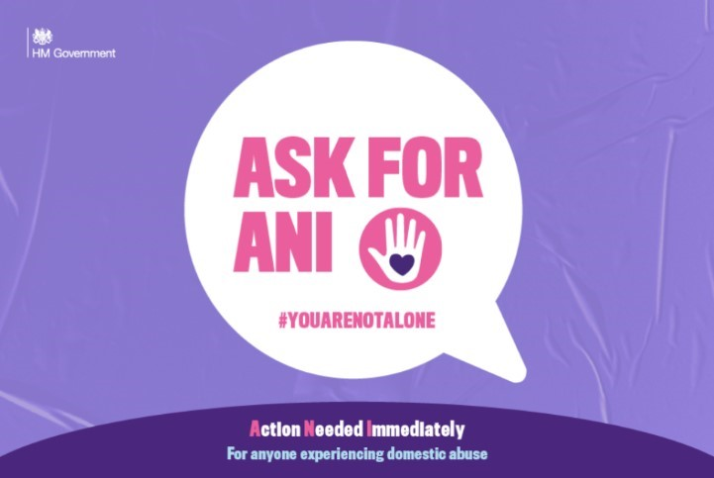

Allows those at risk or suffering from abuse to discreetly signal that they need help and access support. By asking for ANI (which stands for: Assistance Needed Immediately), a trained pharmacy worker will offer a private space where they can understand if the victim needs to speak to the police or would like help to access support services such as a national or local domestic abuse helplines. Specifically, trained staff in pharmacies can provide a safe space for victims to sound an alarm if they are isolated at home with their abuser and unable to get help in another way.

9.0 External Links – Statistics and Information

The following apps are available to download for free information about domestic abuse, sexual consent, harassment and stalking:

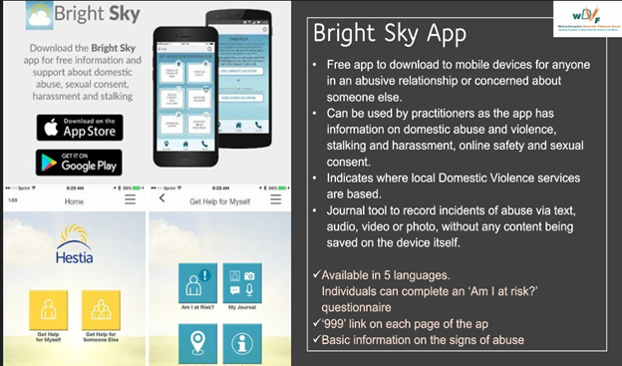
Want to learn more facts about domestic abuse? Follow the links below for domestic abuse statistics and information:

Refuge

Womens aid

Office for National Statistics – Homicide in England and Wales and how are victims and suspects related.
Office for National Statistics - Domestic abuse victim characteristics, England and Wales: year ending March 2019

Statistics on male victims

LGBT victims

Forced Marriage

Honour based violence

Modern Slavery

Elder Abuse

Appendix 1

Flow Chart for managing a disclosure of Domestic Abuse

NB: If an employee does not wish to disclose any information, please direct them to details of organisations that can support them if they change their mind (Appendix 4).

If anyone is in immediate danger call 999.

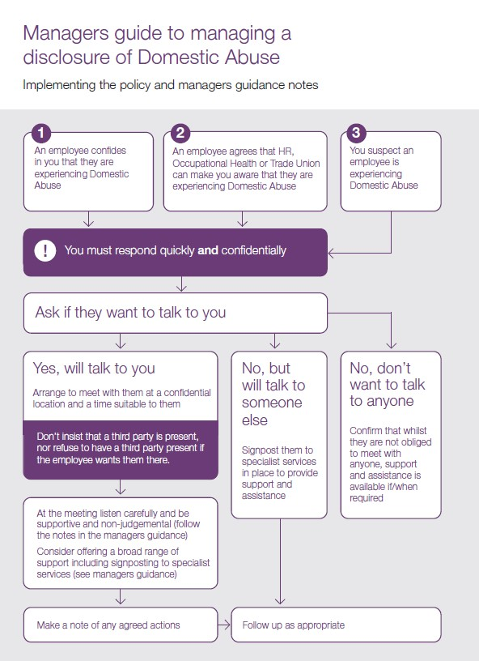

Appendix 2

Confidential Discussion Record – Template

Date: | Present:

EMPLOYEE DETAILS

Name | Job Title | Work Location

Summary of discussions:

Agreed actions / reasonable adjustments:

Agreed date of review meeting:

Employee Signature:

Manager Signature:

Appendix 3

Sources of help and advice: Local and National

Local

West Midlands Police – call 101 or, in an emergency, 999.

The Haven Project supports women and children affected by domestic violence in
Wolverhampton. 24-hour helpline: - 08000 194 400, email:
Helpline@havenrefuge.org.uk

Black Country Women's Aid - for those affected by rape, sexual violence, domestic violence and stalking. Telephone - 0121 553 0090.

Wolverhampton Domestic Violence Forum - Brings together a range of agencies providing services and support to women and families experiencing domestic violence and abuse. Telephone - 01902 555643, email: WDVF@wdvf.org.uk

Wolverhampton Homes' Housing Options – support with access to emergency accommodation. Out of hours call 01902 552999 or during office hours call 01902 556789.

Wolverhampton Homes' Housing Outreach and Support - a community-based team that provides support to a wide range of people experiencing difficulties that may affect their tenancy – telephone - 01902 555760 or email housing.support@wolverhamptonhomes.org.uk

National

National Domestic Abuse Helpline - Provides support, help and information over the telephone where ever the caller is in the country. Telephone - 0808 2000 247 or email helpline@refuge.org.uk

Samaritans - Telephone - 116 123

Rape Crisis - To find your nearest rape crisis centre

Shelter - Shelter helps millions of people every year struggling with bad housing or homelessness through our advice, support, and legal services. Telephone - 0808 800 4444

Victim Support - an independent charity dedicated to supporting people affected by crime and traumatic incidents in England and Wales. Telephone - 0808 588 1449

Crime Stoppers - 0800 555 111

Citizen’s Advice Bureau – the CAB offers support and guidance, debt advice and independent legal advice. Telephone, 03444 111444 or email district@wolverhamptoncitizensadvice.com.

Legal

Community Legal Service Direct is a source of free legal advice. Telephone - 0845 345 4 345

Rights of Women offer legal advice and information to help women understand the law and their legal rights. Telephone, 020 7251 6575

National Centre for Domestic Violence provides a free, fast emergency injunction service to survivors of domestic violence. Telephone, 0844 8044 999

Criminal Law Advice Line – provide advice on issues including sexual offences, domestic abuse/violence and harassment. Telephone 0207 490 8887 or textphone 0207 490 2562

Family Law Advice Line – Telephone, 0207 251 6577 or textphone 0207 7490 2652

Support for Gay, Lesbian, Bi-sexual, Transgender

GALOP - national LGBTQ+ domestic abuse helpline and webchat service. Telephone 0800 999 5428

London LGBT Casework Service – provide emotional and practical support for
LGBT people experiencing domestic abuse. Telephone 020 7704 2040

Children and Young People

Childline – held and support for children and young people. Telephone: 0800 1111

NSPCC helpline - advice and support for anyone with concerns about a child. Telephone: 0808 8005000 or email help@nspcc.org.uk

The Children’s Society – guidance for young people on both domestic abuse and teen relationship abuse

Barnardo’s - support for families affected by domestic abuse

Family Lives - support through online forums

Rights of Women - guidance about child contact arrangements relating to coronavirus

Mermaids – helping gender-diverse kids, young people and their families since
1995. Telephone: 0808 801 0400

Support for Men

Men’s Advice Line - confidential helpline for male victims of domestic abuse.
Telephone: 0808 801 0327 or email: info@mensadviceline.org.uk

The Mankind Initiative: National Helpline 01823 334244

BAME Women and Children

Karma Nirvana - national helpline for victims of honour-based abuse, forced marriage and domestic abuse. They also provide education, training and deliver awareness roadshows - Call 0800 5999247.

Foreign and Commonwealth Office Forced Marriage Unit - supports people who are trying to stop a forced marriage and women who need help leaving a marriage she has been forced into. Telephone 020 7008 0151

The Refugee Council provides free advice and information to asylum seekers and refugees in UK

Southall Black Sisters supports Asian and African-Caribbean women experiencing any kind of gender based violence
0208 571 0800

Muslim Community Helpline is a confidential, non-judgemental listening and emotional support service for UK Muslims. Telephone - 020 8904 8193 or 020 8908 6715

Jewish Women’s Aid Helpline is a confidential, non-judgemental, listening service. Telephone - 0808 801 0500

Jaikara is a local charity which can offer support and advice for those suffering from domestic abuse, forced marriage or female genital mutiliation. Telephone: 03301 331100.

Somalian Women’s Centre offers advice and information for the Somali community living in and around Ealing on housing, immigration, nationality and asylum, education, employment and welfare rights. Telephone - 020 8752 1787

Shakti Women’s Aid supports BAME women experiencing domestic violence in Scotland. Telephone - 0131 475 2399

The Kiran Project provides a range of services for Asian women experiencing domestic violence. Telephone - 020 8558 1986

Chinese Information and Advice Centre offers free legal advice and support including to women experiencing domestic violence. Telephone - 020 7692 3697

BAWSO provides services and support for BAME women experiencing all forms of gender-based violence in Wales. Telephone - 0800 731 8147

JAN Trust works to combat poverty, discrimination, abuse and social exclusion among BAME women including refugees or asylum seekers
0208 889 9433

Help for abusers

The Respect Phoneline is an anonymous and confidential helpline for men and women who are harming their partners and families. The helpline also takes calls from partners or ex-partners, friends and relatives who are concerned about perpetrators. Telephone: 0808 802 4040

Other useful contacts

Able Futures – Support for mental health at work

Rethink Mental Illness Helpline - 0808 801 0525

Recovery Near You – Local support available for drink and drug use. Telephone - Adults – 0300 200 2400. Young People – 0300 123 3360

Alcoholic Anonymous - Information, advice and support to help people recover from alcoholism

Aquarius (Alcohol and Drugs Misuse) - Advice and support and information. Telephone - 01902 420041

Drinkline 0800 917 8280

National Drugs Helpline 0800 776600

