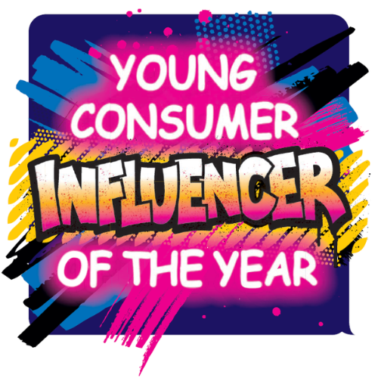
Competition Pack
Young Consumer – Influencer of the Year Competition 2023

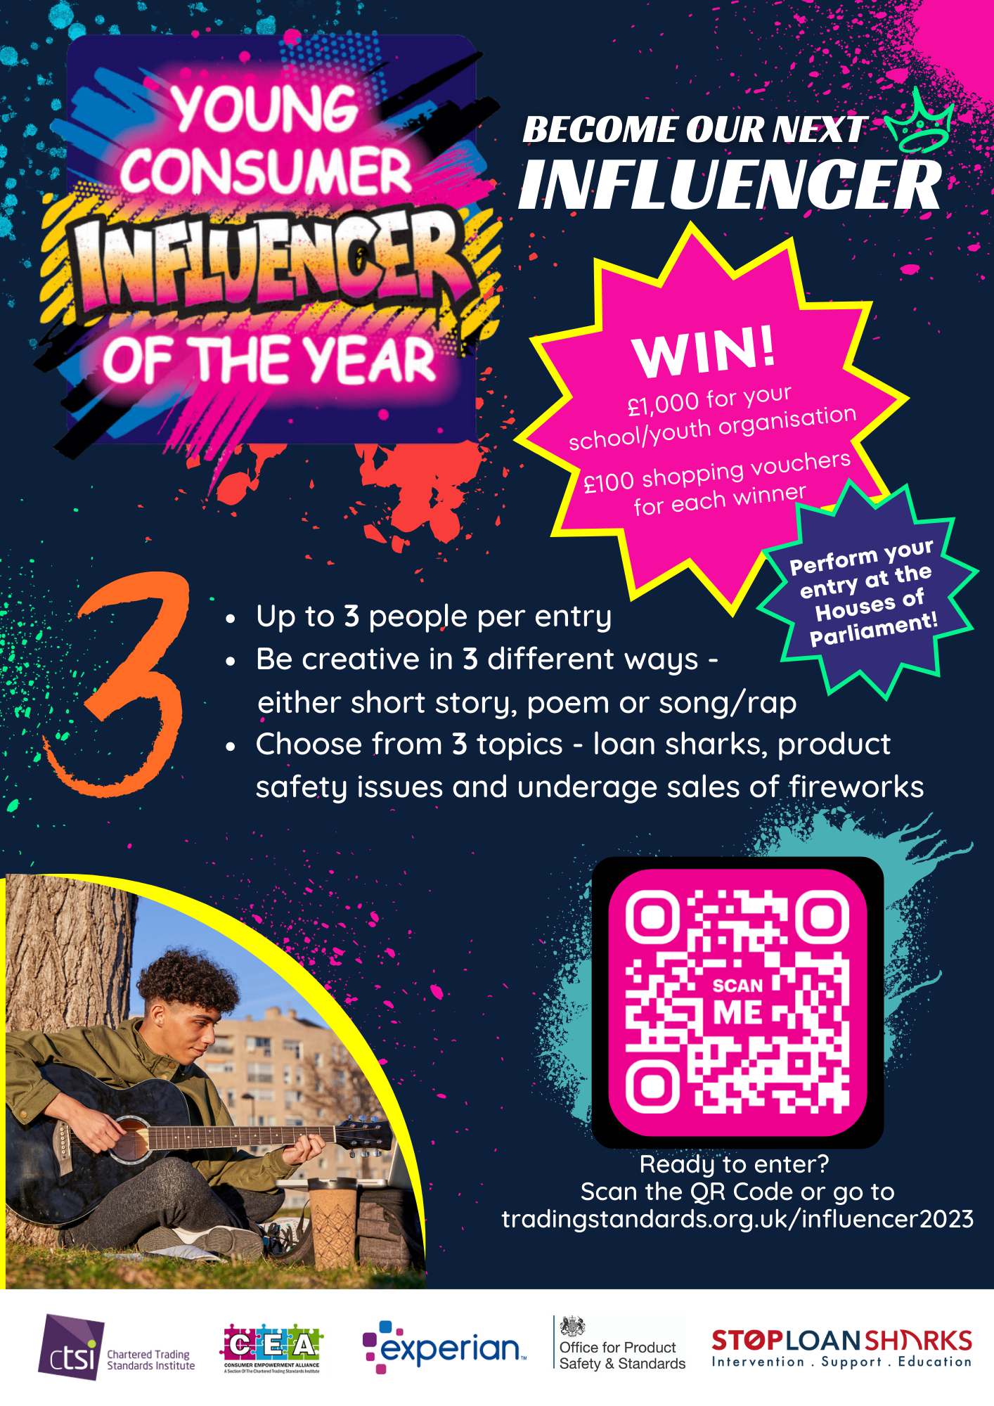
About the competition
Young Consumer Influencer of the Year is a national competition that has been developed by the Chartered Trading Standards Institute (CTSI) working in partnership with England Illegal Money Lending Team, Consumer Empowerment Alliance and Experian. The competition is designed for those aged 13–17 and we are supporting schools and youth groups to help educate young people about illegal money lending, product safety and underage sales of fireworks

What is money lending/loan sharks?
Often known as Loan Sharks, illegal money lenders are not approved by the Financial Conduct Authority (FCA) and will charge extortionately high interest rates and add indiscriminate charges. Loan sharks will often gain control of their victims, using threats and intimidation and keeping victims trapped in a cycle of debt. CTSI and IMLT are campaigning to raise awareness of Loan Sharks to young adults who may be vulnerable during the cost-of-living crisis.
Find out more about illegal money lending and loan sharks

Why is product safety important?
Products such as cosmetics, electrical goods and toys can be unsafe, causing injury to people who use them. Did you know over £2.2m of fake makeup and skincare were seized last year? Most fake cosmetics contain harmful chemicals which can cause damage to your skin. Similarly, e-bikes and e-scooters have been known to set on fire due to defective batteries, with 88 fires in London last year alone!
Learn more about product safety from Consumer Friend

Underage sales of fireworks
Fireworks can be dangerous, especially if they are in the wrong hands. 15 to 19 year olds are more likely to be hurt from fireworks, and over 550 young people end up in hospital
because of fireworks every year.
Find out more about firework safety from ROSPA

How it works
We are inviting all young people to use their creative skills and help us raise awareness in three areas – illegal money lending and loan sharks, product safety issues and underage sales of fireworks. Entrants can enter by using a song/rap, poem or a short story that is informative and engaging to their peers.
Judges will then decide the top three entrants and finalists will battle out their submissions through social media. The entry with the most votes (likes and shares) will be crowned the winner and will be invited to perform their submission at the CTSI Hero Awards at the Houses of Parliament in November. The winner will each receive a prize (up to three winners per group) and their school or youth organisation!

Judging criteria
This year, the judges are looking for creativity and flair of submissions within your chosen subject. Submissions must be informative and engaging to peers.

What you can win
1st place: £1,000 for the school/youth organisation and £100 shopping voucher for each of the winners! (Up to three winners per team).
2nd place: £50 shopping vouchers!
3rd place: £25 shopping vouchers!

Ready to become our next influencer?
Send your entries to influencer@tsi.org.uk by Friday 30 September 2023. Maximum of three people per entry. Open to anyone aged 13-17 across the UK. Visit www.tradingstandards.uk/ influencer2023 for more info

Terms and Conditions
- Young people can enter the competition individually or in groups of up to three people.
- Entrants must be aged 13 on 1st September 2023 up to the age of 17 on 31st August 2024.
- We accept multiple submissions from one school or youth group.
- Submissions must follow the topic criteria – including loan sharks, product safety issues and underage sales of fireworks. The submissions must be informative and engaging to other students.
- Deadline for entry is 30th September 2023. The Young Consumer – Influencer of the Year judges will finalise the top three entries and will announce winners at the CTSI Annual Hero Awards on the 22nd November at the Houses of Parliament.
- Entrants must be available to attend the winners ceremony on Wednesday 22nd November. Reasonable travel expenses will be covered by CTSI.
- Inappropriate submissions that include violence, weapons or profane language will be disqualified from the competition.
- Please send submissions to influencer@tsi.org.uk

Timetable for Young Consumer – Influencer of the Year 2023
Timetable | Date
Competition launch | 22 June at the CTSI Conference in Birmingham
Information packs sent to schools, youth groups and other organisations | Week commencing 26 June
Social media campaign launch | Week commencing 3 July and ongoing till 30 September
Competition closes | 30 September
Entries shortlisted and finalists announced | Early October
Social media campaign to vote for winners | Mid – late October
Winner is chosen | Week commencing 6 November
Winner is crowned | 22 November during the CTSI Hero Awards at the Houses of Parliament

Chartered Trading Standards Institute (CTSI) is working in partnership with England Illegal Money Lending Team (IMLT), Experian, Consumer Empowerment Alliance and Office for Product Safety and Standards to raise awareness of the dangers of loan sharks, product safety and underage sales of fireworks.

