data protection 2020
stop scratching your head about gdpr …ask us!!
BEWARE – PROTECT ALL YOUR MOBILE DEVICES  What are your rights under GDPR  The GDPR provides the following rights for individuals:  - The right to be informed  - The right of access  - The right to rectification  - The right to erasure  - The right to restrict processing  - The right to data portability  - The right to object  - Rights in relation to automated decision making and profiling  HAVE YOU COMPLETED YOUR DP TRAINING  CONTACT DPA@TORFAEN.GOV.UK  IF YOU HAVE NOT RECEIVED AN INVITE | 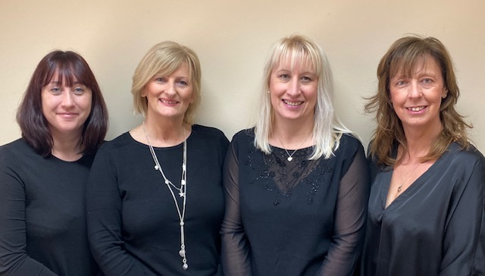  DATA PROTECTION TEAM:  WHO TO CONTACT WITH A SECURITY BREACH OF INFORMATION:  DPA@TORFAEN.GOV.UK  sue.bullock@torfaen.gov.uk 01633 647467  amanda.price@torfaen.gov.uk 01495 766257  sharon.clifford@torfaen.gov.uk 01495 766230  leah.hardwick@torfaen.gov.uk 01495 767443  WHO TO CONTACT WITH AN IT SECURITY BREACH:  SRS 01495 766366  SECURITY@SRSWALES.COM  WHERE CAN I FIND HELP?
WE ARE HERE TO HELP AND FOR A LIST OF FAQ’S VISIT https://swoop.torfaen.gov.uk/en/TheBigPicture/Information-Management/Data-Protection/Data-Protection-and-GDPR.aspx

HERE YOU WILL FIND INFORMATION MANAGEMENT POLICIES
HOW TO CONDUCT A SUBJECT ACCESS REQUEST (SAR’S)
MANAGE A BREACH
WHEN TO CARRY OUT A DATA PROTECTION IMPACT ASSESSMENT
LIST of DATA PROTECTION DEPARTMENT REPRESENTATIVES

DO YOU HAVE AN ACCOUNT WITH ANY OF THESE?



PROTECT YOUR REVIEW YOUR KEEP DATA SAFE

DATA PRIVACY

SOCIAL MEDIA POLICY LINK:
https://swoop.torfaen.gov.uk/en/Document-Library/Corporate-Documents/Social-Media-Policy.docx



I’VE LOST IT!!!

Where has it gone?? That panic when you realise your notebook, papers, bag, works laptop, works phone has gone…STOP, BREATHE, CALL US
DPA 01633 647467, 01495 766257, 01495 766230, 01495 767443
SRS SECURITY 01495 766336
DPA@TORFAEN.GOV.UK

REMEMBER

LOCK YOUR WORK STATION ABIDE BY THE CLEAR DESK POLICY
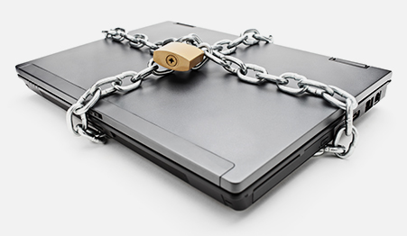
CTRL, ALT, DELETE

