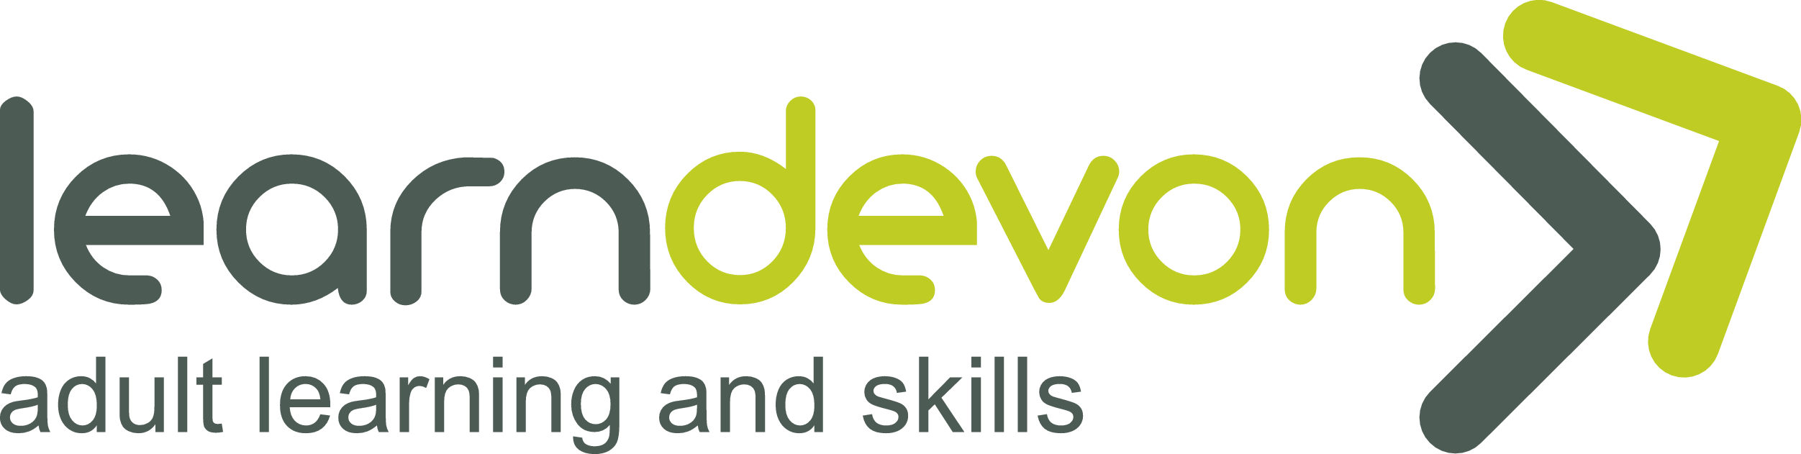
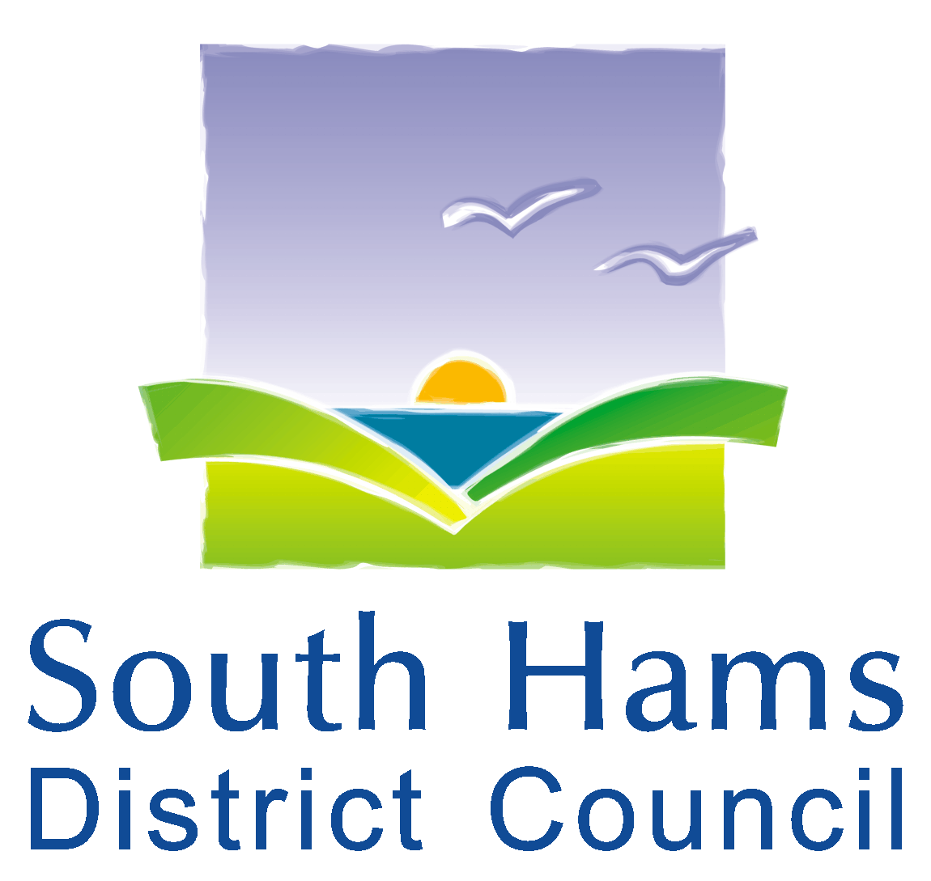

Learning opportunities in the South Hams
South Hams District Council is working in partnership with Learn Devon to review local adult education opportunities.
Please complete this short survey to share your views and help shape the service that we can over in the South Hams
1. Are you aware of the free upskilling opportunities and courses provided by Learn Devon in the South Hams?
Yes, I'm aware of these have used them before
Yes, I'm aware of these but have never used them
No, I'm not aware

2. What types of course would you (or someone you know) be interested in? (select as many as appropriate)
Digital Skills and IT (absolute beginners to qualification opportunities)
Learning for Work (interview techniques, transferable skills, CV writing etc)
English (beginners to GCSE)
English for speakers of other languages (ESOL)
Maths (beginners to GCSE)
Skills and Development (Teaching Assistant qualifications etc)

3. How would you prefer a course to be delivered?
In-person in a community venue
Online
Hybrid (both online and in-person)
Other:
_________________________________________________________________________________
4. What times of the day would be most suitable for you to join a course? (select as many as appropriate)
Mornings Afternoons Evenings
Weekdays Weekends

5. Did you know that by joining a Learn Devon course you can gain additional benefits too? Which of the outcomes listed below would you most like to achieve alongside your learning experience?
Building your confidence
Improve your health and well-being
Preparing you and helping you get a job
Improve your essential skills (English, ESOL, maths, digital)
Family learning to support you with your child/children’s learning
Engage with and develop a stronger community
Preparing you for further learning
Other: _________________________________________________________________________________

6. OPTIONAL: Where abouts do you live in the South Hams? (please enter your nearest village or town).

_________________________________________________________________________________

7. OPTIONAL: If you would like to hear more Learn Devon and our courses, please provide your email address and you will be added to the newsletter. Please use BLOCK CAPITALS.

_________________________________________________________________________________
Once you have completed this survey, please return it to the main desk. A member of staff will return it for you.

