Spring Term 2024-25 Actual Task
Guidance for Providers Early Years Headcount – New “Entitlement Weeks” Field
A new column called 'Entitlement Weeks' will be displayed against the headcount task for the Spring Actual Headcount.
Entitlement Weeks are:
"No. of weeks the child is expected to take their entitlement hours across the funding period (i.e. child’s eligibility year), in line with the parental declaration form"
The column is to support the Early Years Census for 2025 and is to record the number of weeks a child intends to take their funded, extended or expanded hours across the whole year.
The 'Entitlement Weeks' field defaults to 0 for existing children and will show as blank for a newly entered child.
Adding Entitlement Weeks
The Entitlement Weeks field will get automatically populated with 38 when you enter either funded or extended or expanded hours once you are in “Edit Headcount”

Examples below:

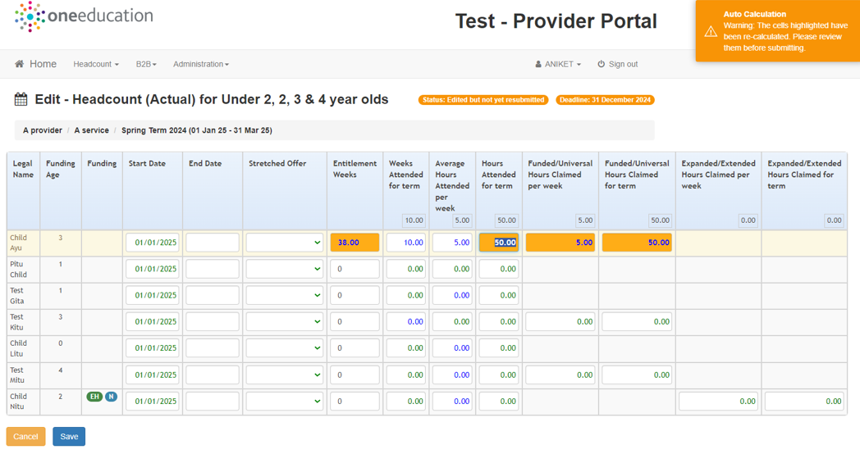
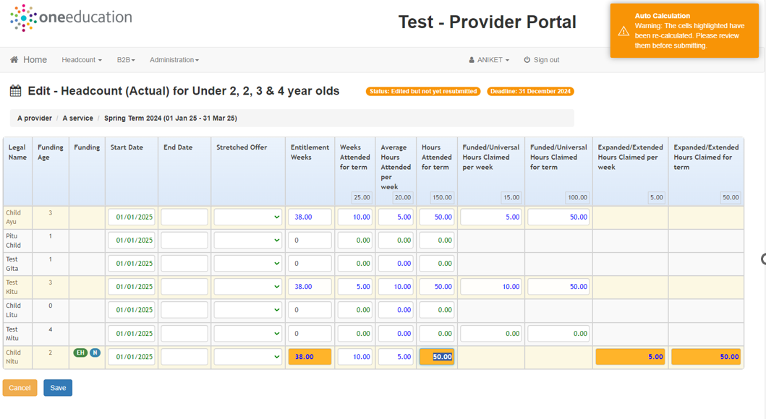

Stretched Places
If the child is attending on a stretched place you will need to take the following action:
- Put Yes in the Stretched Offer column
- Change Entitlement Weeks to 48

*** Please ensure that only 38 or 48 is entered in Entitlement Weeks column ***

Please ensure that this column is only edited for Eligible children.
Eligible children mean that the child must be claiming either funded or extended or expanded hours. If a child is not entitled to claim any of these hours, then the Entitlement Weeks should not be recorded. You will get an error message displayed if you attempt to enter Entitlement Weeks with no funded or extended or expanded hours recorded. An error message will appear irrespective of how many entitlement weeks are recorded.
“Entitlement Weeks should be in the range of 38 to 52 for all the eligible child records”
This is because the child is not claiming any funded, extended or expanded hours and you will have problems saving the record.

