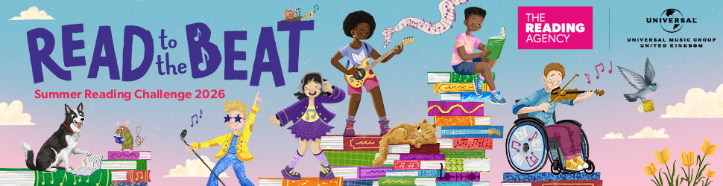
Join the free Summer Reading Challenge at Your Local Library!
Dear parents and carers,
We’re excited to invite your child to take part in this year’s Summer Reading Challenge – Read to the Beat! – Launching at your local library on Saturday 18th July
What is the Summer Reading Challenge?
The Summer Reading Challenge is a fun, free way for children aged up to 11 to enjoy reading during the summer holidays. Children set their own goals, receiving a medal and certificate if they complete them.
Why should my child sign up?
One in four children hasn’t reached the expected level of reading by the age of 11 and many will struggle to keep up at secondary school - reading for fun during the summer is one way to support this.
The Summer Reading Challenge helps your child to:
- Build confidence and self-esteem
- Stay prepared to return to school in the autumn
- Settle into a new year group
- Access free books and fun family activities all through the summer at your local library
Your child will be part of a UK-wide programme developed by The Reading Agency and delivered in partnership with the public library network and this year powered by Universal Music Group UK – whose artists will be championing the joy of reading and sharing their own stories of creative expression. All brought to life with wonderful illustrations by award-winning author and illustrator Harry Woodgate.
“We’ve joined the reading challenge for the past 4 years and every year it has inspired and encouraged a deeper joy for reading. For a young dyslexic boy the challenge helps make reading fun.”
parent/carer of 6–7-year-old boy

How can my child take part? (Library or online)
At the library:
- Visit your local library to sign up – launch day in Shropshire is Saturday 18th July
- Set a summer reading goal and choose from books, eBooks, or audiobooks.
- Enjoy activities and events running in libraries in Shropshire
- Receive a special sticker booklet and collect rewards for reading
Or online
- Visit summerreadingchallenge.org.uk
- Sign up, set a reading goal, and get book recommendations
- Unlock digital badges and earn a printable certificate

We look forward to seeing you in our libraries this summer!
If you have any questions, feel free to contact libraries@shropshire.gov.uk

