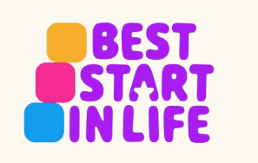
Understanding Your Child
0 – 5 years
“I met others going through the same things. It really helped me feel less alone.”
“The group boosted my confidence as a parent.”

Join our friendly, relaxed group!
Parenting can be full of ups, downs, big feelings and lots of learning — for both you and your child! Your child’s early years are full of change and transition, such as starting nursery or school and moving into the next phase of development. In our weekly sessions we will explore ways how you can support your child through these transitions and other tricky moments. Join us and other parents and carers to share simple ideas that can make life calmer and more positive.
Upcoming Session
- starts Monday 21st September, 12.30–2.30pm at The Lantern, Shrewsbury, SY1 4NG
the group meets once a week over 10 weeks, excl. half terms and bank holidays with the last session being on Monday 30th November 2026.
What We’ll Talk About
• Transition periods in your family’s life
• Communicating and building connection with your child
• Routines like sleep and bedtime and any other routines you have as a family
• Understanding behaviour and big emotions
• Child development and how you can support it
Want to Join Us?

Email: parenting.team@shropshire.gov.uk
Call: 01743 250950
Visit: The Parenting Team | Shropshire Council

Prefer flexible online learning?

Try our free online learning pathways at
Becoming Togetherness - Togetherness

