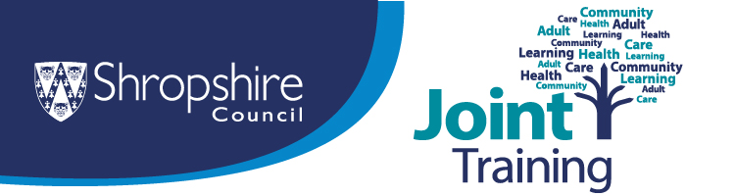

Training opportunities for anyone working with or supporting children, young people or their families in Shropshire local authority area

Pricing Structure
Shropshire LA state-funded schools (maintained and academies) and Shropshire Early Years settings are in Group 1
Independent schools and all other schools outside Shropshire including Telford & Wrekin are in Group 2

Child Exploitation Awareness
Thursday 9th July – Teams – 13.30 to 15.30 OR Tuesday 22nd September – Teams – 09.30 – 11.30
Aims to: Enhance knowledge and practice for those working with children at risk of exploitation.
Learning Objectives:
- Understand the signs, indicators and trends of modern exploitation.
- Understand Shropshire’s exploitation profile.
- Explore the impact of ACEs, trauma, grooming and drug/alcohol use.
- Consider use of appropriate and effective language with working young people.
- Accessing, referring or signposting to the right services when help is needed.
Face to Face Cost: Group 1 £0 Group 2 £41.50
Online Cost: Group 1 £0 Group 2 £35
Agencies in Group 1 receive pre-funded places (so no cost)
Click here for further information and booking details

Child Exploitation Advanced
Tuesday 16th June – The Lantern - 14.00 to 16.00
Aims to: Enhance knowledge and practice for those working with children at risk of exploitation.
Learning objectives:
- Today is not designed as an entry-level exploitation training (see information in audience section below).
- Explore practical methods of offering support and engaging in meaningful interventions with young people.
- Explore how to complete high-quality CE risk assessments.
- Understand latest themes & trends with child exploitation (especially evolving use of technology).
- Refresh knowledge of statutory safeguarding duties and the law.
- Understanding triage outcomes and how thresholds are met.
- Identify when, why and where to signpost or where to get support.
Cost: Group 1 £31.00 Group 2 £41.50
Click here for further information and booking details

Child Sexual Abuse and the Child Sexual Abuse Pathway
Wednesday 1st July – The Lantern - 9.30 to 12.30
Course Aim: To provide a greater understanding of Child Sexual Abuse and the Pathway to follow in Shropshire Local Authority area.
Learning Outcomes:
- Have a greater understanding of Child Sexual Abuse
- Recognise signs and indicators of Child Sexual Abuse
- Gain an awareness of the National and Local statistics around Child Sexual Abuse
- Be introduced to the Child Sexual Abuse Pathway used in Shropshire and understand its purpose in guiding professionals
- Understand the importance of communicating concerns of Child Sexual Abuse and how to respond.
Cost: Group 1 £0 Group 2 £59
Agencies in Group 1 receive pre-funded places (so no cost)
Click here for further information and booking details

Coercive Control and Trauma Informed Practice
Friday 22nd May – Lantern – 9.30 to 13.30 OR Thursday 2nd July – The Guildhall – 9.30 to 13.30
Aims to: Increase your understanding around what coercive control is, the tactics that may be used by an abuser and how to adopt a trauma informed approach.
Learning outcomes: This training module will look at:-
- What is domestic abuse - recap
- What is coercive control
- What the legislation says
- The impacts on a person
- What is trauma and how it can impact a person
- How we can work in a trauma aware and informed way
- Support available to victims and perpetrators.
Cost: Group 1 £57 Group 2 £76.50
Click here for further information and to book a place on this training.

Domestic Abuse and the Impact on Children
Tuesday 23rd June – The Guildhall – 9.30 to 13.30 OR Tuesday 15th September – Guildhall – 9.30 to 13.30
Aims to: Increase your knowledge around the impact of domestic abuse on children and young people living within the household and outline support available for families.
Learning outcomes: This training module will look at:
- What is domestic abuse - recap
- What the legislation says
- The impact on children
- What is trauma
- Signs and behaviours shown
- How to support children and young people living through this
- Support available for children, young people and families.
Cost: Group 1 £57 Group 2 £76.50
Click here for further information and booking details

Domestic Abuse Confident Intervention: tools to safely support domestic abuse victims
Thursday 18th June – The Guildhall – 9.30 to 13.30 OR Friday 25th September – The Lantern – 9.30 to 13.30
Aims to: Increase your confidence in assessing and understanding the risk to victims of domestic abuse who you are working with and in helping to get the correct support in place.
Learning outcomes: This training module will look at:-
- What is domestic abuse - recap
- What is a DASH risk assessment
- How can a DASH be used in your roles
- What is MARAC
- Support available to victims and perpetrators
- Attendees will take away practical tools on best practice to complete and understand risks of Domestic abuse.
This session is delivered along with lived experience and provides an interactive real-life scenario between worker and Domestic abuse victim.
Cost: Group 1 £57 Group 2 £76.50
Click here for further information and booking details

Domestic Abuse Beyond the Break-Up: the tactics and impact of post-separation abuse
Wednesday 1st July – the Guildhall – 9.30 to 13.30
Post‑separation abuse doesn’t end when the relationship does—in many cases, it escalates.
Aim of session: This training explores how perpetrators use ongoing coercive control, legal systems, child contact, financial pressure, and reputation attacks to maintain dominance long after a victim has left.
Learning Outcomes: Participants will learn to recognise the patterns, tactics, and warning signs of post‑separation abuse, understand its impact on adult and child survivors, and build confidence in responding safely and effectively.
Cost: Group 1 £57 Group 2 £76.50
Click here for further information and booking details

Introduction to Early Help & Thresholds
Wednesday 17th June - Teams – 10.00 to 12.00 OR Thursday 13th August – Teams – 10.00 to 12.00
Aims to: Give an overview of the Early Help system in Shropshire Local Authority area.
Learning outcomes: Attendees will gain understanding of:
- The Early Help system in Shropshire Local Authority area.
- The roles of different services and professionals within the system.
- Where to find information on Early Help services and referral pathways.
- Where to find information around Thresholds for different levels of need.
Cost: Group 1 £0 Group 2 £0
All agencies have pre-funded places (so no cost)
Click here for further information and booking details

Substance Misuse and Young People
Aims to: Provide an understanding of young people using substances, exploring addiction and potential risks that can be associated with substance use.
Learning outcomes:
- To deepen knowledge around different substances and their effects
- Identify different signs and indicators of substance use in young people
- Consider ways of working with young people around substance use
- Think about risks that may be associated with substance use
- Know what services and resources are available and where to signpost people to.
Cost: Group 1 £44 Group 2 £59
Click here for further information and booking details

Understanding and Working with Neglect in Children and Young People
Monday 8th June – The Lantern – 9.30 to 12.30 OR Thursday 16th July – The Lantern – 9.30 to 12.30 OR Tuesday 15th September – Guildhall – 9.30 to 12.30
Course Aim: To enable front line practitioners and volunteers to recognise and respond to neglect in Shropshire.
Learning Outcomes:
- Understand the term ‘Neglect’ and how it impacts Children and Young People.
- Identify the signs and indicators as well as the different areas of Neglect.
- Consider factors which may lead to Neglect.
- Be aware of tools and pathways to aide in the finding and reporting of Neglect in Shropshire.
- Learn from Local Safeguarding Practice Reviews.
Cost: Group 1 £0 Group 2 £59
All agencies in Group 1 have pre-funded places (so no cost)
Click here for further information and booking details

Click here for information on our Group pricing structures

Any queries regarding any of the courses above please email joint.training@shropshire.gov.uk

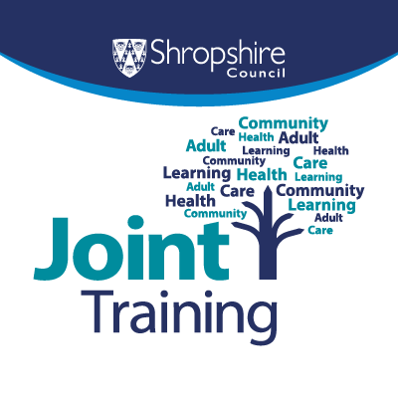
Join the Joint Training mailing list
Sign up to the Joint Training mailing list to receive our regular newsletter, updates on upcoming courses and other important information. To do this, simply click on this link:- SIGN UP to Joint Training updates

