
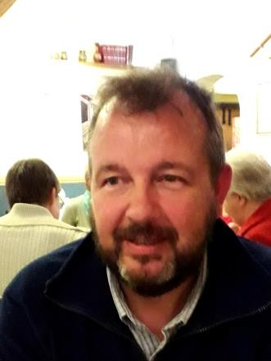
Introducing Dave Thorley
and Educational Visits - Cross Phase

Dave is currently the Local Authority Outdoor Education Advisor for Shropshire working within the Education Improvement Service. He has over the last 40 years worked within the Voluntary, Charitable and Statutory sectors through the medium of Outdoor Education. Having managed several Outdoor Education Centre’s in Central London he moved to Shropshire in 2007 taking up the post of Duke of Edinburgh’s Award Officer before taking up his current role in 2015.
Target Audience: Primary/ Secondary EVC Co-Ordinator’s.

Events:
Coordinating educational visits and journeys (initial training [1]) and (revalidation training [2]) Cross Phase Educational Visits Network [3]

Course Content

These EVC meetings will cover issues relating to the quality assurance of educational visits and the development of the EVC Coordinator’s role.
Delegates will have the opportunity to meet with and benefit from the support and experience of others who share the same
role.
Delegates will have an opportunity to reflect on the role of the EVC coordinator.

Next EVC Network: Tuesday 17th March 2-3.30pm via ‘Teams’, to book place email contact below with name, school / establishment and email contact for ‘Teams’ invite. In this session we will have current updates including the transfer to ‘evisits edition 2’ next September and 2 local Outdoor Learning providers.

Contact: EducationalVisits@shropshire.gov.uk
1

