Support Needed: Share Safeguarding Guidance with Schools

Since the launch of the National Safeguarding Framework for Extracurricular Activities, we have been engaging with LADOs across the country, as well as MPs, councillors, organisations, and policy makers. Many of you have highlighted a key concern: unlike schools, extracurricular activity providers are not legally required to follow safeguarding standards.

In direct response to what we have heard from LADOs, we are now asking for your support in helping us educate parents about this gap. Families need to know that there is currently no legal requirement for extracurricular providers to safeguard children.

We would be grateful if you could send the parent checklist and graphic (below) to schools within your local authority, encouraging them to share it with their parent body — for example, through digital newsletters or other regular communications. This will help parents ask the right safeguarding questions before enrolling their children in extracurricular activities.

Alongside this, please also encourage parents to sign our national petition, calling for legislation to make safeguarding a requirement for all extracurricular activity providers.

If you would like the graphic as an attachment, please reply to this email and I will send it to you. Alternatively, you can right-click on the image in this email to save it directly.

By working together and ensuring schools pass this message on, we can raise awareness now while also building momentum for legislative change.

Thank you for your ongoing commitment to safeguarding children. Together, we can help close this dangerous gap and protect every child in extracurricular activities.

Yours faithfully,
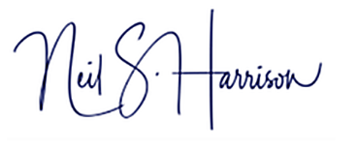

Neil Harrison
Chief Executive Oﬃcer
British DanceSport Association

