

Dear All,
Welcome to the first newsletter of the academic year 25/26. I hope you all had a good summer and enjoyed some time away from work.

There are some important messages in this newsletter which I'll highlight and urge you to read.

- New free online training sessions from the DfE for Designated Safeguarding Leads (DSLs) in Independent Schools and practitioners in Early Years and Foundation Stages (EYFS).
- An update from Home Office colleagues on the new Key Principles of Prevent. These key Principles have been developed to set out and clarify existing Prevent policy and help people understand Prevents core purpose.
- An update on the implementation of Martyn’s Law from our Protect and Prepare colleagues.
- An update on the new FE setting resources on Educate Against Hate. These new resources will include guidance and lesson plans on a variety of topics including online extremism, spotting lies and conspiracies, and British Values.

  
  

Training Sessions

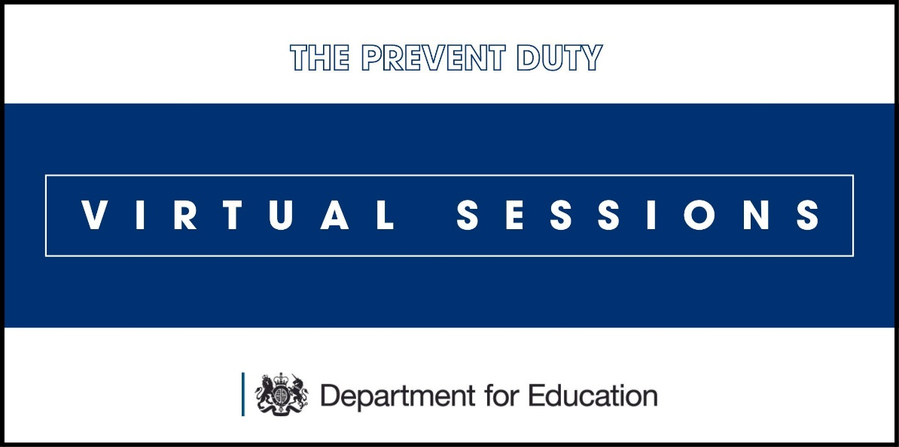
Prevent in Education Virtual Sessions from the DfE
We continue to deliver training sessions aimed at designated safeguarding leads (DSLs) and school governors to support them in understanding the Prevent duty and their safeguarding responsibilities in protecting young people from radicalisation and extremism.

NEW for 25/26 AY Following the successful roll out of the DFE training packages for DSLs and governors, we are pleased to announce the launch of two further training packages for the education sector. Please note we have continued to place a limit on attendance numbers but we have offered dates throughout the year. We will review demand and respond accordingly so dates could change.

The first package is intended for DSLs in independent schools. The objectives of this training are:
- To understand the importance of referring to Prevent
- To understand your responsibilities in relation to Prevent as a DSL
- To consider what evidence Ofsted/ISI will look for
- To recognise the tools available to help you
- To understand referral pathways and Channel panel

The second package is directed towards Early Years Foundation Stage practitioners. The objectives of this training are:

- To understand your role as an Early Years practitioner in relation to Prevent
- To understand the importance of referring to Prevent and the legal duty
- To recognise the tools available to help you
- To understand what Ofsted might expect to see in relation to Prevent
- To recognise how to build resilience to radicalisation by promoting Fundamental British Values

Please click on the button below to be taken to all available dates and further details for the webionar sessions we offer
-DSLs
- Governors
- EYFS practitioners
- DSL in independent schools

If you have booked a place but no longer require it, please can you ensure you cancel your ticket via Eventbrite. We have waiting lists for some sessions.


Prevent in Education Virtual Sessions from the DfE
Over the remainder of 2024 and in early 2025, DfE Regional Prevent Education Coordinators (RPECs) will be delivering training sessions aimed at designated safeguarding leads and school governors to support them in understanding the Prevent duty and their safeguarding responsibilities in protecting young people from radicalisation and extremism.

Please click on the button below see all available dates and further details.
Additional Virtual Training Sessions
Sitting outside of the above training offer, some of our RPECs deliver their own sessions that you might be interested in attending.

Our London RPEC delivers 4 sessions on a regular basis including a Prevent induction/refresher, an introduction to incels, an online platforms and extremist content session, and a gaming and extremism session.
Our East Midlands RPEC also delivers 2 sessions on a regular basis including a Prevent awareness session tailored for staff in education, and a session aimed at FE skills providers subject to the Prevent duty.

Martyn's Law

The Terrorism (Protection of Premises) Act 2025, commonly known as Martyn’s Law, received Royal Assent in April 2025.The Government intends for there to be an implementation period of at least 24 months before the act comes into force. This period will enable those responsible for premises and events to have sufficient time to understand their new obligations, and to plan and prepare accordingly.

Whilst those that fall within scope of the act may wish to consider the requirements, there is no requirement to comply with them until the legislation comes into force. The Government will publish statutory guidance during the 24-month implementation period. This will be subject to stakeholder consultation prior to publication and will assist those responsible to understand the requirements set out in the legislation.

Martyn’s Law aims to improve public safety by requiring certain premises to reduce the impact of a terrorist attack and minimise harm should one occur.
To help education providers understand their responsibilities under the new law, the Department for Education has published a comprehensive policy overview on GOV.UK. This is not statutory guidance.
What the overview covers
- Why Martyn’s Law is necessary and the context behind its introduction.
- How the law applies to education settings, including which types of institutions fall in scope.
- What the DfE is doing now and plans to do over the 24-month implementation period to support the sector
- What education settings need to do to prepare and comply with the legislation before it comes into force.


Prevent Key Principles Update from the Home Office

Following the tragic attack in Southport in August 2024, the Prevent system has been under significant pressure with the number of referrals increasing substantially. Part of the reason for this has been a lack of clarity on the thresholds within which Prevent operates, particularly in relation to cases related to 'fascinated with extreme violence or mass casualty attacks'.

To support frontline professionals and practitioners the Home Office has brought together existing guidance into the linked Key Principles of Prevent document, alongside FAQ’s and case studies. Please feel free to share these with colleagues and local partners.

The Key Principles do not introduce new policies or expectations but clarify practices that have been operational since 2019. The Key Principles have been widely tested with Prevent practitioners and frontline professionals and are drawn directly from existing guidance and training. For professionals and practitioners already working within Prevent, these principles will be familiar.

Prevent’s core aim is unchanged: to stop people from becoming terrorists or supporting terrorism. It is, and always has been, an early intervention programme, designed to offer timely support to those at risk of being drawn in to terrorism.

The Key Principles set out that, while ideology is an important consideration, it is not mandatory for a Prevent referral. However, where there is not a concern that someone may be drawn into terrorism, alternative local support services should be considered. Further information has been provided in the accompanying FAQs.





The support available to FE colleges and training providers to meet the Prevent duty is changing this summer, because building young people’s resilience to extremism is more effective when its teacher led.

From September 2025 the Education and Training Foundation offer will be replaced by high quality lesson plans, guidance and ready to use resources, hosted on Educate Against Hate FE.

Designed for practitioners to deliver to their students in flexible teaching formats to meet the range of learning contexts across the sector.
FE practitioners can also access further training and support at Prevent duty training - GOV.UK.

Resource Reminder
- Prevent duty self-assessment tool: further education - GOV.UK (www.gov.uk) [FE specific]
- Prevent legislation, guidance and resources - The Education and Training Foundation (et-foundation.co.uk) [FE specific]
- Educate Against Hate - Prevent Radicalisation & Extremism
- Going Too Far? (lgfl.org.uk)
- The Prevent Duty in higher education (HE): training and guidance for practitioners - GOV.UK (www.gov.uk) [HE specific]
- Test Your Internet Filter | SWGfL Test Filtering
- Prevent duty: risk assessment templates - GOV.UK (www.gov.uk)
- Prevent duty guidance: Guidance for specified authorities in England and Wales (publishing.service.gov.uk)
- The Prevent duty: safeguarding learners vulnerable to radicalisation - GOV.UK (www.gov.uk)



Please note this document provides links to a number of media publications and articles for information purposes. This is not an endorsement of the provider or the content.



 |  | 

Copyright © 2023 Department for Education, All rights reserved
Prevent.westmidlands@service.education.gov.uk

