Improvements to Communication with the EHCP Team
We are aware that there are frustrations around communications within the EHCP team.
Our aspiration is to be responsive, and we are aware that due to the volume of emails, phone calls across the partnership and parents that we are struggling to keep up with responding in a timely manner.
In listening to our partners, we would like to propose an escalation process, as follows:
Case Officer – Senior Case Officer – Team Manager – PEP/Preventative Lead.
To manage the incoming traffic of information requests, our preferred method of communication is email initially. We would request that we embed a protocol of naming to emails which include wording in the subject line:
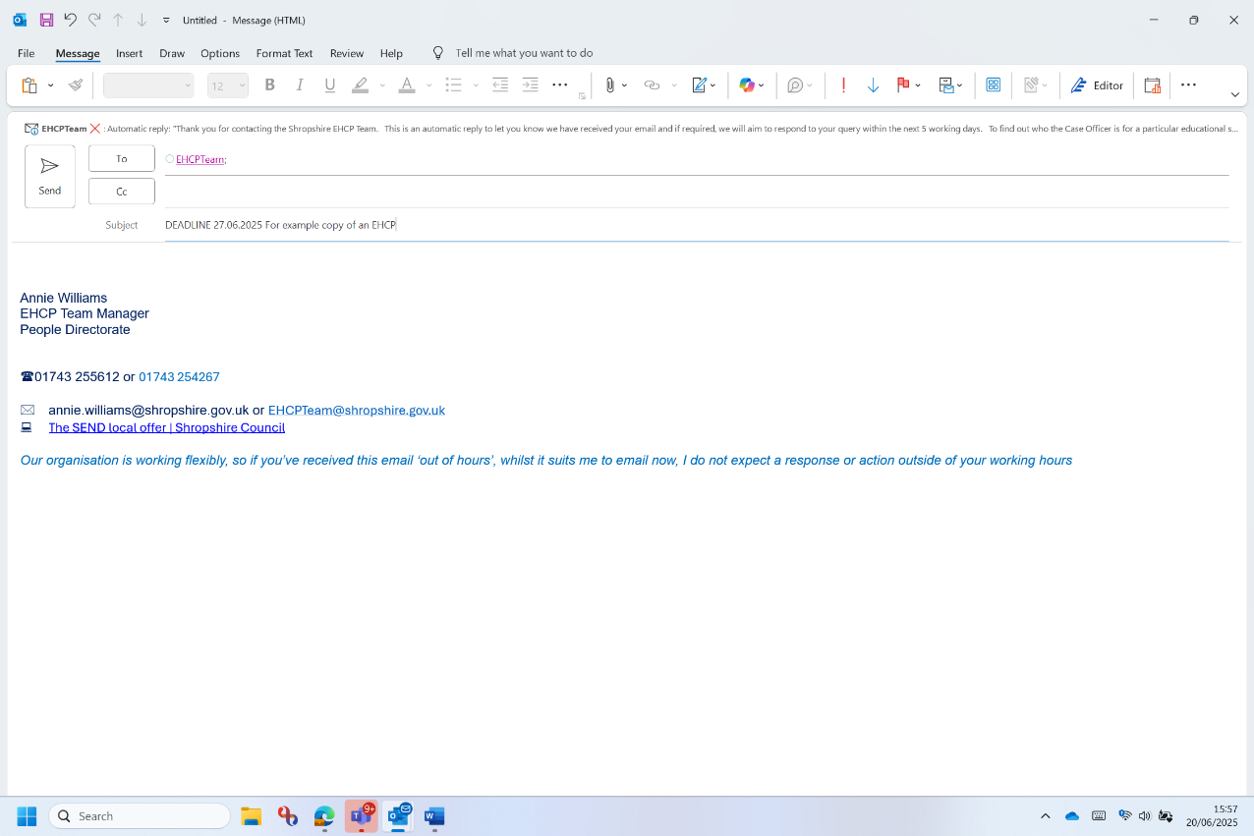
By adding a DEADLINE – 27.06.2025, rather than URGENT, the team can readily understand by when you need a reply. If partners can apply this objectively, then we can manage the incoming and output of information more easily and manage expectations.

You will note from the example, that we haven’t added anyone to be copied in. If you direct your request firstly to the EHCPTeam@ email account, or the Case Officer, if you are already in dialogue with them, it will help to support with the volume of emails coming into everybody’s inbox.
If you are aware of the pupil’s Case Officer (Case Officer Allocation List) please direct your email directly to the Case Officer, there is no need to also copy in the EHCPTeam@shropshire.gov.uk email address.
If the email remains unanswered after the agreed 5 days turnaround, you can forward to the next person within the escalation process.
The suggested naming convention here would be ESCALATION. This is clear to us then, that there is not a 5-day tolerance and a reply is expected by the requester.
If an enquiry is about a response for an Annual Review, then you can use the Annual Review email account for those specific queries: senannualreviews@shropshire.gov.uk
Please be aware that Thursdays are focused plan writing days and therefore the EHCP Team are not available Thursdays and will not respond on a Thursday. We kindly request that you avoid sending messages on this day but to make contact on the other four days of the week so as not to delay response times.
Thank you.

