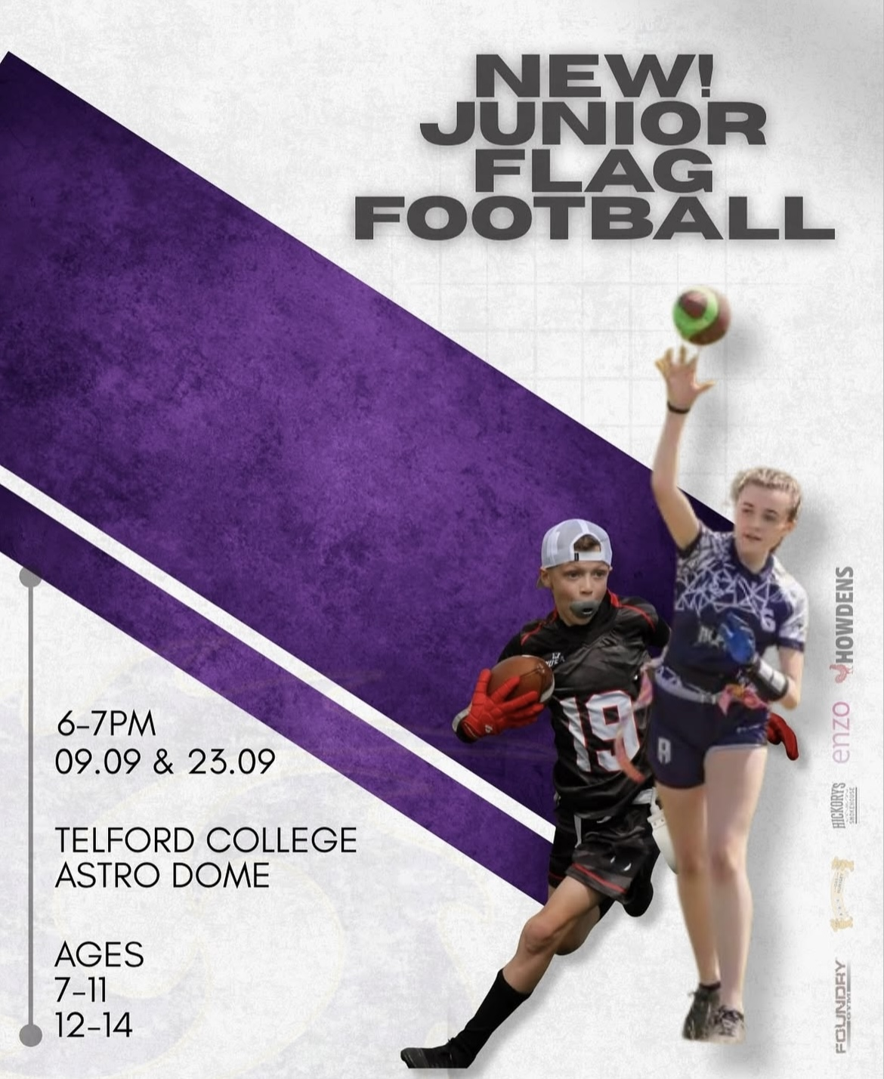
American Flag Football with Shropshire Revolution
🏈 Telford College Astro Dome 🏈
🏈 6 till 7pm - Tuesday 9th & 23rd of September 🏈
🏈 Ages 7-11 & 12-14 🏈
Discover one of the UK’s fastest growing sports with an NFL Flag rookie session! Whether you’re new to the game or just curious this is your chance to get involved.
FUN, FAST, INCLUSIVE – no experience needed. If these sessions take off, you could become an important player in the very first Flag team in Shropshire.
Come join us at our taster session and become part of the journey!

