

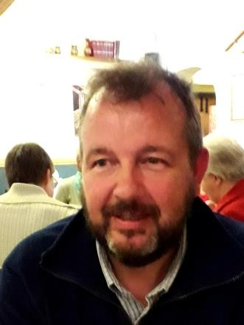
Introducing Dave Thorley
Educational Visits - Cross Phase
Dave is currently the Local Authority Outdoor Education Advisor for Shropshire working within the Education Improvement Service. He has over the last 40 years worked within the Voluntary, Charitable and Statutory sectors through the medium of Outdoor Education. Having managed several Outdoor Education Centres in Central London he moved to Shropshire in 2007 taking up the post of Duke of Edinburgh’s Award Officer before taking up his current role in 2016.

Target Audience: Primary/ Secondary EVC Co-ordinators.

Course Content
- These EVC meetings will cover issues relating to the quality assurance of educational visits and the development of the EVC Coordinator’s role.

- Delegates will have the opportunity to meet with and benefit from the support and experience of others who share the same role

- Delegates will have an opportunity to reflect on the role of the EVC coordinator.

EVC Training Dates 2025 / 26
All training sessions will be delivered via ‘Teams’ online by Dave Thorley (LA Outdoor Education Advisor). To make a booking on any of these courses please email educationalvisits@shropshire.gov.uk with the name and email address of the person you’d like to book on and they will then be added and invited to a ‘Teams’ meeting.
EVC Initial Training – Tuesday 23rd September 2025, 9.30 – 11.30am + 1-3pm
EVC Revalidation – Thursday 23rd October 2025, 9.30 – 11.30am
EVC Network – Thursday 6th November 2025, 2-3.30pm
EVC Initial Training – Thursday 22nd January 2026, 9.30-11.30am + 1-3pm
EVC Revalidation – Thursday 5th February 2026, 9.30 – 11.30am
EVC Network – Tuesday 17th March 2026, 2- 3.30pm
EVC Initial Training – Tuesday 5th May 2026, 9.30 – 11.30am + 1-3pm
EVC Revalidation – Thursday 21st May 2026, 9.30-11.30am
EVC Network – Wednesday 24th June 2026, 2-3.30pm
Evisits induction can be booked directly with Dave Thorley – dave.thorley@shropshire.gov.uk – this session takes around 40 minutes and is delivered via a ‘Teams’ invite – there is no cost for this!

