Dear Parent / Guardian
Measles is circulating
I am writing to make you aware that cases of measles have been rising in England this year.
Measles can be a very unpleasant illness. In some people, especially children, it can be very serious and lead to hospitalisation.
People who are most likely to become very ill from measles are:
● young children
● pregnant women
● people who have a weak immune system. This is when your body finds it hard to fight off infections and stay healthy
The best protection against measles is the measles, mumps, and rubella (MMR) vaccine. The MMR vaccine provides long-lasting protection against measles.
How do you catch measles
You can get measles if you get close to someone else with measles. You can also get measles by touching things that have been coughed or sneezed on.
Most people start feeling ill 10 days after getting measles. But sometimes it can take as long as 3 weeks.
Symptoms of measles
Measles usually starts with cold like symptoms e.g., a high temperature, blocked or runny nose, sneezing, cough, red, sore watery eyes. Other symptoms: Small white spots in mouth
Measles rash (red and blotchy) which usually appears a few days after the cold like symptoms starting on face and behind ears then spreading to rest of the body.
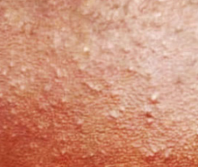
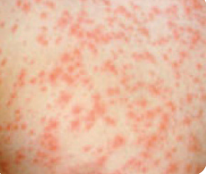

Measles is a highly infectious viral illness, so anyone with symptoms is advised to stay at home and phone their GP or NHS 111 for advice, rather than visiting the surgery or A&E, to prevent the illness spreading further.
There is information on measles on the NHS website.

NHS advice
Anyone with symptoms should not return to school or nursery for at least 4 days from when the rash first appears. After 4 full days a person can carry on as normal if they feel better and do not have a high temperature.
Some people who are close to the person who is ill and are unvaccinated may be asked to stay at home for longer.
How to look after yourself or your child
Measles usually starts to get better in about a week.
There are things you can do to help ease the symptoms.
It can help to:
- rest and drink plenty fluids, such as water, to avoid dehydration
- take paracetamol or ibuprofen for a high temperature
- give your child paracetamol or ibuprofen if they're distressed or uncomfortable – check the packaging or leaflet to make sure the medicine is suitable for your child, or speak to a pharmacist or GP if you're not sure
- use cotton wool soaked in warm water to gently remove any crusts from your or your child's eyes
Help reduce the spread of infection
Wash hands regularly with soap and water
Use tissues when you cough and sneeze
Throw used tissues into the bin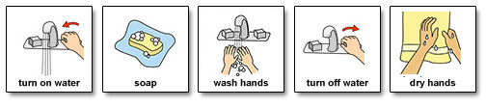
Vaccination
Anyone who has not had 2 doses of the MMR vaccine should ask their GP surgery for a vaccination appointment.
Measles spreads very easily among those who are unvaccinated.
Having two doses of the Measles, Mumps, Rubella (MMR) vaccine at the right time (dose 1 from 12 months and dose 2 from 3 years 4 months) is the best way to protect your child and help prevent it spreading, especially to those most vulnerable. Two doses of the MMR vaccine give you excellent lifelong protection. If you or your child have missed out, contact your GP surgery to catch up as soon as possible. To see if the child in your care is up to date with their MMR vaccines, check the child’s personal child health record (PCHR), known as the red book, or contact their GP practice. Anyone can enquire on their own immunisation record via their GP and may also be able to check vaccination status on the NHS App. It is never too late to catch up. The MMR vaccine is free on the NHS, whatever your age. If anyone has missed one or both doses of the MMR vaccine, contact their GP practice to book an appointment.
Best Regards

