STEP Early Career Framework and Appropriate Body news

Summer term 2024-25 starters registration information

The DfE portal will remain open for Summer term registrations up until Friday 23rd May.

Please follow the below process to successfully register your ECTs and Mentors for the Summer Term start. Please note, if your ECT(s) are already registered with STEP and are staying at the same school in Summer 2025, their induction will continue and you will not need to re-register any details.

Registration for ECTs starting induction in Summer 2024-25:

Step 1 – register ECTs and their Mentors via DfE portal at: DfE Online Service - (Best Practice Network then collect additional details directly from the ECTs and ECMs to enable allocation to their local training group). Please select ‘Shropshire and Telford Education Partnership (The Priory School)’ as the Appropriate Body and Delivery Partner. Best Practice Network would be the Lead Provider if you are going with them.

Step 2 – register your ECT’s induction with STEP on ECT Manager portal:

- If you are already registered on ECT Manager, please sign in and go to:

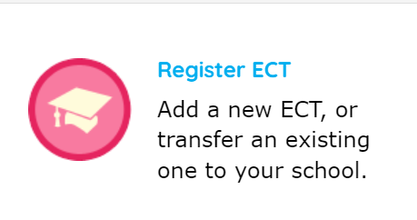

However, if you have never registered with STEP on ECT Manager, please follow the below instructions:

    - To register with Shropshire and Telford Education Partnership, STEP, please click on the following link: The Shropshire and Telford Education Partnership (STEP) – ECT Paperless Induction and Assessment Management System (ectmanager.com)

    - Before registering, please view the following short video for a details step by step guide for how to register your school: Register your school at this Appropriate Body | ECT Manager Help Center

    - Please note, once you have registered your school, this will first of all need to be approved by the STEP team before you can start adding your ECTs. We will aim to do this within 48 hours. Once approved, you can then start adding your ECTs. Please refer to the following video to do this:
Register an ECT | ECT Manager Help Center

Step 3 – if this is your first ECT and you are using Best practice Network as your Lead Provider, please register with them via: Best Practice Network - School Registration Form (bpnsystems.net)

Full details of the registration process can also be found on our website at Shropshire and Telford Education Partnership - ECF/AB (stepwm2.co.uk).
Summer Term reporting deadline

Our Summer Term reporting deadline will be: Friday 11th July 2025. This deadline excludes mid-term starters. For full-time ECTs who started induction in September 2023, this will be their Term 6 Final Assessment.

STEP upcoming webinars:

New Early Career Teacher Entitlement (ECTE) Provider – University College London (UCL)

As you may have heard, from September 2025, we will no longer be able to use Best Practice Network as our Lead Provider for the ECF programme. The updated terminology for the Early Career Framework will be the Early Career Teacher Entitlement (ECTE). Please refer to the following DfE guidance around this: Early career teacher entitlement (ECTE) support - GOV.UK

We are happy to announce our new Lead Provider for the ECTE programme will be University College London (UCL). For further information around this, we will be running a webinar on Tuesday 20th May from 3.30 – 4.30pm. Please look out for your invitation or join via the below link.

Microsoft Teams Need help?
Join the meeting now
Meeting ID: 312 145 319 960
Passcode: XE3ba36A

Summer drop-in sessions

Our online drop-in sessions will take place on the following dates and invites have been forwarded:

- ECT drop-in – Wednesday 21st May 3.30 – 4.30pm
- IT / ECM drop-in – Thursday 22nd May 3.30 – 4.30pm

If you haven’t received your invite or require any further support or queries, please contact us at: ECF@stepwm2.co.uk

