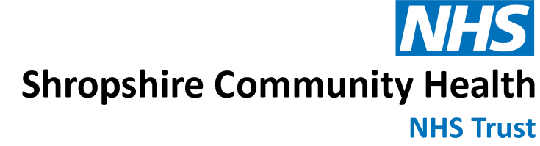

Children’s Speech and Language Therapy Services

CHILDREN’S SPEECH AND LANGUAGE THERAPY
PRE-ASSESSMENT REFERRAL UPDATE
The Children’s Speech and Language Therapy (SLT) Service are trialling a new initiative and we kindly ask for your support with this. The initiative is to help manage the significant number of referrals being received and the consequent long wait times for assessment. This will enable us to identify the children who most need our help and reduce the waiting times.
For children who have been referred to Children’s SLT and are currently on the waiting list for an initial assessment, prior to a child’s initial appointment a pre-assessment form will now be sent to the child’s education setting and parents/carers to request an update. We are asking for your support to please complete the questions on the form, giving as much information as you can, and return it to shropcom.childtherapydocumentexchange@nhs.net prior to the child’s appointment date. The form is brief and quick to complete. This will enable us to gain an update on the child’s progress both at school and at home, to find out whether there are still concerns and check that the appointment is needed, and to also make sure they are on the right pathway. If there are no further concerns, we will discharge the referral. If either parent/carer or setting still have concerns, we will retain the referral.
We hope that whilst the child has been waiting for an appointment their education setting and parents/carers have been able to access our website for further information and support:
https://www.shropscommunityhealth.nhs.uk/childrenspeechlanguagetherapy
We also have an SLT advice line, which is available to parents and carers of children currently on our caseloads, those referred and those not known to the service: 01743 450800 (option 4).
If there are any questions about the update above, please contact the Children’s Speech and Language Therapy Service on 01743 450800, option 4.
Many thanks in advance for your help.

