Safety tips for families visiting farms and other animal attractions this Easter

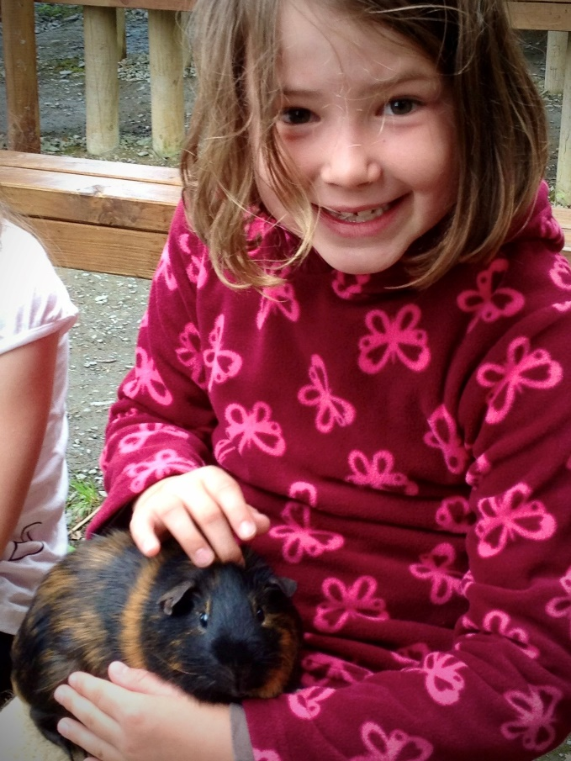

With the Easter holidays approaching, families visiting farms or other animal attractions in Shropshire are being advised to follow advice to help keep children safe and healthy.
Visitor attractions involving contact with animals are understandably popular with parents and children but do carry a risk from infectious diseases.
Common types of illness include infection with cryptosporidium parvum, E. coli O157 and salmonella.
All these bacteria live in the gut of the animals. Infections are caused either by touching animals in the petting and feeding areas, or by coming into contact with animal droppings on contaminated surfaces around the farm. These harmful bacteria can get accidentally passed to your mouth by putting hands on faces or fingers in mouths before washing them thoroughly. It only takes a small number of the bacteria to cause infection.
Following these practical steps will help your child stay safe and healthy:
- Children should wash their hands with soap and water in the following situations: after contact with animals, before eating, before and after using play equipment, after using the toilet and when leaving the site. This will help to explain why they must wash their hands thoroughly in these situations and to show them what proper handwashing looks like. Bear in mind that alcohol gel and hand sanitising wipes are not a suitable substitute for proper hand washing with soap and running water – it doesn’t work against Cryptosporidium.
- Do not suck fingers or put hands, pens, pencils, or crayons etc. in mouths.
- Check that cut, grazes etc. on children’s hands are covered with a waterproof dressing.
- Do not kiss animals.
- Eat only food that you have brought with you or food for human consumption that you have bought on the premises and eat only in designated areas.
- Never eat food that has fallen to the ground.
- Never taste animal foods.
- Children should not eat, drink, or chew anything (including sweets) outside the areas designated for eating at the visitor attraction.
- Try to avoid wearing open-toed shoes. Where possible, clean, or clean and change footwear before leaving. The site should have facilities to clean footwear and pushchair/pram wheels as you leave the site. Wash hands after cleaning/changing footwear. Then wash your hands thoroughly with soap and warm running water
- If you have held or had contact with an animal, wash clothing at 40C or hotter when you return home.
- Do not use or pick up tools (e.g. spades and forks) or touch other work equipment unless permitted to do so by site staff.
- Do not climb on to walls, fences, gates, or animal pens etc. Some animals put their feet on the fences of their pens and contaminate them with faecal matter.
- Listen carefully and follow the instructions and information given by the site staff.
- Do not wander off into unsupervised or prohibited areas e.g. manure heaps.
- Allow plenty of time for hand washing before eating or leaving the site so that the children do not have to rush.
What should I do if I feel unwell after a farm visit?
- If you or anyone in your group feels unwell or has any symptoms such as diarrhoea or vomiting within 2 weeks of visiting a farm, contact your GP or call NHS 111 as soon as possible. If you or anyone in your group - particularly if they fall into a vulnerable group - has bloody diarrhoea, seek immediate emergency medical attention.
- Anyone who has experienced sickness or diarrhoea after visiting a farm could pass the illness on to others, so they should not attend work, school or nursery until they have been free of symptoms for at least 2 days. However, with infections from some bugs, extra tests may be needed to ensure they have fully recovered and will not pass on the infection to others before starting back at work, school or nursery. People who handle food, children under 5 years and those who work closely with people who may be vulnerable to infections should discuss with their GP or local health protection team before returning to work, school or nursery.
