Quick Reference Guide
Registration on the Shropshire Telford & Wrekin VCSE DPS
Instructions for Registration
1 | Type in eu-supply.com to your browser
2 | Registration  Go to EU-Supply and make sure to click “New supplier registration”on the list on the left

3 | You will be directed to the Supplier Registration form, which you need to complete in full.  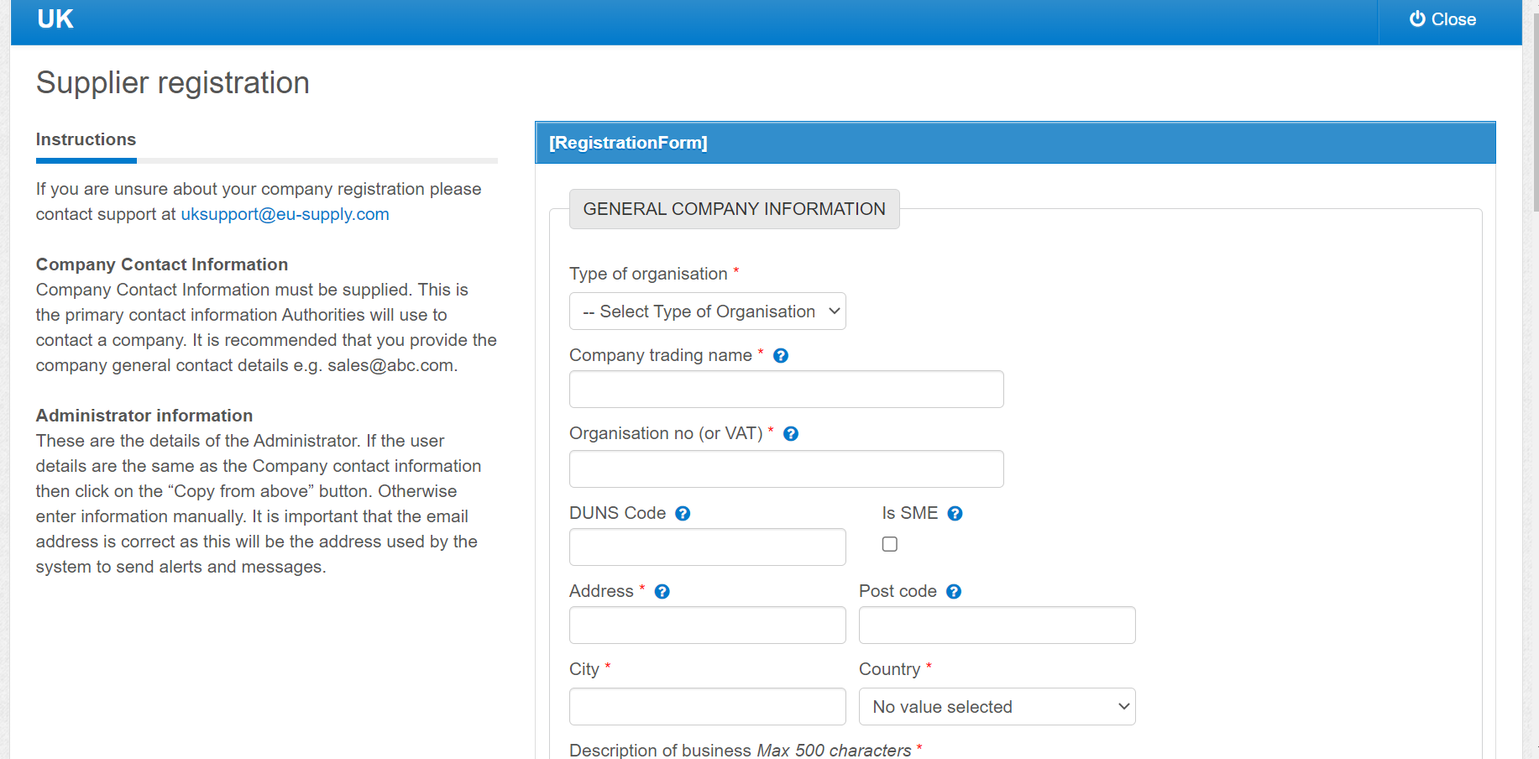  When you have completed the ‘Supplier Registration’, click the ‘Save’ button on the bottom right of the screen  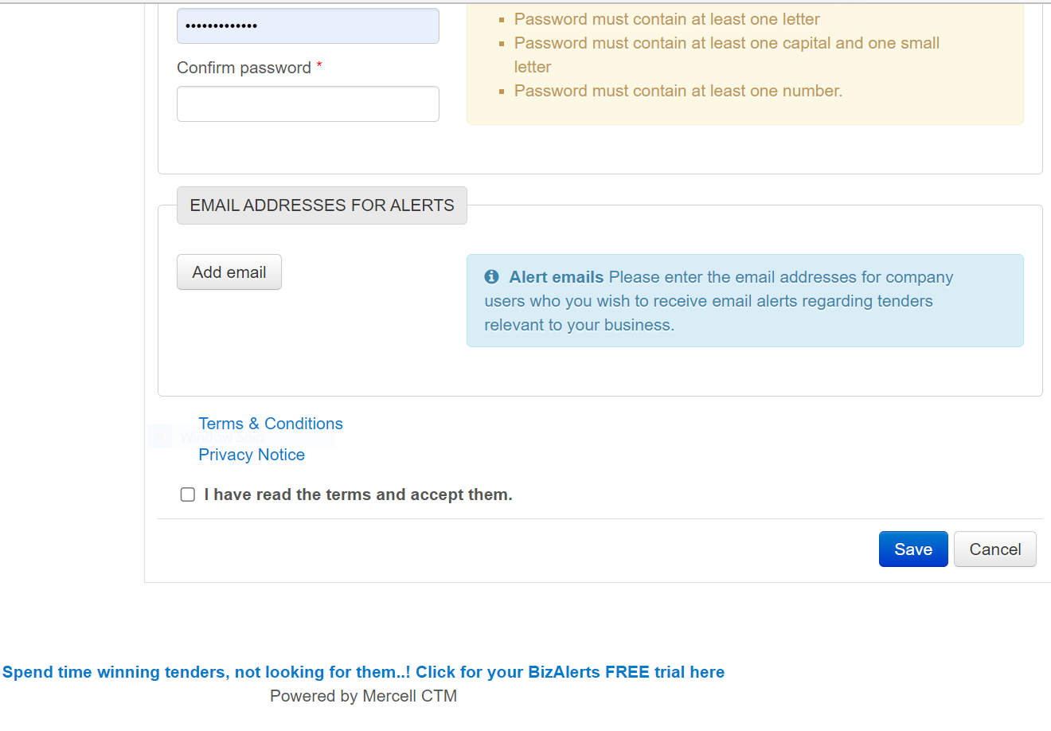

4 | Once you have created an account, go to your organisations home page  This is where you will see recent messages (procurement will message you on this for any queries/questions relating to your responses) This should also be used to ask questions of procurement  Click CTM Published Tenders  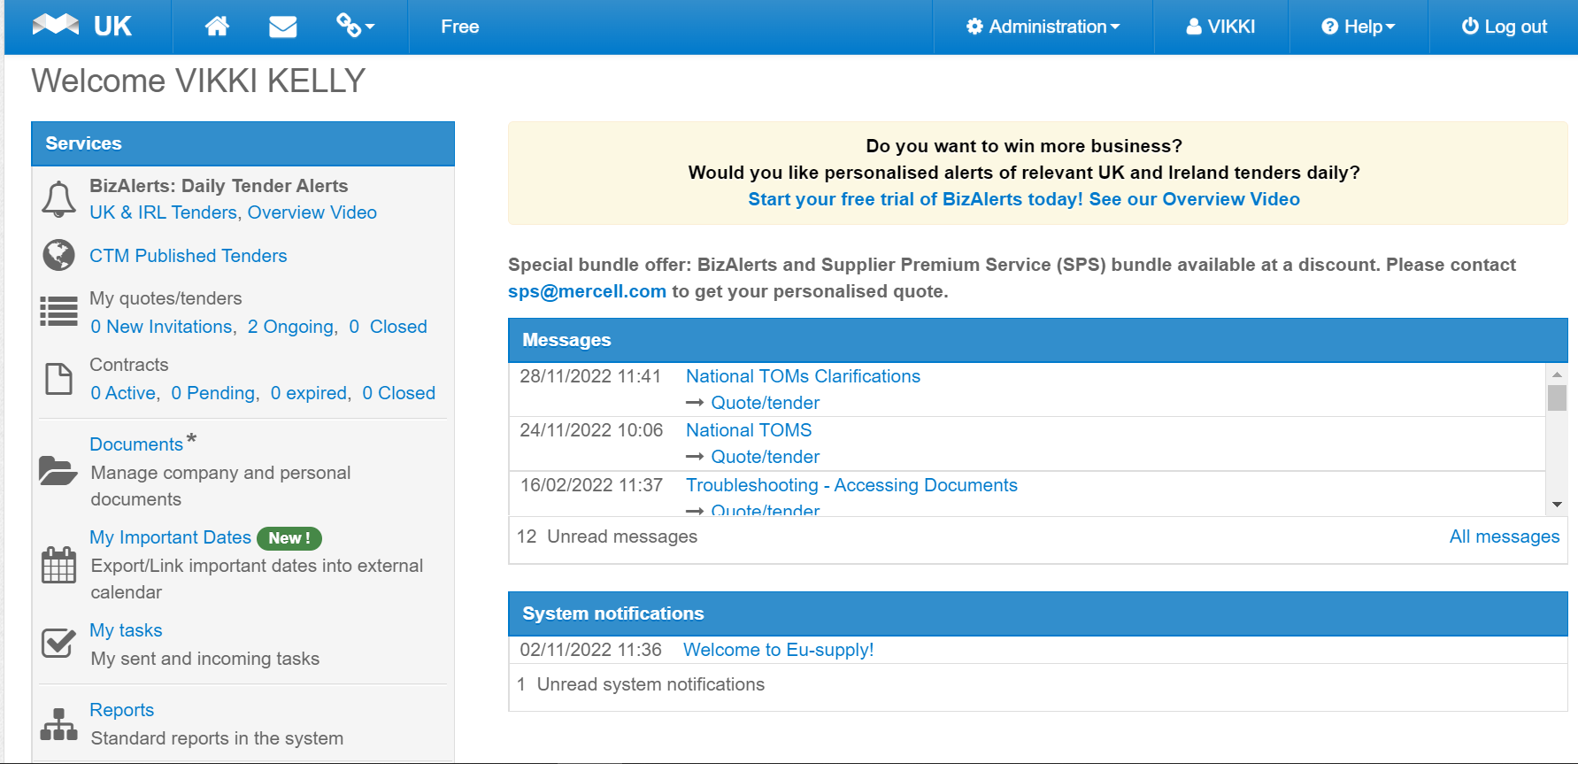
5 | This will direct you to ‘Ongoing Public Tenders’ . This is where you can find a list of all tenders registered on EU-Supply  Type VCSE in the ‘with keyword’ box and click ‘search’ A list of all ‘Name’ will be displayed. Click on ‘Shropshire VCSE Mental Health Transformation’  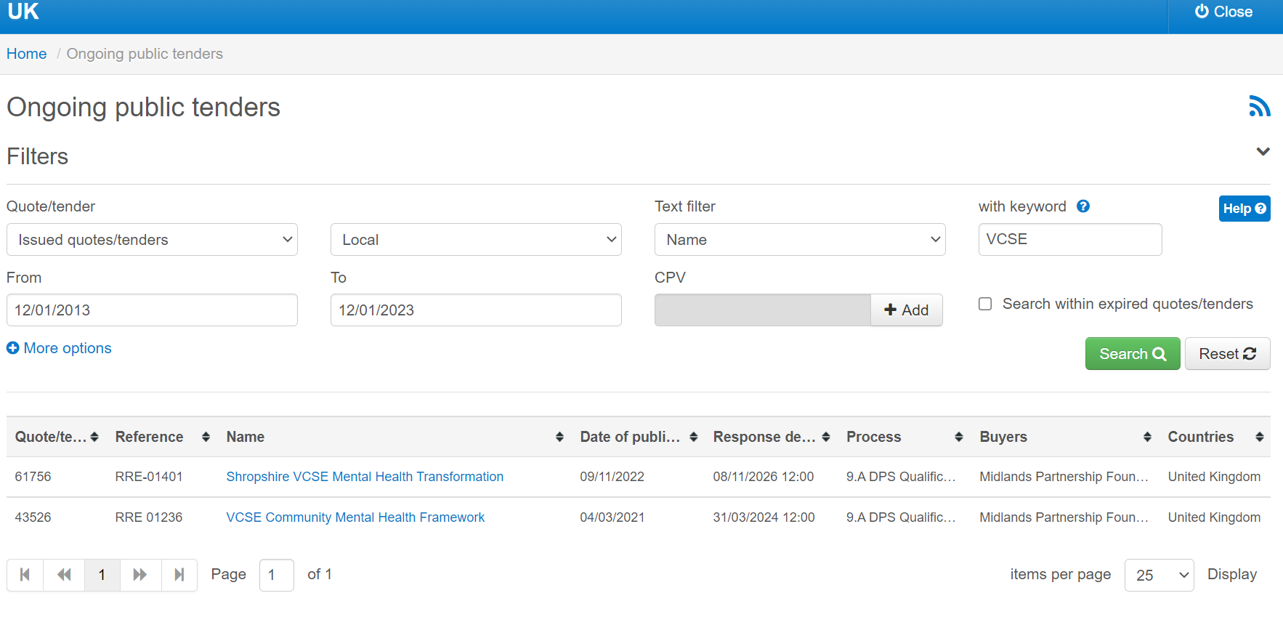

6 | Once you have clicked on ‘Shropshire VCSE Mental Health Transformation’ you will this screen. Located in the top left hand corner there will be a box that says “Accept” make sure to click this and that will confirm you have registered to the DPS.  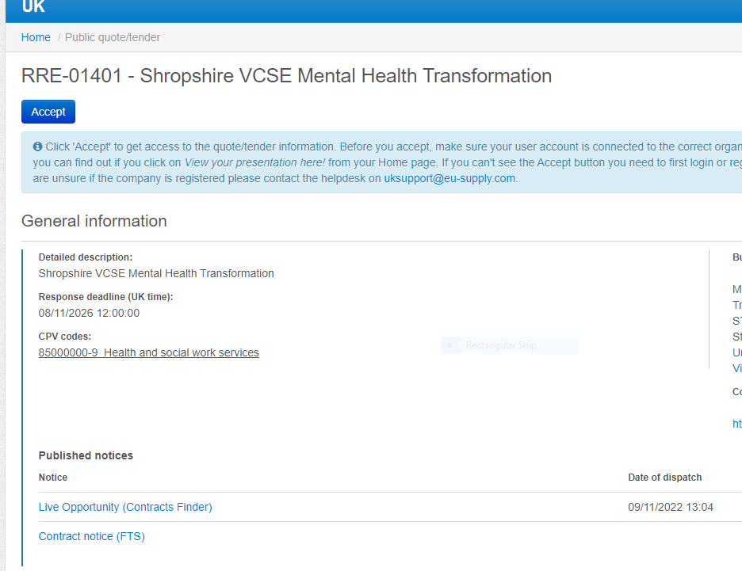
Instructions for Completing Stage One – Eligibility Questions
7 | To complete stage one you will need to go down to “My Responses” this will take you to a page that has 29 questions that all require a response.  this will take you to a page that has 29 questions for you to complete  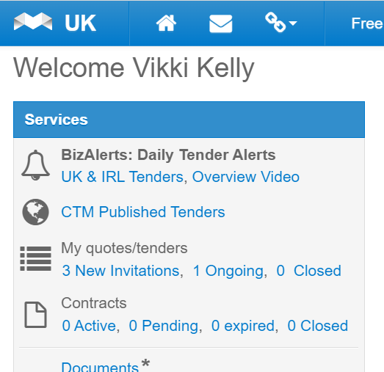
8 | If you log out you can get back in to this screen by looking at the ‘My quotes/tenders’ and it should say “1 ongoing” click into this and it will bring you back to the screen for the responses.
9 | Sample of the questions in Stage One – Eligibility Questions  Some questions will require you to upload documents. These documents are required by procurement for your organisation to “qualify”.  Upon completion of all questions, click “save and next”, this will notify procurement that you have given a response.  The MPFT procurement team then have 10 days to contact you if anything further is required and to go over your responses.  When your organisation has qualified, you will be notified and this will enable you to get notification of any tenders being put out to market on this particular DPS.  