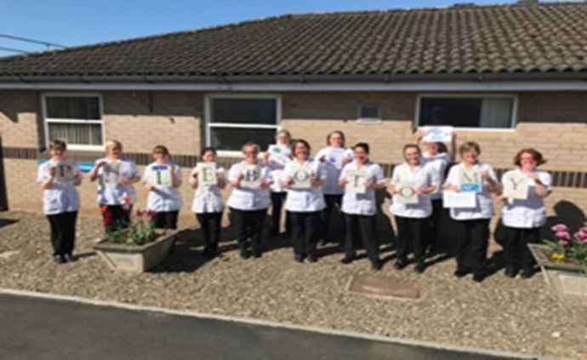
Clinical Support Services Patient Engagement and Involvement Representatives
A profile of the role
Examples of services within Clinical Support Services are:
• Radiology including Breast Screening
• Pathology including Phlebotomy, Anti-coagulation therapy and the Mortuaries
• Therapies: Physiotherapy, Occupational Therapy, Speech & Language Therapy, Dietetics
• Pharmacy including specialist homecare medicines
We would like a Patient Engagement and Involvement Representative to work with us in each of our 4 Centres to become our “critical friends”:
- Help us to review patient and service user feedback and develop action plans to improve our services, for example, Friends and Family Test results, national and local surveys
- Meet and speak to our patients to help us to find out what they think about our services and how we could improve them
- Challenge us to make the improvements to our services that our patients want
- Help us to make plans for changes to the way we deliver our service or to their locations
- Join us in some of our regular meetings to help us to think about the patient’s view when we review concerns raised with the PALS Team or formal complaints or risks to patient safety and to help us develop action plans
- Join us in reviewing our department environments to make sure they are as user friendly as possible
Ideally, we’d like you to spend about 12 months or more with us in this role and offer us between 1 to 4 half days a month, we can be very flexible to suit the amount of time you can offer.
We can offer you the chance to get to know our friendly staff and our services and all the support you will need to familiarise yourself with our work and to help you settle into the role.

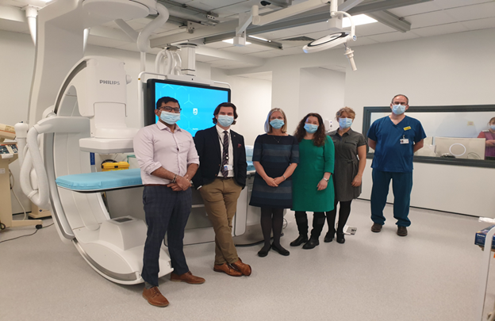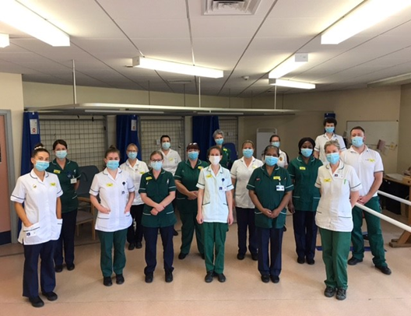

We would be very happy to have a chat with you about the role and how we can support you.
If you’d like more information about working with one of our Centres or you’d like more information in general, please contact one of our team below (we have answerphones on all lines so if we are not available, please leave a message and we will call you back):
Dianne Lloyd, Acting Deputy Divisional Director for Clinical Support Services on 01743 26100 ext. 3945 or email dianne.lloyd@nhs.net
Emma Weaver, Radiology Centre Manager on 01743 26100 ext. 1860 or email emma.weaver8@nhs.net
Adrian Vreede, Pathology Centre Manager on 01743 26100 ext. 3515 or email adrian.vreede@nhs.net
Hayley Pearson, Acting Chief Pharmacist on 01743 26100 ext. 1174 or email hayley.pearson1@nhs.net
Mandy Taylor, Acting Therapy Centre Manager on 01743 261000 ext. 1743 or email mandy.taylor22@nhs.net

Many thanks for your time considering this opportunity

