Shrewsbury Health and Wellbeing Hub
Targeted Engagement 16 January - 31 March 2023
Social Media Messages:

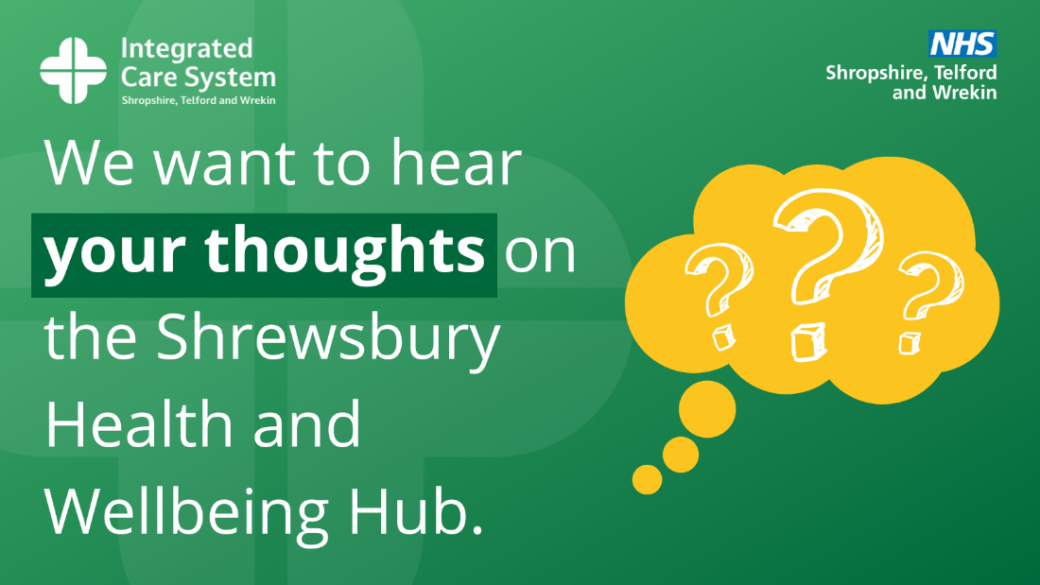

Targeted Messages
- We want to hear from you! Do you want to know more about plans for a new health and wellbeing hub in Shrewsbury, bringing health, social care and community services under one roof? Contact Sara Buckley at stw.getinvolved@nhs.net.
Click here to find out more:
https://www.shropshiretelfordandwrekin.nhs.uk/engagement-activity-launched/

- What do you think about the Shrewsbury Health and Wellbeing Hub? A wide range of health and community services could be housed within the proposed new facility. We want to hear your comments and suggestions. Contact Sara Buckley at stw.getinvolved@nhs.net to get involved.
Click here to find out more:
https://www.shropshiretelfordandwrekin.nhs.uk/engagement-activity-launched/

- We are listening! Want to discuss the proposed Shrewsbury Health and Wellbeing Hub? We know that there are residents whose views we have not yet heard – your feedback can shape future healthcare services for the town. Tell us what matters to you. Contact Sara Buckley at stw.getinvolved@nhs.net.
Click here to find out more:
https://www.shropshiretelfordandwrekin.nhs.uk/engagement-activity-launched/

- Have your say! Our plans for a community-based health and wellbeing hub in Shrewsbury will offer a range of joined-up health and social care services – what do you think? Tell us by contacting Sara Buckley at stw.getinvolved@nhs.net.
Click here to find out more:
https://www.shropshiretelfordandwrekin.nhs.uk/engagement-activity-launched/

Generic messages
- We want to make general practice (GP) services better for the future, with more quality services delivered in one location. Tell us about your views on what services should be delivered by contacting Sara Buckley at stw.getinvolved@nhs.net.
Click here to find out more:
https://www.shropshiretelfordandwrekin.nhs.uk/engagement-activity-launched/

- A purpose-built hub to improve not only medical but also the lifestyle and social factors, which impact on a person’s health and wellbeing, is proposed for Shrewsbury. What are your views? Contact Sara Buckley at stw.getinvolved@nhs.net.
Click here to find out more:
https://www.shropshiretelfordandwrekin.nhs.uk/engagement-activity-launched/

