

Looking to the Future - Workshop for Carers

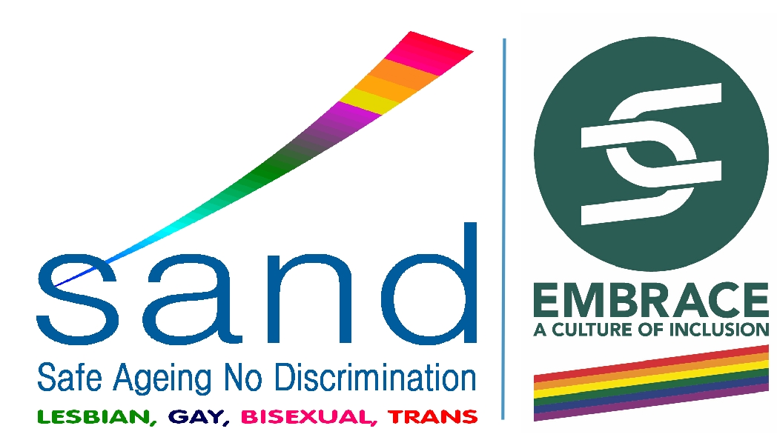

**Free to attend**

* Run by Shropshire Carers Support Team
* Includes guest speakers (Viv Hawkey, Shropshire Council and Nicola Hawes, Wace Morgan Solicitors)
* Refreshments included
* The event is being hosted to celebrate national Carers Right’s Day 2022

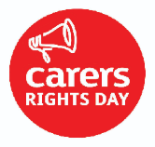

Email us:

[Shropshire.carers@shropshire.gov.uk](mailto:Shropshire.carers@shropshire.gov.uk)

Call the team on

01743 341995

**For more details:**

Thursday 24th November 2022 10.15am – 1.00pm

10.30am – 1.00pm

Oswestry Library, 9 Arthur Street, Oswestry, SY11 1JN

**Come and join us:**

Working closely with SAND