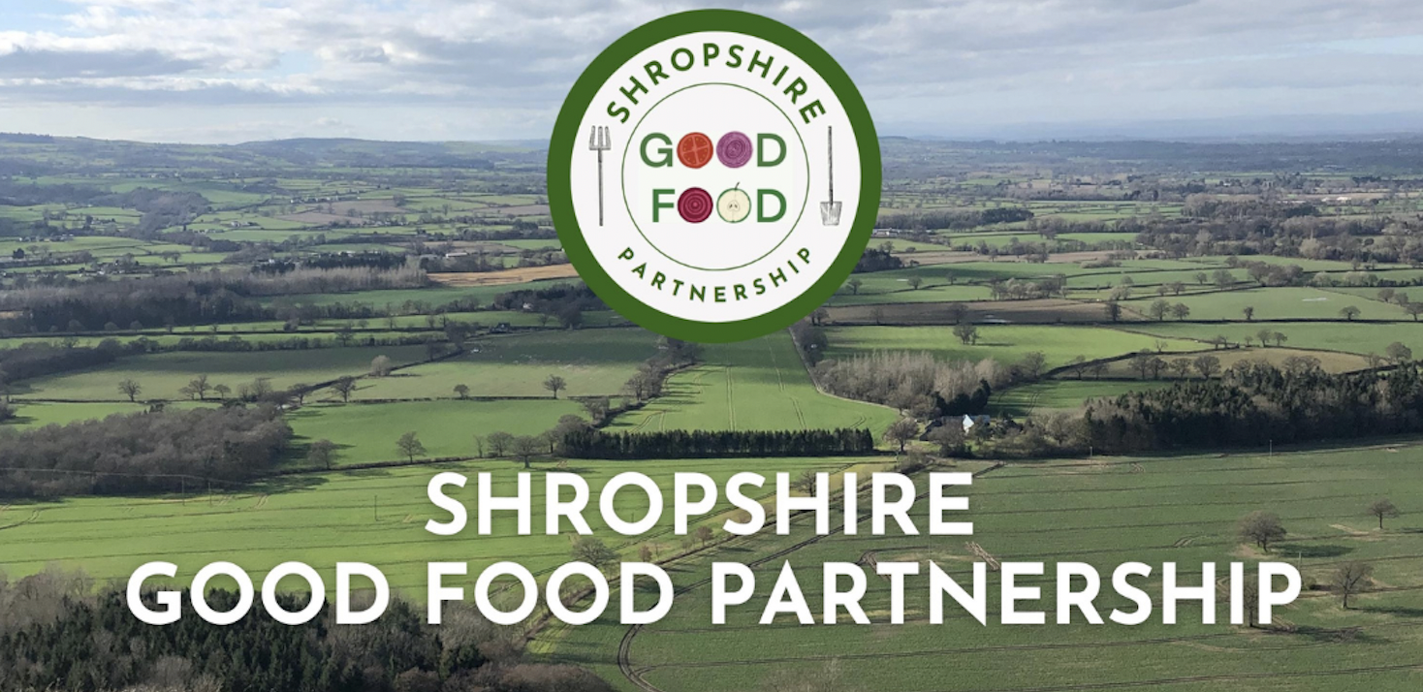

You are invited!

The Shropshire Good Food Summit is a day of collaboration, planning and action to build the County's local Good Food Movement.
Please register through Eventbrite

About this event
The Shropshire Good Food Summit will be taking place at the University Centre Shrewsbury on the 15th of October. Please Register through Eventbrite to join us for an inspiring day of collaboration, visioning and practical action.

This event brings together Shropshire Good Food Members, Food Champions from across the county, Farmers, Growers, Councillors, food businesses and anyone interested in the building momentum for Shropshire's Good Food Revolution.

We can now confirm that our Keynote speaker will be the exceptional Emily O'Brien, who will be speaking about the National context of food system challenges. Emily leads on Partnerships and Development for the Sustainable Food Places Network UK. She is the Parliamentary Spokesperson for Lewes, District Councillor for Ouse Valley & Ringmer, as well as Deputy Chair of LGA People & Places Board and Convenor of Green Party Food & Agriculture Policy Working Group.

Guest speakers currently confirmed include:
Dr. Emily Fay, who works within Shropshire Council leading the Shaping Places for Healthier Lives initiative, focusing on Food Insecurity, Health, Wellbeing and Prevention. She will be addressing the Cost of Living Crisis and the impacts on both household food security and the food safety net provided by charitable organisations

John Ward of Pengwern Associates: A consultancy focused on the economics of climate change, the environment & international development. John will be presenting the business case for a Shropshire Good Food Strategy.

After our introductory Plenary session, we will be having a member's 'Food for Thought' session. This is about knowledge sharing and storytelling with Local Food System Champions. We are inviting people who we see as leading the way in different aspects of food and farming in Shropshire to come up and share for 5 minutes on what they do and what are the most important things we should be thinking about and working on:

- Julian Dean - Green Party, Councillor for Shropshire
- Karen Williams - Barnabas Centre
- Ian Steele - Treflach Farm
- Lizzie Hulton-Harrop - Rural Land Manager, Pollardine Farm
- Ralph Early - Food Ethics Council
- Fleur Joyce - The Street Allotment Project
- Ben Wilson - OsNosh Community Kitchen & Food Rescue
- Iona Huang – Researcher, Harper Adams University
...and more to be announced!

*Lunch will be provided by OsNosh.*

Our afternoon is focused on the 'HOW'.
Three collaborative sessions will guide participants in discussions on the big issues of our day:

-The Cold Winter: Working together to respond to the cost of Living Crisis
-A bioregional approach for a climate-friendly food system
-Us and Them: Councils and Civil Society Groups in partnership for local food transformation

These collaborative sessions will focus on re-framing issues for a bespoke approach to our region and will form the basis of as a series of recommendations for Shropshire Council along with Telford and Wrekin Council, in line with the Government National Food Strategy released in June 2022. This participatory process will also be an essential part of a Big Lottery funding bid being sought by the SGFP to support more community initiatives across Shropshire.

Tickets are by donation, which is intended to cover the cost of lunch being provided by Community Kitchen and food rescue organisation OsNosh. Recommended donation is £10 per attendee, and for students and the un-waged on a pay-as-you-feel basis.

For additional information about the Shropshire Good Food Partnership, please see our website: https://www.shropshiregoodfood.org/
Contact: hello@shropshiregoodfood.org

