Pond enhancement works; request for quotes (Contractor Information)
Background: Shropshire Council Outdoor Partnerships Team manage Stanmore Country Park in Bridgnorth. A project is being put together that will be submitted to Severn Trent Water for grant support
Project Name: Stanmore Country Park Improvements
Overall project aim: To rejuvenate the wetland and woodland habitats of Stanmore Country Park and improve the path network for people of all abilities
About the park: Stanmore Country Park is a wonderful park at the edge of Bridgnorth in Shropshire. Paths weave through woodland and grassland offering wonderful opportunities for peaceful walks. The paths around the site are generally level and hard-surfaced, some running along the old concrete roads remnant of RAF Bridgnorth. Because of this the park is popular with disabled users and pushchairs.
Stanmore Country Park was formerly the site of RAF Bridgnorth Training Camp from 1939-1963. It was here that young RAF recruits came to do their 8 weeks of basic training or ‘square bashing’ as it was referred to. The appearance of the site today bears little resemblance to its days as a training camp. The only recognisable remains of the camp today are the old concrete roads on the Hobbins side of the park and the chimney of the old camp’s cookhouse on the Russell Close side of the park. This is now a memorial to all those who did their basic training on the site. The current car park is located on what would have been one of the camp’s four parade grounds. The rest of the site was dominated by barrack huts, parade grounds, sports fields, bath houses, a camp cinema, classrooms, offices and equipment stores.
There are two housing estates bordering the park known as ‘The Hobbins’ and ‘Russell Close.’ The Hobbins were the married airmen’s quarters, whilst Russell Close was the married officer’s quarters.
When the park was created, large numbers of trees were planted. These plantation woodlands are now in need of management to improve their biodiversity value and create a more diverse age structure.
For more information about the park, please see: http://www.shropshiresgreatoutdoors.co.uk/site/stanmore-country-park/
About the project: An application will be submitted to the Severn Trent Water Community Fund in May 2022 to carry out the following works;
Woodland management. Coppicing trees to create woodland rides and diversify the age structure of the woodland and boost biodiversity value
Improving access. Due to the flat ground and good path network, the site offers excellent opportunities for countryside access including wheelchairs, pushchairs and mobility scooters. Some of the path surfaces have deteriorated over time and are now muddy and badly drained in places. Paths will be surfaced and drainage installed, where necessary.
Wetland enhancement. 2 ponds on the site will be enhanced to create valuable wetland habitat for wildlife and people. This will also help with improving water quality
The project is being managed by Shropshire Council Outdoor Partnerships Team who manage Stanmore Country Park. The team work with the Friends of Stanmore Country Park. Final design will be approved by the Parks and Countryside Sites Officer and members of the Friends Group, prior to installation. This will form the project team, referred to later in this document.
One of the key objectives for the grant funding is around improving the park for people. We would like to appoint an artist/wood carver/play consultant (referred to from now on as ‘the consultant’) to carry out the following work
Consultants Brief
We are seeking a consultant to create a series of low-key wooden play features/carvings that tell the story of the park. Themes that could be explored include;
- History as a former RAF base
- Wildlife value of the park
- The connection that visitors have with the space, both real and imagined
The pieces will be located along the easy access nature trail and the aim is that they will encourage children to explore the park by offering opportunities for natural play as they enjoy a family walk. The play features will focus on simple activities like climbing, balance and stimulating children’s imaginative play, in order to keep the features relatively simple to maintain. An obvious example could be a wooden plane that incorporates some of these elements of play or carving a series of fairy doors into a tree to explore the imagined side of our connection with the outdoors
The artwork must sit lightly in the natural and historic landscape and be made from sustainably sourced UK timber. This could include carvings/willow sculptures and possibly materials from around the park (if deemed suitable)
If successful, the start date for the project will be September 2022. The play features will need to be installed by September 2023
Output
To design, create and install a number of wooden play features at Stanmore Country Park. Staff from the Outdoor Partnerships Team will hold two workshops at a local primary school. First workshop will be to get children to help generate ideas. Second workshop will be to show the children the designs and get feedback
The project officer will then provide a summary of the children’s ideas/sketches/inspiration to the successful consultant to guide the design process
A decision to exactly where the new artwork will be installed on site will be made when the design of the play sculptures have been finalised.
Examples of the kind of works that could be considered
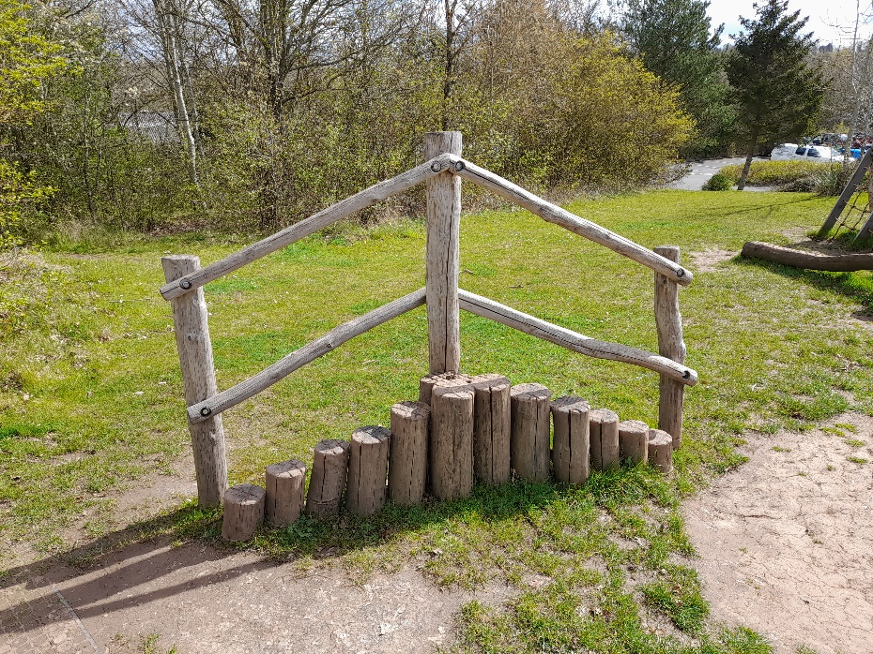
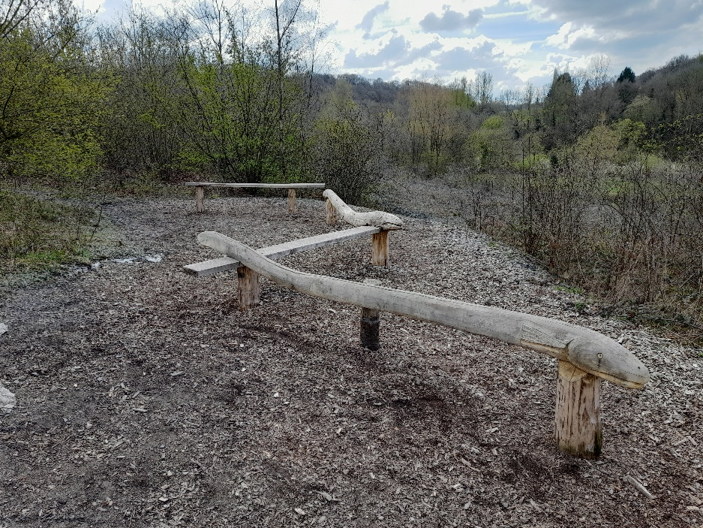
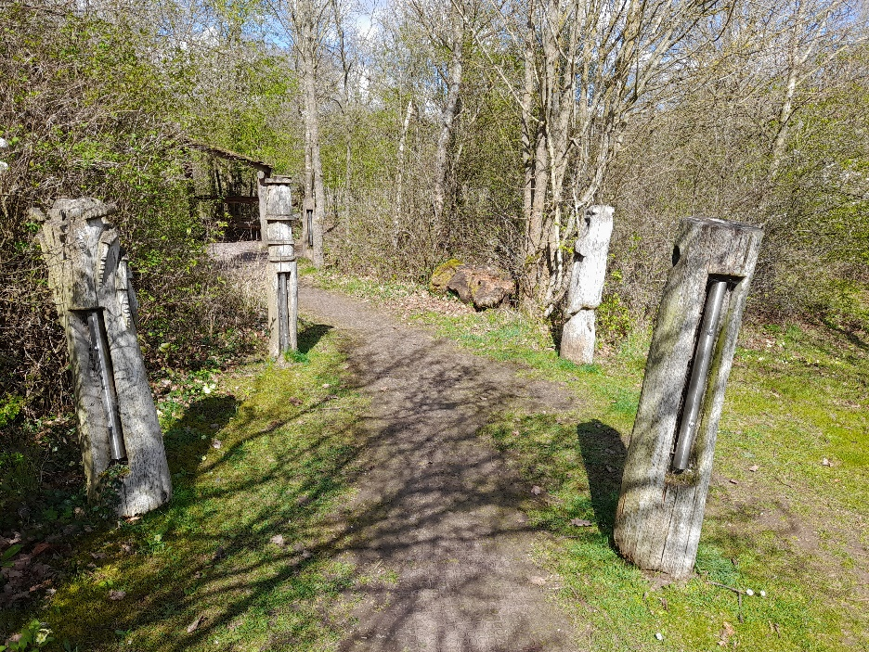
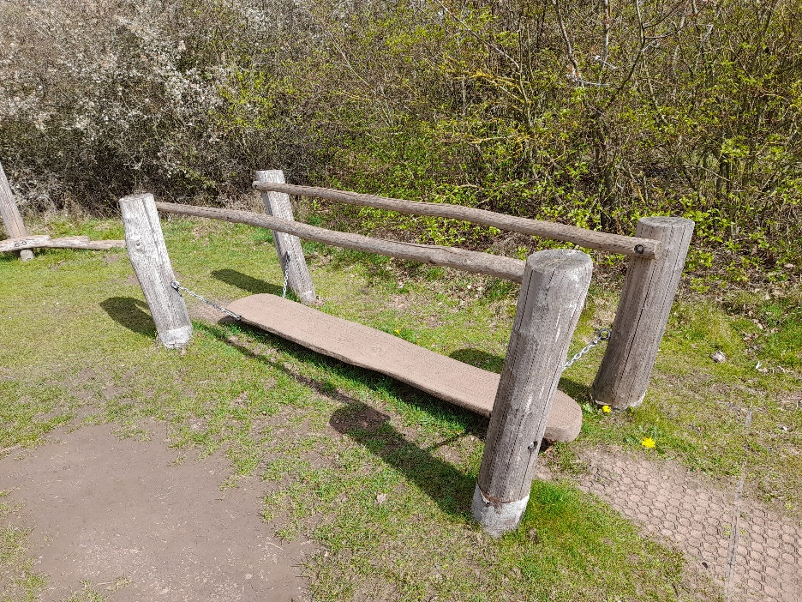
Resources available
Wildlife records and historic information about the RAF camp are available as resources to inspire and guide the design of the play features
What kind of artist are we looking for?
- We are seeking someone with the following demonstrable experience:
- Wood carving and public art
- An interactive/play element to their work
- Working with members of the public
- Working to a deadline
- Working to a fixed budget
Criteria for selection
- Availability to work on site when needed
- References or examples of similar work undertaken
- Relevant skills and experience
Budget available
There is a budget of around £20,000 available for this work. This is to include;
- Preparing a design of play features to be approved by the project team
- Creation of play features on site, including all materials needed and any necessary landscaping works to put good the ground around the play features afterwards
- Consultants are asked to provide an itemised quotation for the provision of services. Prices quoted should include any VAT and disbursements. This should include the cost of all materials and artists time and expenses.
- We will work with the successful consultant to negotiate a suitable payment schedule against milestones. Please note a proportion of your payment will be retained against completion of the work.
Submission Process
Consultants wishing to apply should submit a proposal detailing how they will respond to the brief and explaining:
- Their relevant experience
- An itemised quotation
- References and/ or testimonials of their work
The proposal should be sent to Edward Andrews, Parks and Countryside Sites Officer, Shropshire Council by 5pm on 3rd May 2022.
edward.andrews@shropshire.gov.uk
To discuss the project, please call 01746 781192
Eligibility
Freelance consultants must have a legal right to work in the UK. We welcome applicants from consultants at various stages of their career and a range of demographic backgrounds. This is not an employment contract, and the consultant is expected to handle their own tax, NI, pension and insurance

