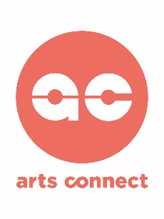
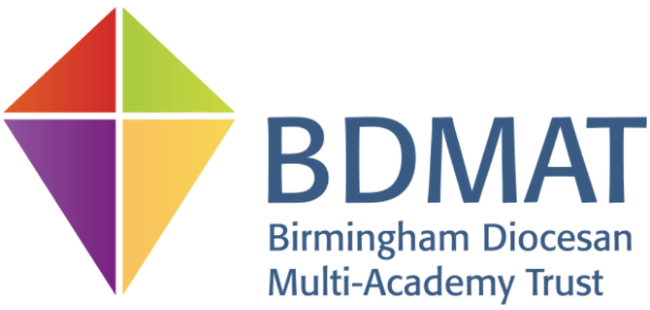

Arts Ambassador Schools’ Network Commission - £8,900
Deadline: 27 March 2020 (no later than 12.00 noon)
CALL FOR ARTISTS/ARTS ORGANISATIONS with Textiles specialism, including aspects of Printing.
Title: Me, the Artist and Maker.
Project Brief: To develop skills for children and teachers in textiles, and aspects of printing, linked to environmental issues using recycled and/or found materials. To create quality work for a BDMAT Exhibition that develops the values of the individual schools and BDMAT, and raises aspirations.
We want to explore these themes in an exciting and innovative way through working with an artist/s from a textile background, with knowledge of printing. We are keen that this programme will develop art & design knowledge for teachers particularly around skill progression in these areas. The experience should inspire children through engaging with a professional artist/s and raising their aspirations for careers in the arts.
We are looking for artist/s or an arts organisation to work with six primary schools across Birmingham and Tamworth, all members of, or associated with, Birmingham Diocese Multi Academy Trust (BDMAT), to deliver a programme of high-quality textile workshops. The workshops will lead to a final Celebration Event Exhibition where all children and staff involved can exhibit and celebrate their work in a creative way. We are keen that through this programme children and staff will explore and experiment with materials and equipment to develop skills and understanding in textile design, and if possible also in printing, and we are open to proposals covering different approaches.
We would like children to also develop confidence in using vocabulary in relation to: art and design; about themselves and their aspirations; their school’s values. We recognise that the arts are excellent in creating an exploration and greater understanding of complex issues and developing cultural capital.
Background:
The BDMAT Arts Ambassador Network is a partnership between Arts Connect and six primary schools (not all part of the MAT and not all CofE but they work closely with one another) which cover children aged 4 to 11 years. The commission will involve two classes in five schools and three classes in one infant school. The six primary schools are:

St Laurence Church Infant School 3 x Y Rec classes (4-5 years)
Nonsuch Primary School 1 x Y1 and 1 x Yr6 class (5-6 and 10-11 years)
The Nethersole CofE Academy 1 x Y1/2 and 1 x Y3/4 classes (5-7 and 7-9 years)
Hawkesley Church Primary Academy 1 x Y4 & 1 x Yr5 class (8-10 years)
St Michaels CofE Primary Academy 1 x Y1 class (5-6 years) and 1 x Yr6 class (10-11 years)
Heathfield Primary School 2 x Y1 classes (5-6 years)
This network aims to develop teachers and young people as Arts Ambassador leaders to increase the impact of arts and creativity in each school across the network.
Arts Connect is an initiative of the University of Wolverhampton, tasked to deliver the Bridge programme in the West Midlands to improve arts & cultural engagement of children and young people. For further information visit: www.artsconnectwm.co.uk
Arts Connect’s Arts Ambassador School Network programme brings established school networks together to develop teachers as arts leaders (i.e. Arts Ambassadors), and to achieve an Artsmark as part of a whole-network focussed programme on the arts. Arts Connect provides support for the network through match funding and a Network Coordinator, who also delivers Young Arts Ambassador and Governor training.

The BDMAT is a family of 51 Church of England schools across Birmingham, Tamworth, Solihull, Sandwell, Warwickshire and Worcestershire (four BDMAT schools are involved in the Arts Ambassador network, along with two associate schools with their own values which may vary from the BDMAT schools). The Church of England Birmingham Diocesan Board of Education has a strong commitment to ensuring that all people within its schools have the opportunity to flourish, within an understanding of what God desires for humanity, educating for ‘dignity and respect, knowledge and skills, hope and aspiration, community and living well together’.

The Commission:
We are looking for an artist/s, or arts organisation, to work with 6 primary schools to explore the concept of Me, the Artist and Maker, and linked to each school’s values. The schools wish to focus work around environmental issues using recycled and/or found materials. Each of the schools is keen to develop skills and knowledge progression within textiles and design, and printing, as well as the artist/s providing inspiration for careers within the arts and raising aspirations. It is hoped that each of the schools will create an artwork to contribute towards an exhibition at the Celebration Event for the BDMAT network. We envisage the artist/s will be experienced within textiles, and ideally aspects of printing, in schools and offer a range of techniques, materials and equipment for the children and staff to experience and develop their skills. We are excited to hear from artists/arts organisations who respond with exciting proposals to help shape our ideas around ‘Me, the Artist and Maker’.

The programme should aim to build confidence and skills as well as creative expression among the young people, as well as to inspire and equip the teachers with creative approaches that they can develop beyond the life of the project. It should be an inspiring and engaging programme, and aim to provide an innovative approach to learning by developing understanding of the theme through quality artistic processes and experiences.
There is an expectation that the artist/arts organisation will provide a minimum of 1 twilight session of Professional Development (CPD) for staff from across the network. This might be co-delivered with school Arts Ambassadors (i.e. lead teachers in each school) to include specific art form skills as well as the pedagogy of learning through the programme, including changing attitudes, developing language skills, and improving the quality of artistic outcomes. The session could be integrated into the delivery programme as an after school CPD session for staff at each school as part of the workshop delivery allocation.
We would expect that the artist/arts organisation will take a lead on project managing the artistic programme in partnership with the Arts Ambassador teachers in each school, working alongside the BDMAT Network Lead and Arts Connect Arts Ambassador Network Coordinator. It is expected that each practical workshop will involve a debrief at the end of the session with class teachers, Arts Ambassador lead for the school and artists, and a session report submitted to the Network Lead.
Contractual details:
The fee is £8,900; based on the artist/arts organisation being responsible for own tax and NI on a freelance basis. This fee includes:
- 3 network meetings with schools (allow ½ day for each – see *dates in Timescale section):
  - After appointment
  - One before the Celebration Event
  - End-of-programme evaluation session
- Individual planning with schools
- The whole network receiving a minimum of 33 whole day/equivalent arts workshops with the children (5.5 days in each of the 6 schools which could include 0.5 session as a CPD Twilight for staff at each school)
- CPD session with staff across all the schools (this could be built into the workshop day as a twilight after school for each school or be one separate session for the whole network)
- Managing and delivering the Celebration Event day
- Materials
- Management, admin and travel
*Timescale:
Application Deadline: 27 March 2020 (no later than 12.00 noon)
Notification of Interviews: no later than 3rd April 2020
Interviews: 22nd April 2020 at Nonsuch Primary School, please pencil the date in your diary. The interviews will include an adult panel plus a workshop with young people from the network’s schools. (It is expected that all artists working in schools would be involved in the Interview process).
If successful: the planning and some activity will be in this academic year 2019/20 but it is planned that the majority of the delivery in schools and the final event will be in the next academic year 2020/21:
Network meetings with schools:
9.6.20 (1.00-3.30pm) meeting Network schools at St Michael’s CofE Primary Academy 3.11.20 (1.00-3.30pm) planning Celebration Event at mac, Birmingham
27.5.21 (1.00-3.30pm) evaluation and next steps at Heathfields Primary School

Celebration Event:
24.3.21 all day, mac in Birmingham, format and timings tbc.

How to Apply:
Both individuals and arts organisations/companies can apply. We anticipate that the commission will be to artist/s or an arts organisation to work across all the schools, though we recognise that you may wish to involve other artists managed by the lead artist/ organisation. All successful applicants will need to evidence their portable DBS or undertake a DBS check, along with any other artists from their organisation. You must carry Public Liability Insurance for all artists.
Please submit a proposal on how you would deliver the commission and your ideas for the creative content of the workshops and for the sharing event. You need to include:
- Your experience of working with networks of schools (please give examples, e.g. through online links, website, etc.).
- Your suitability.
- An outline of your approach to the commission, explaining how you will use your artistic skills to engage primary aged children and teachers, enabling them to be part of the team of artists to create quality work to share and to develop the skills of children and staff. Also your thoughts for skills progression through CPD for participating staff.
- Two Referees, ideally schools.
- A budget of how you propose to allocate the commission.
- If an individual artist, please provide an up to date CV; if an organisation please provide an outline of your company’s Aims, Mission, Vision and information on the people involved in this commission.
- If you are intending to use freelance artists we would like to know who you are proposing to work with and have a copy of their CV.

(Please note that if shortlisted we would want to interview all the people involved in delivering in schools)

Please send your proposal and all support documentation by Friday 27th March 2020 (12.00 noon) to all of the following:
Judy McFall (Network Coordinator): judymcfall2@gmail.com
Pepita Hanna (Arts Connect): Pepita.Hanna@wlv.ac.uk
Hanna Reeve (Network Lead): h.reeve@stmich21.bham.sch.uk
For any queries:
- Pepita Hanna (email above, tel 0121 446 3204/07967 222817)
- Judy McFall (email above, tel 07983 879669)

