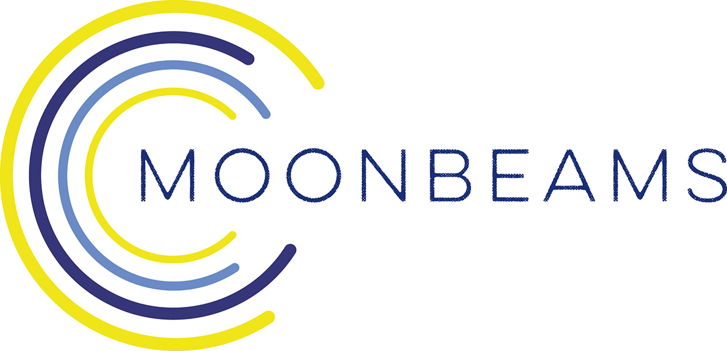

Seminar: Spaces of the Imagination for Early Years
Thinking with Materials: Fostering contexts for creativity and critical thinking

Date: Tuesday 3rd December 2019 (9.45am-4.15pm)

Venue: Midlands Arts Centre, Cannon Hill Park, Birmingham B12 9QH.

Price: £40 per delegate.

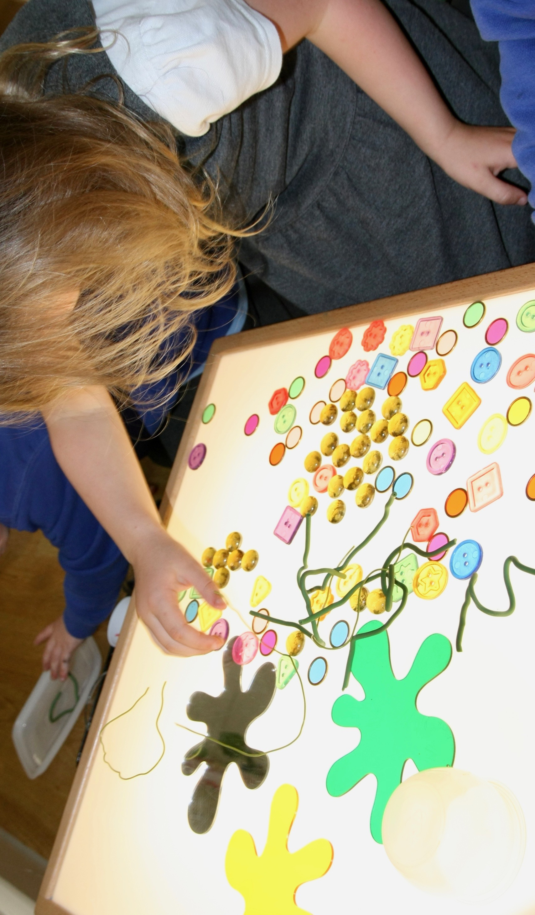
When children give shape to ideas they have about the world; when they express thoughts, theories or emotions, they do so by making meaning using the available materials that are to hand. Explore how you can create opportunities that enable creative and critical thinking by considering materials and the role of the educator alongside of the child in an active enquiry.

This seminar will look at using everyday materials, such as recycled and re-purposed objects, graphical media, paper and card to provide you with a hands on experience of working creatively and critically. By understanding the creative processes ourselves, we can then think about how we can generate creative contexts with a wider range of materials to build on children’s own creative and expressive capacities based on their ideas and enquiries. It will give you the opportunity to reflect in action on your own practice and your setting’s environment.

No experience is needed; it will be joyful blend of theory and practical engagement and is open to all abilities.

30 places are available on a first-come-first-served basis for £40 each (includes lunch and refreshments)

Debi Keyte-Hartland

The seminar includes a workshop with leading artist educator and pedagogista Debi Keyte-Hartland. Debi was part of the Moonbeams programme and has worked nationally and internationally with children and educators for 25 years. She is an associate consultant with Early Education and a co-director of Sightlines Initiative. She is also an associate lecturer with CREC on the MA module Creativity and the Arts in Early Childhood.

She is interested in how children collaborate with others (other children and adults) and how together, in sociable contexts of learning, search for meaning about the world they are part of. She is also interested in children’s drawing as means of communication and in how Loris Malaguzzi’s idea of the ‘One hundred languages of children’, an approach used in Reggio Emilia, can be brought into play in developing long term ‘projects’ with young children.

To Book

To book your place/s please complete the EventBrite below:

https://www.eventbrite.co.uk/e/moonbeams-seminar-spaces-of-the-imagination-for-early-years-tickets-77795553595

You will then receive a Confirmation Ticket with all the Details. Places are limited to a first-come-first-served basis.

If you have queries please contact

Gemma Corden Arts Connect’s Administrator:

Gemma.C@wlv.ac.uk

0121 446 3204 ext 391

