

Secondary Dance Teacher Network
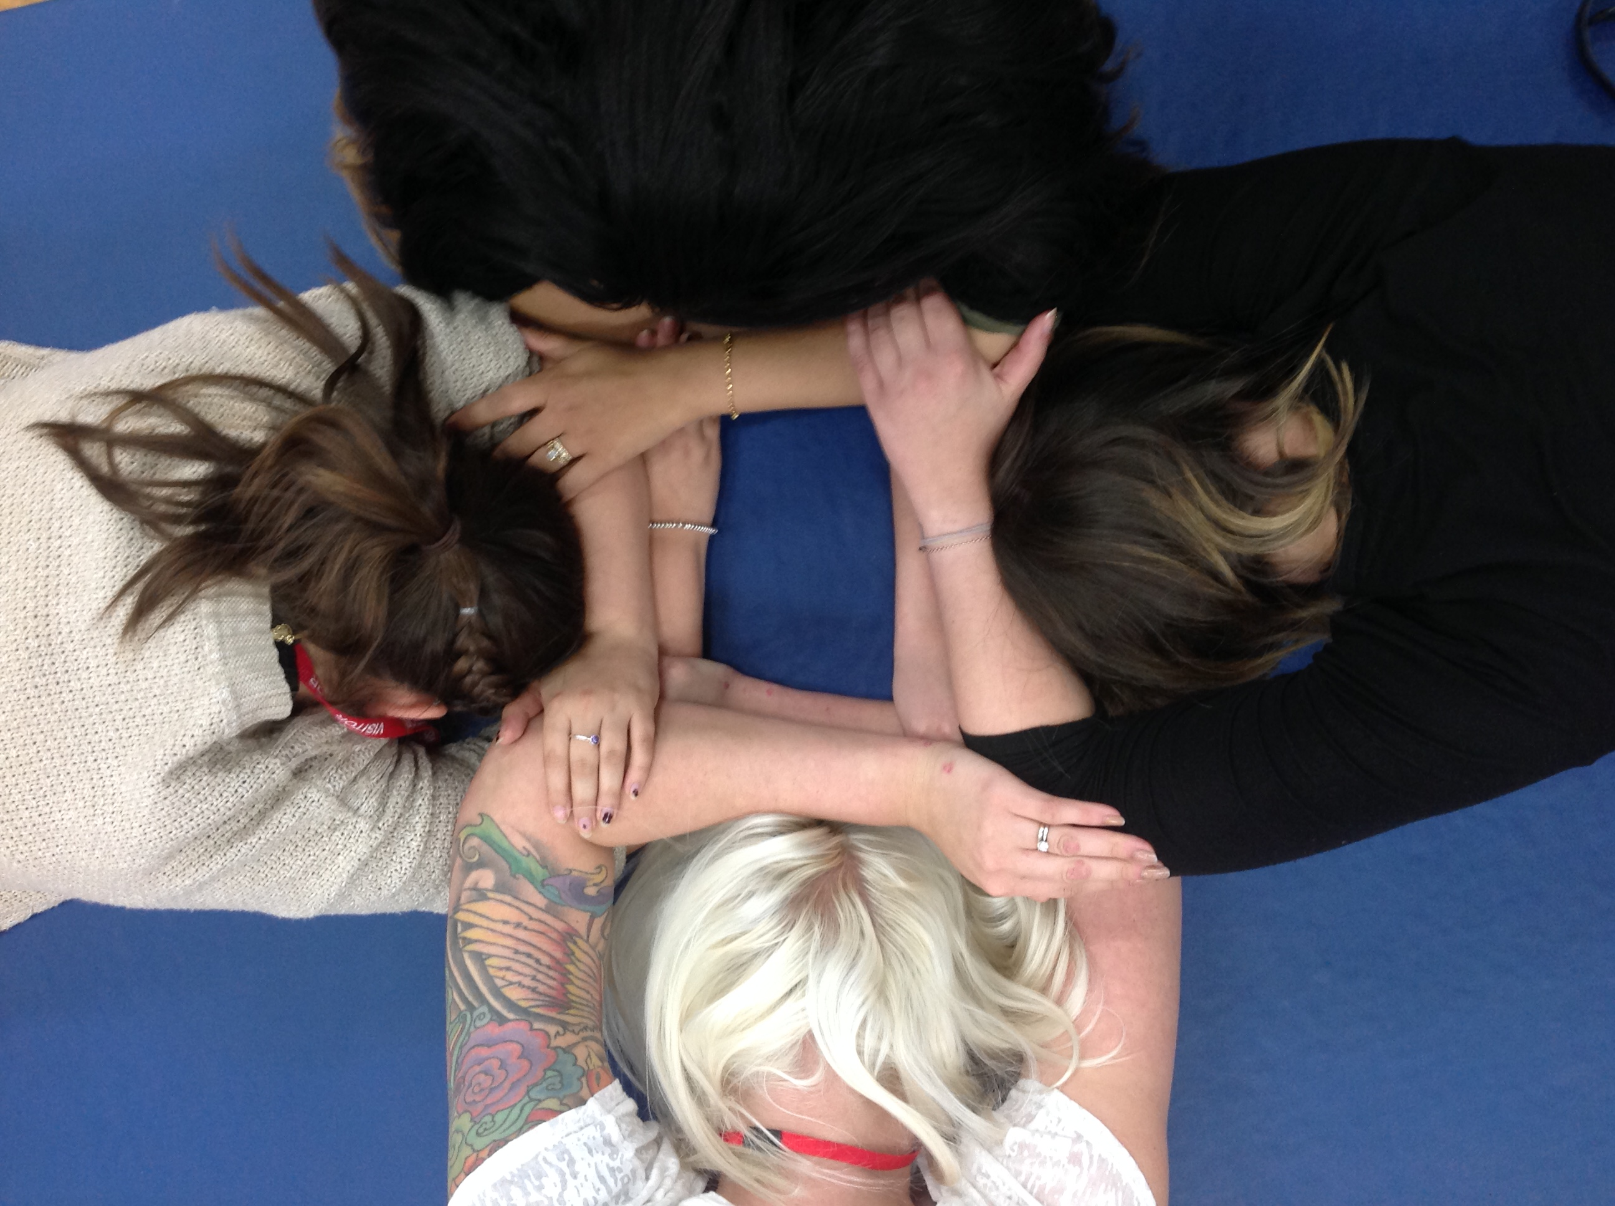

Thursday 21st November 2019, 4.30pm - 6.00pm
CBSO Centre, Berkley Street, Birmingham, B1 2LF

What is it appropriate to deliver for Dance at KS3? Can it underpin learning and feed into KS4 Dance qualifications?

We are delighted to welcome Justine Reeve to Birmingham to lead our next Secondary Dance Teacher Network.
Justine is a dance educationalist, teacher, dancer and choreographer and having taught for over 25 years, dance education is prominent of part of Justine's work. She has written published dance resources for South East Dance, Pavilion Dance South West and Pearson Education and her book 'Dance Improvisations' is published by Human Kinetics. She has been a standards verifier for Edexcel’s/ Pearson’s BTEC Level 2 and 3 and was an A Level Dance examiner/moderator. She has been involved in the writing of many syllabus units for Level 2 and 3 as well as educational resources for Dance companies. In 2015 the Developer/Writer for London Curriculum Dance Module for Sadler’s Wells. She has been devising and delivering continued professional development courses for Keynote Educational since 2005 and was an animateur with Rambert Dance Company for ten years. Justine is well known to dance practitioners as the creator of 'The Dance Teachers agony aunt' facebook group providing online support for more than 1500 dance teachers in the UK. She is presently an external expert for OFQUAL.
Please feel free to bring examples of your SOW, assignment briefs, IV plans or examples of student work for a sharing/discussion with colleagues and experts.

Booking is essential because places are limited https://www.eventbrite.co.uk/e/secondary-dance-teachers-network-meeting-tickets-77318673233

Refreshments provided.

