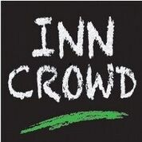
LIVE LITERATURE IN PUBS AND COMMUNITY SPACES ACROSS THE UK

Calling Live Literature Performers: We want your show!

‘The Inn Crowd is a brilliant project. It supports and enables performers to make work, helps us reach new audiences, and promotes live literature across the UK. Get involved!’ Sophia Walker

Who we are

INN CROWD is a programme of high quality live literature performances touring to rural pubs across England from 2019 – 2022. It helps reinforce pubs as central to rural community life by bringing exceptional cultural experiences to new audiences.
The first Inn Crowd tours ran from November 2016 to July 2019, and involved 45 shows, performed 240 times in 90 venues across the South and South East of England. INN CROWD is now a national project and we are looking for shows for our next round of touring.
INN CROWD is a collaboration between Applause Rural Touring, Creative Arts East, and National Centre for Writing, working with Pub is the Hub.
For more details about INN CROWD, visit www.inncrowd.org.uk

What we are looking for

We are looking for two types of performances:

Reshape: shows, sets or performances that have been fully or partially developed and can be reshaped to suit the INN CROWD scheme with assistance from the INN CROWD consortium.

Co-Production: ideas for new shows, sets or performances that can be developed with time and assistance from the INN CROWD consortium.

Artists and companies can be based anywhere in the UK but must be available to tour in rural pubs across England on any of the following upcoming tours:
- February 2020 to July 2020
- August 2020 to January 2021

You are welcome (but not obliged) to submit proposals for more than one show in more than one category – e.g. you may have both an idea for a redevelopment, and a completely new piece of work. Please fill out separate forms for each individual show.

About your performance

To help you consider how your performance might be suitable for a rural pub tour, here is what you could expect:

Performances may be suitable for adult, or for family audiences. We welcome Live Literature that includes elements of theatre, poetry, spoken word, storytelling, literary adaptation, comedy, live art and audience participation - but the starting point for performances considered for this scheme must be a written or composed text.

We particularly welcome applications from diverse artists, including people of colour and those with a disability. We have found participating INN CROWD pubs and audiences to be open-minded, receptive, and accessible.

The pub venues on this tour will vary enormously – your work may take place in a bar setting or a function room with extremely minimal technical facilities. There may be background noise or other pub activity taking place during your performance, or food and drink being served in the same space. Spaces may vary in size.

Shows will ideally be at least an hour long in total, and allow for an interval or drinks break. Shows or performance which can react to or incorporate audience participation will work well in the INN CROWD context.

What we offer

We act as producers to get your show booked in rural pubs and non-traditional community spaces.

As rural touring specialists we are continuously developing new networks of performance spaces and working with voluntary promoters to pitch your shows to pubs. We manage the logistics of booking shows for you.

We offer a fee of between £350 and £500 per performance. This fee includes all VAT, travel costs, equipment hire, accommodation and other expenses

As well as this INN CROWD offers the following development budgets:

Reshape: up to £1,200 development budget + rehearsal space at National Centre for Writing in Norwich.

Co-Production: up to £3,000 development budget + rehearsal space at National Centre for Writing in Norwich..

Artists or companies with Reshape or Co-Production applications should be free and expect to be invited to a sharing session on 10th October 2019 in London. Travel will be reimbursed for artists and companies selected to attend this session.

As a result of this session we hope to support up to three Re-shapes and up to three Co-Productions.

Artists or companies taking part in INN CROWD can expect to be booked for an average of ten performances. (Please note that bookings are chosen by pubs and Inn Crowd cannot guarantee any bookings.)

What we expect from you

You will recognise that we have both a funding and developmental role in your show, and work with us to ready your show for INN CROWD – this will include providing all show images and copy in a timely manner, acknowledging us publically as developers of your show, and communicating effectively on your progress.

Ensure robust and effective communication with Inn Crowd to ensure a timely response to proposed bookings. We prefer direct communication with artists around the booking of shows, to ensure the right fit for each venue.

While we understand that availability cannot be guaranteed, we expect you to give priority to INN CROWD bookings for an agreed period of 6 months.

You will credit Inn Crowd and its partners on all relevant publicity materials (including print and online marketing and advertising), both for performances as part of INN CROWD and for any wider touring of the completed show.

For Co-Production, we will ask for the Premiere of your show to be with INN CROWD. We understand that other opportunities may arise and will not prevent you taking these, but will ask that they be billed as ‘previews’ or ‘scratch shows’.

Deadline for Reshape and Co-Production proposals

5pm on Monday 23rd September 2019

How to Apply

Reshape and Co-Production Proposal: Complete the application form here: www.forms.gle/g8BAiCvtheGWLPHmk and then send a full budget to Sam Ruddock sam@nationalcentreforwriting.org.uk.
If you do not receive confirmation of receipt within three working day, please contact Sam Ruddock on 07943063015.

If you have a show that is Ready-to-Go you can get in touch at any time. To propose a show, set or performance suitable for rural touring in a pub setting and available for booking now please email Sam Ruddock sam@nationalcentreforwriting.org.uk to introduce your work. He will send you a form to complete.

We welcome submissions at any time and there is no deadline for this strand.

Timeline

Deadline for proposals – Monday 23rd September 2019

Reshape and Co-Production applicants informed by end of Monday 30th September 2019

Showcase and information sessions– 10th October 2019 – please note that successful Re-Shape and Co-Production applicants will be invited to this day.

For an informal discussion about The INN CROWD, please contact sam@nationalcentreforwriting.org.uk

Credits

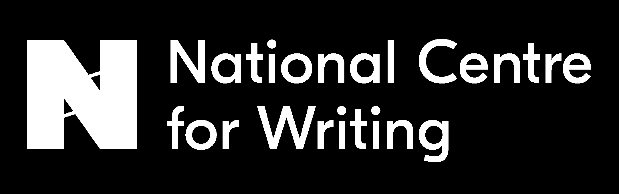
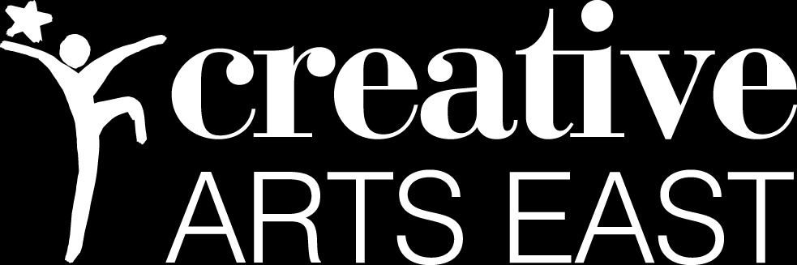
INN CROWD is a partnership project from
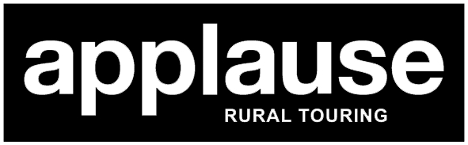

INN CROWD is supported by
