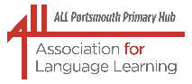ALL Portsmouth Primary Hub

Portsmouth LA Network Leads and Solent Languages Network

Wednesday 7 October 2026, Online 1600 – 1700

‘Together we are stronger’

In our efforts to support and strengthen our community of good practice, we are once again delighted to offer attendees two separate, equally thought-provoking presentations. These two sessions will provide useful and important information as well as creative inspiration for all of us in our different settings.

Part One 1600 – 1620: There are amazing opportunities that will shortly be available with the return of the Erasmus+ programme. In this short session, colleagues from the British Council, the DfE’s agent in the UK for this programme, will signpost the way ahead and offer suggestions about how we can work together and take best advantage of those opportunities.
NB: The opportunities opened up by the Erasmus+ programme can be for whole-school activities, as well as activities involving different curriculum areas, not just for languages. Why not encourage interested colleagues to attend our meeting too?
Part Two 1620 – 1700: Look, talk, create
In this session, Danielle Dion-Jones, our very knowledgeable and inspiring presenter, will look at how to incorporate works of art into language lessons to encourage learners to speak more creatively and spontaneously.
Danielle will explore activities that have worked well at KS2 and discuss how this approach can help learners build their skills and confidence through KS3 and into KS4.
NB: Many of the examples will be in French but Danielle will include examples and suggestions for teaching Spanish too.
Liz Lord invited you to a Microsoft Teams Meeting:
ALL Primary Hub, Network Leads and Solent Languages CPD
Wednesday, 7 October 2026 15:45 - 17:00 (GMT)
Meeting link: ALL Primary Hub, Network Leads and Solent Languages CPD | Microsoft Teams | Meet-up-Join

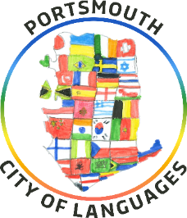
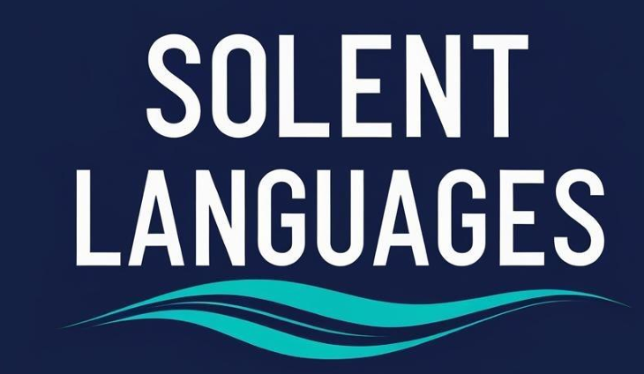
Danielle Dion-Jones
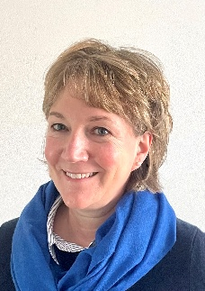
Danielle has taught in all sectors from primary to HE - in England and Canada, as a specialist languages teacher, class teacher and lecturer.
With a passion for second language acquisition, she follows the principles of Drama in Education, aiming to make learning engaging, meaningful and more authentic. Danielle specialises in teaching languages through drama and has seen first-hand the way this can build fluency and accuracy.
Danielle has taught French to A level and more recently, she has worked as the Foreign Languages/EAL lead in a large state primary school in London, with an attached centre for children on the autism spectrum - implementing a bespoke, inclusive and multilingual curriculum across the school.
Danielle now works as an MFL consultant, developing cross-phase collaboration and curriculum continuity between the primary and secondary phases in London schools, providing CPD, mentoring and coaching. She also supports GCSE and A level French students and runs a French and Drama Club in her local secondary school.

If there is a particular topic that you would like covered in our meetings, please do get in touch. We plan to continue merging our language groups for future meetings as one of the steps to bring us closer together as a language teaching and learning community.
Together, we can make a difference!
