Languages in Portsmouth
June 2026
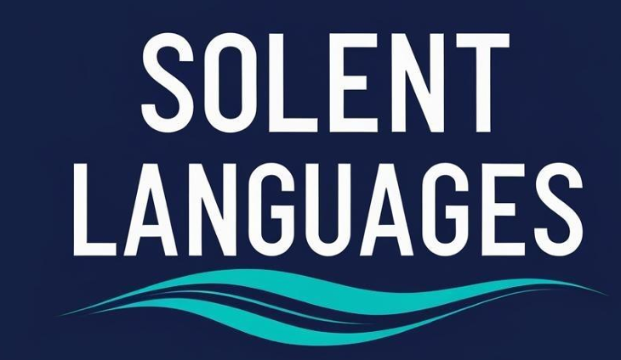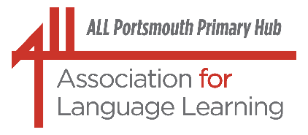
Portsmouth LA Primary Language Leads

Dear Colleagues

Enjoy these warmer days and lighter evenings. And enjoy reading the different pieces of languages and pedagogy information and news included in this update
(our 41st, can you believe it?!?).

And, of course, take time to relax, recharge, refresh and recharge over the summer holidays to come.

With best wishes, Liz, and colleagues from the Solent Language Network and Portsmouth, City of Languages,

(lizlord0502@gmail.com)



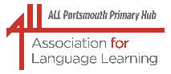ALL Portsmouth Primary Hub

Portsmouth LA Network Leads and Solent Language Network

Wednesday 3 June 2026

Headlines:

Primary Languages: Results from the Progression in Primary Languages Project: Key messages: Curriculum time matters (60 minutes per week for optimal learning, appropriate pedagogy, lots of opportunities for practice, pupils need to experience progress to be motivated, a confident and engaging teacher is central to success.

(Amazing research colleagues: Suzanne Graham, Rowena Kasprowicz and Alison Porter from the Universities of Reading and Southampton!)

Engagement in Languages: Based on the work of Fredricks et al, Jonathan Mumford of Liverpool Hope University proposed four key aspects of engagement – behavioural, emotional, cognitive and social and suggested different scenarios/activities to activate engagement in languages lessons from these perspectives.

**To help planning for future meetings, and if you attended this meeting, please complete the questionnaire below.)

And this was our 40th ALL Hub meeting in Portsmouth – amazing!

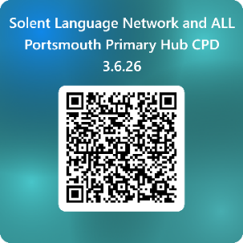

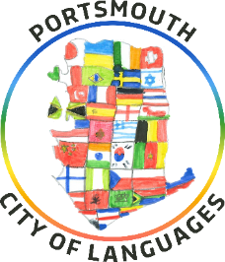

Please have a look at, and take advantage of, this amazing opportunity for languages educators to come together as a community of practitioners, passionate about creating the best languages learning experiences.

We are delighted to invite you to this year’s Solent Languages Conference, taking place on Wednesday 8th July at Admiral Lord Nelson School in Portsmouth. This is a completely free event, open to language professionals from across the area, and we would be very pleased to welcome you.

Places are limited, so we strongly encourage you to book as soon as possible to avoid disappointment.

Booking link: https://www.eventbrite.com/e/solent-languages-network-conference-tickets-1987681881013?aff=oddtdtcreator

This year’s conference theme is “Let’s get creative and bring the joy back into languages learning!”
Across the day, sessions will focus on inspiring, practical, and innovative approaches to language teaching that re-energise classrooms and place creativity and enjoyment at the heart of learning.

The conference offers a fantastic opportunity for colleagues from all educational settings to come together, share best practice, and be inspired by an exceptional line-up of speakers and presenters. It promises to be a lively, thought-provoking, and collaborative day focused on strengthening language education across our region.

As part of the programme, we are especially pleased to announce a performance by local students, who will be singing the newly released and specially composed Portsmouth, City of Languages song – a celebration of languages, culture, and creativity that we are sure will be a highlight of the day.

Lunch will be provided for all attendees. If you have any dietary requirements, please confirm these by replying via email to esmith@salterns.org once you have booked your place.

And another date for diaries

Following the success of last year’s focus on careers and employment and languages, a second Languages at Work day will be hosted at Admiral Lord Nelson School on Monday 5 October 2026. The morning session will be planned for secondary learners and primary pupils will be invited to the afternoon session.

More details will follow soon.

************************************************************************************************

Sue Cave has also been in touch recently with information about the Primary Languages Conference 2026 and its new format:
Sue writes, “The ALL Primary Languages Conference will be in a different format to previous years and will be known as ‘The Primary Languages Show’. There will be a collection of recorded presentations which ticket holders will be able to view, comment on, share ideas about and ask questions and the presenters will be able to respond. There will also be a live evening fringe event.
The theme of the conference this year is ‘The Primary Languages Journey’ and this is a call for contributions. We would be very interested to hear from teachers, teacher educators, and researchers who would like to join us in sharing ideas and best practice.

To find out more about this exciting new conference, possible themes for presentations, and how to put forward a proposal, please go here www.tinyurl.com/plscall26 We look forward to hearing from you. The deadline is Monday 6th July 2026.

I know we have amazing primary languages practitioners in Portsmouth and further afield – why not share your experience and knowledge and put forward a proposal to present? We would be so proud!

We are hearing wonderful things about how lots of you celebrated
languages as part of our Portsmouth City of Languages
celebrations in March – congratulations and a huge thank you!
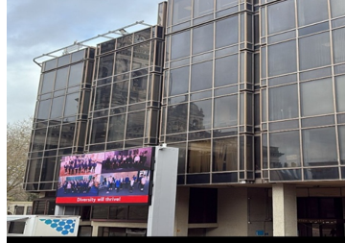

To read a summary of some of the events that took place visit the Portsmouth City of Languages website – and another date for diaries, our Week of Celebrating Languages 2027 will take place from 15 to 19 March next year.

Lightning Languages supporting Portsmouth City of Languages

Have a look at this message from Bethan McHugh of Lightning Languages (Twinkl):

“This took a while to create, but today I have a very exciting Cities of Languages page to share with you. We now have this fantastic HubSpot where you can immediately access the resources, which is great for sharing.

https://144591076.hs-sites-eu1.com/lightning-languages-cities-of-languages

What's exciting is that Leeds will soon join, and we also have Wiltshire on the way as the first county of languages, so we can keep adding to this page as the collection grows. From now on, the resources will be hosted on both the Twinkl website and the new HubSpot page so teachers can access the materials however suits them best. We still have our original landing page on the website but this original one requires an account to access the resources, even though they are free.”

Existing landing page: https://www.twinkl.co.uk/resources/twinkl-partnerships/cities-of-languages-partnerships

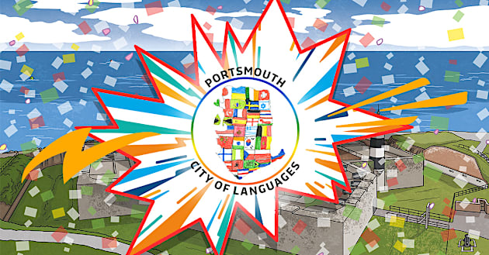

Some sobering thoughts
This is possibly one of the most challenging times for all of us passionate about the social and educational importance of languages education. The Portsmouth City of Languages group and the Solent Language Network, along with our professional association, ALL, continue to work enthusiastically to support and motivate colleagues involved in teaching languages in the city and across the key stages.

Schools Week Esmé Kenney 23.04.26
Languages education is facing very real challenges today that can’t be ignored. Read this recent article from Schools Week, “Language learning is continuing to decline with many schools cutting down further”.

EBacc withdrawal ‘squeezes languages out of the picture’

And our professional association, ALL, has prepared a full response and submitted this to the DfE:
Association for Language Learning responds to KS4 Performance Measures consultation.

The Association for Language Learning (ALL) has submitted its response to the Department for Education’s consultation on proposed changes to Key Stage 4 performance measures.

In developing its response, ALL engaged with members across the sector through membership engagement events (e.g. policy webinar) and a dedicated survey, drawing on the experience and professional judgement of language teachers, school leaders and trust-level practitioners working in a wide range of contexts. The response also builds on ALL’s evidence and policy positions articulated in its submission to the Curriculum and Assessment Review (CAR).

ALL recognises the government’s stated aim of increasing curriculum breadth and flexibility within accountability measures. Many members welcome a move away from rigid structures and support the recognition of creative and technical subjects alongside academic routes.

However, the Association raises significant concerns about the impact of the proposed reforms on language education. Evidence from our members indicates that, in a high-stakes accountability system, flexibility alone does not guarantee breadth. Without explicit incentives or protections, schools are likely to prioritise subjects perceived as lower risk within performance measures. Given the comparatively severe grading outcomes in GCSE languages, there is a clear risk that language learning will become further marginalised, particularly in schools serving disadvantaged communities.

ALL is also concerned that certain proposals, including the inclusion of science as an additional breadth category, may unintentionally narrow the curriculum and reinforce subject hierarchies, undermining the consultation’s stated objectives.

In line with its CAR response, ALL emphasises that curriculum breadth cannot be left to chance. Accountability measures, inspection frameworks and curriculum policy must work coherently if all pupils are to have equitable access to a broad and balanced education that includes languages.

The TES on Monday 27th April 2026 noted the public debate over the change from the 2019 Ofsted Framework to the 2025 Framework and the significant impact that this has had on schools and their decisions. Survey respondents have reported early and ongoing reductions in language provision, including reduced curriculum time, fewer languages being offered, and staffing reductions.

ALL warns that these trends risk becoming structural and irreversible unless addressed as part of system-wide reform.

ALL’s response calls on the Department for Education to:
- ensure explicit protections for curriculum breadth, including languages;
- avoid reforms that reinforce subject hierarchies;
- align accountability reform closely with inspection expectations; and
- recognise language learning as a strategic national priority rather than an optional enrichment.

A full version of ALL’s response to the KS4 Performance Measures consultation is available on the Association’s website here.

And recent news about how local languages champion and Languages PGCE course leader at the University of Portsmouth, Tanya Riordan, is fighting our cause:
Tanya writes, “I have been advising the All Party Parliamentary Group for Languages on averting a teacher recruitment crisis. The key barrier rests with immigration rules that are preventing UK-trained teachers, recruited from overseas with bursaries, from getting jobs in UK schools despite these subjects acutely relying on overseas recruitment. As a group of committed teacher trainers, we first met to advise Baroness Coussins in December 2024 on the issues concerning international student teachers such as visa requirements, cost of living, culture shock, status of languages in schools and an ever-changing curriculum leading to lack of school placements. Baroness Coussins was able to secure a debate in the House of Lords in January 2026 asking for a visa waiver for language teachers which was rejected by Jacqueline Smith, Labour MP.
Undeterred we teamed up with the Institute of Physics who are experiencing a similar crisis and advised ministers in April 2026. Our recommendations this time were amended to: create a three year visa route (ITT year + ECT 2 year period); simplify the process for schools with a centralised visa service at no cost to the school or the candidate and establish coherence in policies between the Home Office and the DfE to support the recruitment and retention of shortage subject specialists. Currently only 10% of secondary schools in England are registered to sponsor a skilled worker visa resulting in the majority of international trainee teachers returning home following their initial training year. Darren Paffey MP for Southampton is preparing to debate this in the House of Commons in the near future.”

These challenges are described further in a recent article published on The Languages Gateway, 21 May 2026

International teachers support the drying pipeline of teaching workforce in MFL.

As the government withdraws bursaries for international students training as teachers in the UK, Juliette Claro argues that international teachers are, on the contrary, absolutely central to the future of modern languages education.
By Juliette Claro, Lecturer in Education - Secondary PGCE MFL, St Mary's University of London.
International teachers support the drying pipeline of teaching workforce in MFL
PS Juliette is one of the speakers at our Languages Conference at ALNS on 8 July.

Unfortunately, further developments have exacerbated the situation for languages education, as described in Schools Week on 31 May 2026.

Ministers scrap physics and languages bursaries for foreign trainees

Read the full article here.

The challenges are definitely there for languages education but there are lots of us who continue to fly the flag for languages and believe that this is very much an issue of social justice and a contribution to community cohesion – let’s continue to work together to strengthen our community of good practice.

And, of course, there continue to be so many amazing opportunities for us to share and offer our colleagues and learners!
The wonderful British Council continues to offer life-changing opportunities and experiences – check out what might work for you, and your learners!



Discover life-changing opportunities with Erasmus+

Erasmus+ opens new opportunities for people from across the UK to gain knowledge and experience by studying, training or working abroad. Funding is available for international placements and partnerships for organisations working in education, training, youth and sport.

Ready to take your first step into the world of international education and partnerships? Or to understand how Erasmus+ has changed? With the next funding application window fast approaching in November 2026, it’s time to start planning now. This June, we are organising a series of free online events for everyone in higher education, school education, vocational education and training, including colleges and training providers, and adult education. Join us to discover what Erasmus+ can offer.
Whether you are just starting your journey or looking to build on your previous experience, we have a session for you.

Discover life changing opportunities with Erasmus+

An introduction to Erasmus+

Join this session to learn more about the Erasmus+ programme and how your school, your pupils and your staff can benefit. For UK schools only:

Monday 8 June from 16.30 to 17.30 GMT.
Register here

Partner finding session: Participation in democratic life
Interested in an Erasmus+ project on participation in democratic life? Join this session to find a partner school and take your first step towards a joint project. For UK schools and European schools interested in working with the UK:

Wednesday 10 June from 16.30 to 17.45 GMT.

Register here

Partner finding session: Digital transformation

Interested in an Erasmus+ project on digital transformation? Join this session to find a partner school and take your first step towards a joint project. For UK schools and European schools interested in working with the UK:

Monday 15 June from 16.30 to 17.45 GMT.

Register here

Partner finding session: Inclusion and diversity

Interested in an Erasmus+ project on inclusion and diversity? Join this session to find a partner school and take your first step towards a joint project. For UK schools and European schools interested in working with the UK:

Thursday 18 June from 16.30 to 17.45 GMT.

Register here

Have a look at this very short video about the importance of getting ready to make applications – and remember, Erasmus+ is for the whole school, not just languages, and we can share out the work too!


Positive and very exciting news from the Goethe-Institut!
Recently we held our very first workshop to create the teaching materials for the National German A-Level Class (NGAC), which will pilot this autumn together with various secondary schools.
The workshop marks the beginning of a programme designed to give any student who wants to continue with German at A-level the opportunity to do so, regardless of their school’s individual circumstances.
In partnership with Languages for All, the Goethe Institut UK is launching a collaborative A-level model where teaching is shared between the partner school teacher (in person) and an NGAC teacher (live online). This blended approach ensures high quality and consistent German teaching across participating schools.
The NGAC initiative supports schools that may not have the staff, cohort size, or timetable capacity to offer A level German on their own. Through shared teaching and resources, it gives students the opportunity to progress confidently from GCSE to A level.
Want to find out more? Get in touch with us at gimagine@goethe.de!

And continue your CPD journey and visit NCLE’s LEO website – full of fabulous resources!
If you have a ‘quiet’ moment over the next few weeks or during the summer break, why not have a look at Language Educators Online (LEO) ?
Language Educators Online (LEO) – the free, flexible online platform dedicated exclusively to the professional development of languages teachers.
Developed by the UCL Institute of Education and funded by the DfE, this modular learning platform supports you to build your knowledge, skills, understanding and confidence in languages teaching helping you motivate and engage pupils and improve learning outcomes. LEO introduces the latest ideas and cutting-edge approaches like AI for the languages classroom. Find out more here.

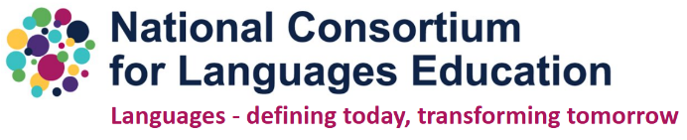

************************************************************************************************

Looking ahead, Clare Seccombe has pulled together great ideas for celebrating European Day of Languages in September (26 September or thereabouts):

Ideas for a French or Spanish Day (can be adapted to other languages too!)

Clare writes:

“It's the time of year when primary schools are planning French Days, Spanish Days, days for other languages or indeed international days. Schools are also starting to think about European Day of Languages in September. Posts looking for advice and ideas for these sorts of days are common on the primary social media groups.
I've pulled together lots of ideas, mainly from the Languages in Primary Schools Facebook group (LiPS), so many thanks to everyone there who has posted ideas in the past. I thought that having everything in one place would be helpful.
The main thing that I think should be borne in mind when planning a French Day or Spanish Day is that 'French' is not just France, and 'Spanish' is not just Spain. It is advisable to incorporate as many as possible of the countries where the language is spoken. It is also advisable to steer clear of stereotypes such as berets and onions for French and a Mexican sombrero for Spanish.
If it's a French day you're organising, you must read this blogpost by Jane Birtwistle. It's full of great ideas and pictures. These activities I have listed have French and Spanish (the languages that I teach) in mind, but they can be adapted for other languages or for international days.

And hot off the press:
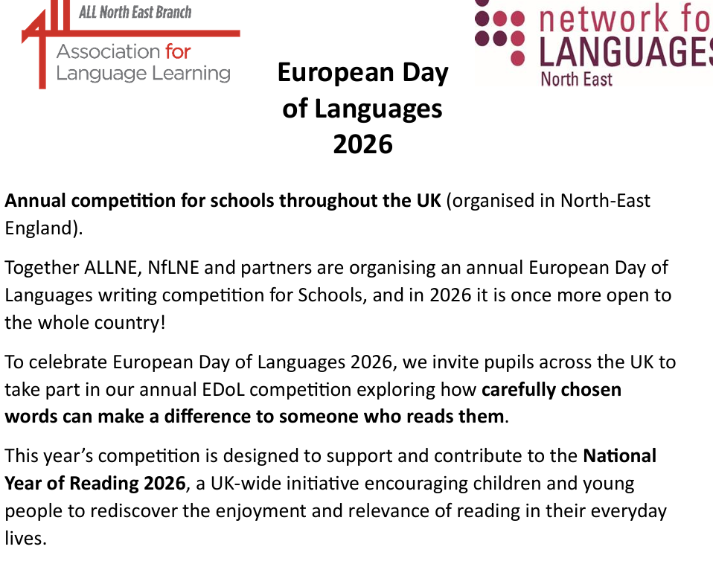
(Full details are included in the flyer attached to the accompanying email)

************************************************************************

Vocabulary is not just about words: it’s about access, equity, and belonging

Read and enjoy this article by Marijke Rivers-Andries published on 01/05/2026 and found on LinkedIn.
In every classroom, vocabulary is doing more work than we often realise.
It’s not just about learning new words. It’s about whether learners can access the curriculum, participate in lessons, and show what they know.
For multilingual learners, this is especially important.
Because when learners don’t have access to the language of the classroom, they don’t just struggle with communication. They are locked out of learning. And crucially, they are often expected to navigate this in a language that is not their own.

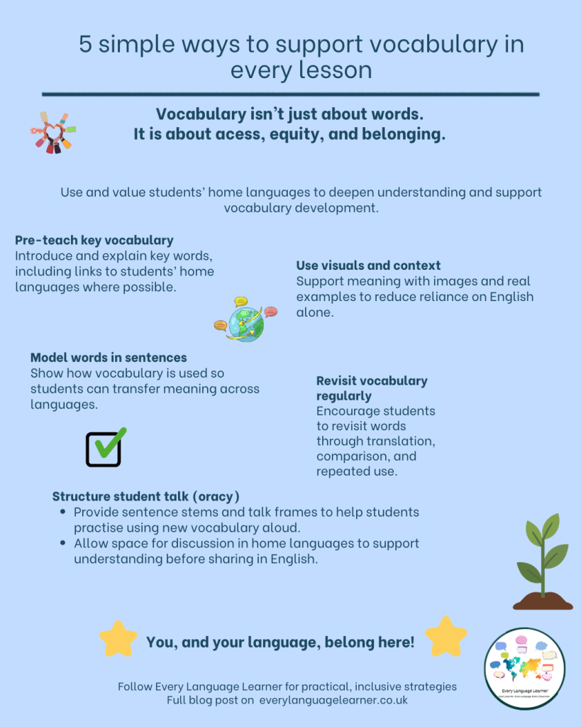

Read the full article here.



Mingalaba and LingoTeach.ai

World Cup Football Newsletter for Teaching Languages
Get FREE lesson resources, match reports, teaching tips, and World-Cup themed activity ideas to maximize how you make use of the World Cup in your language lessons this June! We'll send to your inbox match updates, player profiles, and plenty of themed activities to get your students motivated to learn languages through the excitement of the World Cup!
Find out more here!

A reminder of the many plates our trainee teachers have to spin!

“Yet a trainee teacher is not merely a novice performer learning a set of moves. They are a novice thinker in a complex environment. They are trying to read the room, hold subject knowledge in mind, manage behaviour, interpret pupil responses, remember the plan, adapt the plan, watch the clock, use the board, speak clearly, notice who is lost, respond to wrong answers, maintain warmth, avoid panic, and appear more settled than they are.”

From Dr Haili Hughes’ recent Substack post,

Mentoring is not a script, a shoulder, or a checklist (29 May 2026) Read the full post here.

And the Association (ALL) for Language Learning has recently announced its new mentoring programme.



“We are delighted to announce the launch of the ALL Language Teacher Peer Mentoring Programme. Participation in the programme is available exclusively to active members of ALL. To register, members should first log in using their membership credentials.

Become a Mentor with the ALL Language Teacher Peer Mentoring Programme

*Support colleagues. *Share your expertise. *Grow as a professional.

The Association for Language Learning (ALL) Peer Mentoring Programme connects experienced language teachers with colleagues seeking support, ideas and encouragement. As a mentor, you will play a key role in strengthening the languages community and championing high-quality language education.

Get a Mentor with the ALL Language Teacher Peer Mentoring Programme Talk through ideas.

*Build confidence. *Feel supported.

The Association for Language Learning (ALL) Peer Mentoring Programme connects language teachers with experienced colleagues who can offer support, ideas and encouragement. It is there to help you grow as a professional, look after your wellbeing and feel part of the wider language community

Read more here.

Yet another great reason to join our professional association: this Peer Mentoring Programme is about ALL Members supporting ALL Members!

(Joining details later in this Update)

On a related theme, enjoy this article (provided in full) from NCLE’s Lucy Wicks:
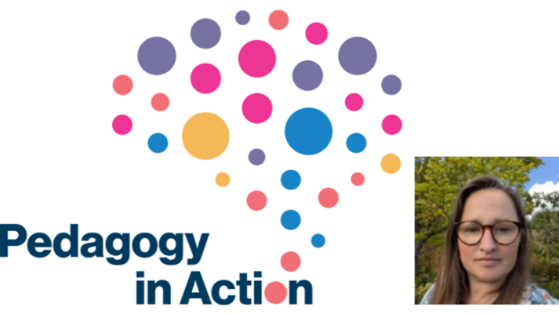

Belonging in the Classroom:

Why Motivation Starts with Connection 29 April 2026
Following her talk at the Pedagogy in Action conference in March 2026, MFL teacher Lucy Wicks explores how a sense of belonging in the classroom underpins student motivation, wellbeing, and achievement. Drawing on her own research and classroom practice, including across subject areas, she argues that small, intentional tweaks to teacher habits can have a powerful impact on student belonging and, by extension, learning across subjects.
“Teachers across subjects often identify the same students as disengaged, lacking confidence, or seeming emotionally distant from learning. We try different strategies - new seating plans, encouragement, sanctions, rewards - and yet the impact can be frustratingly limited. Increasingly, guidance suggests that what is missing may not be ability or effort, but a sense of belonging (NEU, 2023).

With a surge in popularity for books on belonging aimed at teachers (e.g. Chowdhury, 2025), and school leaders’ dismay at post-pandemic declining attendance figures, Belonging has become a buzz word among school leadership and in staff rooms. I argue that belonging is not a “nice extra”. It is a fundamental psychological need and when it is absent, motivation suffers.

Belonging as a Basic Human Need
The need to feel connected, understood, and valued by others, to feel that you belong, is central to human motivation. When students feel they belong, they are more likely to:
- Engage willingly with learning.
- Take risks, including speaking up or making mistakes.
- Persist when work becomes challenging.
- Experience greater wellbeing
Conversely, students who feel disconnected often display lower confidence, reduced effort, or behaviour that masks insecurity rather than defiance. In Self-Determination Theory (Deci and Ryan, 1985), this need for belonging is described as relatedness, alongside autonomy and competence. Whilst all three needs will need to be fulfilled for learners to be optimally (intrinsically) motivated, it can be helpful as a classroom teacher to reflect on individual needs and to develop strategies to enhance learners’ perceptions of these.

Is Belonging a Pastoral or a Curriculum Priority?
Belonging, with its potential for improved attendance and well-being (NEU, 2020), is often framed as a pastoral concern, yet it is deeply embedded in everyday classroom practice. At a whole-school level, curriculum structures, assessment routines, and behaviour policies all communicate powerful messages about who belongs and who does not. At a classroom level, how teachers choose to enact these routines and policies is also powerful. It has been a successful shift in my own school’s culture in recent years to focus on “Connect before you Correct” (see Golding and Hughes, 2012), which helps to preserve a strong teacher-pupil relationship even when sanctions must be applied.

In my MSc research on motivation for learning Chinese, I attempted, through adjustments to my own lesson plans to raise Year 9 pupils’ perceptions of competence, autonomy and relatedness, essential components of high quality ‘intrinsic’ motivation (Deci & Ryan, 1985; Graham, 2012). Despite having taught Chinese and other languages for over 20 years, the effect on my own practice was quite profound, and enabled me to enjoy my job even more than I already did. Belonging is therefore both pastoral and pedagogical and cannot be addressed meaningfully without considering classroom practice itself.

Small Tweaks, Big Impact
Teachers in many contexts face genuine constraints. Time pressures, curriculum coverage, accountability measures, and behaviour systems can all sometimes appear to work against relational connection. In language classrooms, additional barriers may include anxiety about speaking, fear of mistakes, or cultural expectations about participation (MacIntyre et al, 1998). Yet belonging does not require radical structural change. Research consistently shows that small, intentional actions can have disproportionately (positive) effects (Walton & Cohen, 2011). Working with teachers from across subject areas to develop practical strategies that support belonging via the curriculum, we focused on making small tweaks in delivery and lesson structure rather than “back to the drawing board” ideas. These included:
- Making learning personal: using students’ names in examples, feedback, and assessments.
- Normalising mistakes: explicitly celebrating errors as part of learning.
- Building peer connections: rotating seating, teaching collaboration skills, and rewarding teamwork.
- Creating continuity: embedding routines to help absent students catch up without stigma.
- Inviting student voice: regularly asking for feedback and giving learners agency over aspects of their learning.

Belonging is relational work, and it requires effort. One of the most powerful shifts teachers can make is adopting a stance of curiosity: learning about students as actively as we expect them to learn our subject content. This may involve speaking with colleagues, listening to families, or simply noticing patterns over time. As teachers, we model what it means to belong by how attentively we notice others. These actions signal to students that they are seen, valued, and expected to succeed.

Why Belonging Matters for Outcomes
A strong sense of belonging supports not only motivation but also attainment and wellbeing—for students and teachers alike. When students relate to their peers, their teacher, and the content they are learning, classrooms become more resilient, humane, and effective learning spaces. Motivation grows where students feel they belong. The possibilities of a strong sense of belonging are many and benefit the whole school community now and in the future.
What small tweak could you make tomorrow that might help one student feel more connected to your classroom?”
Lucy Wicks is Head of Mandarin at Didcot Girls’ School with experience as a Teacher Educator at ITT and ECT levels. She currently works for NCLE at the IoE, UCL coordinating national language projects. She has undertaken MSc research in student motivation focusing on Self Determination Theory.

For a full list of references, see the original article here.

Kate Percival, MAT lead at Primary Languages Network, has written this great post (one of a series) about making sure that languages are recognised and celebrated in schools.
“Languages to be proud of”
Read the article from Kate here.

And, as usual, finishing this update on a lighter note with ‘nuggets’ from different social media platforms – thank you to the amazing colleagues who share these great ideas, and apologies if they are not all accredited. Some of these gems are just for colleagues and some for learners – to use as a starter task, to enhance a topic, to support learning or to act as a hook into new learning:

En español

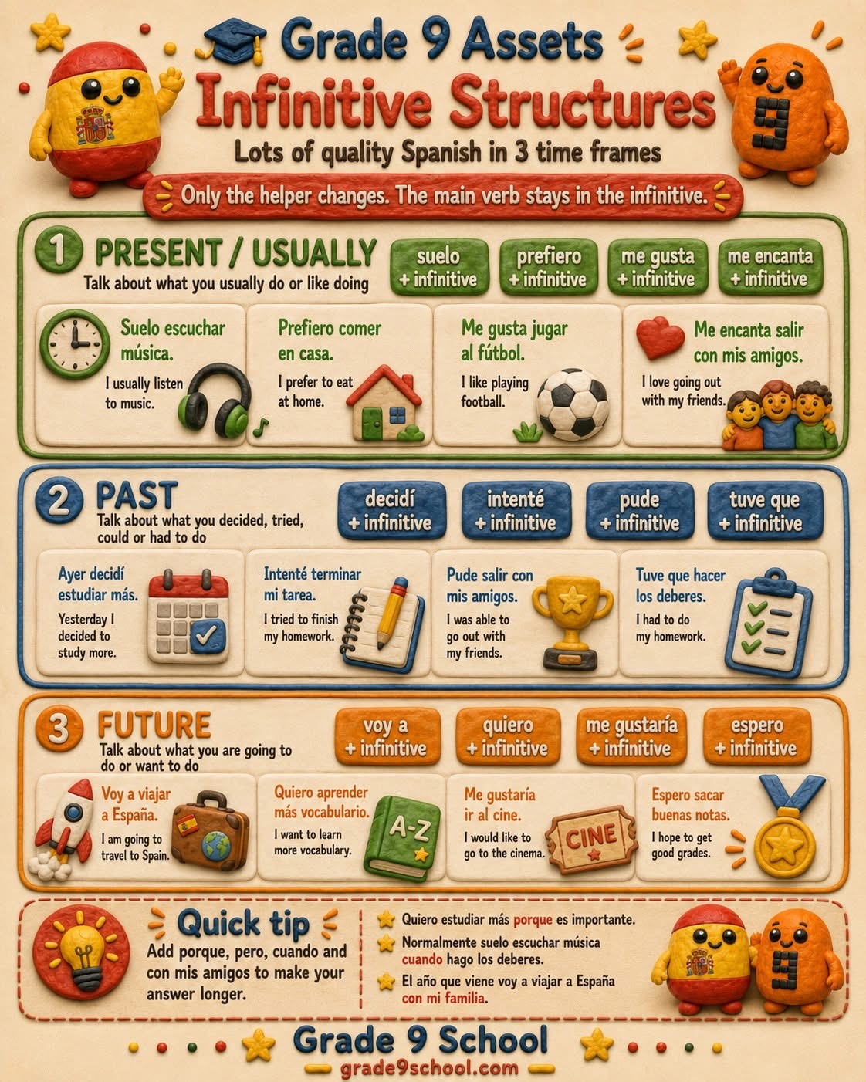
The power of punctuation!


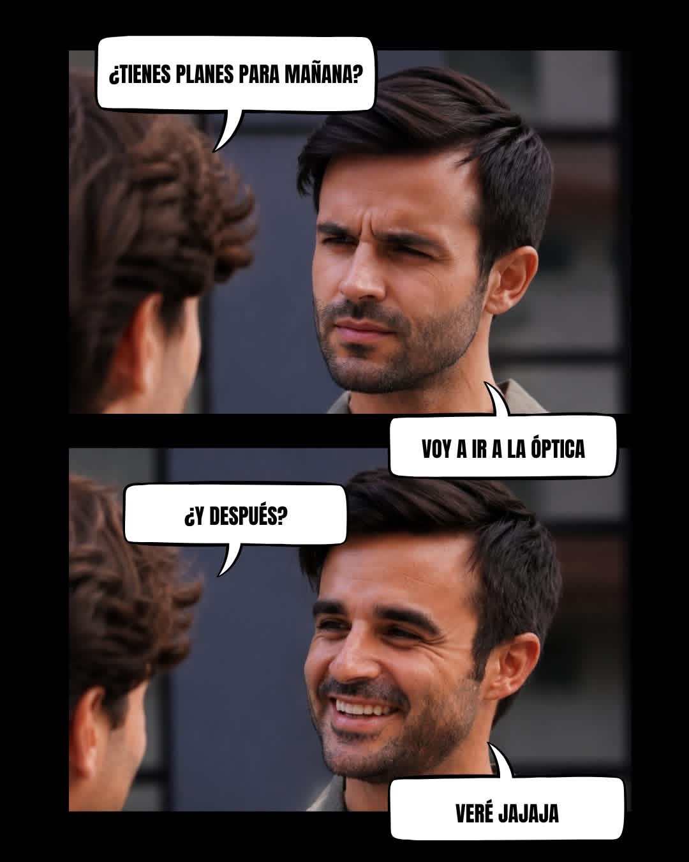
Looking into the future

Patients must have patience!


Definitely my kind of ‘perro’!



Reflect back on those earlier ‘challenges’ and
let’s keep on going!
Und ein bisschen Deutsch
"Kuckuck und Hai" (Cuckoo and Shark) is a popular German musical fable and play on language. It features an absurd encounter between a bird and a shark driven into the forest by climate change. It is widely known in the form of a children’s rhyme and as a viral rap/poetry track by cabaret artist Bodo Wartke and Tom Böttcher.
Enjoy! And sing along!
Kuckuk und Hai
And Bodo Wartke, along with Marti Fischer, is also famous for turning the famous German tongue twister, Rhabarberbarbara, into a catch rap song and dance.

Rhabarberbarbara with Wartke

And a version with lyrics and a cartoon version.

Oranges are not the only fruit – or are they!

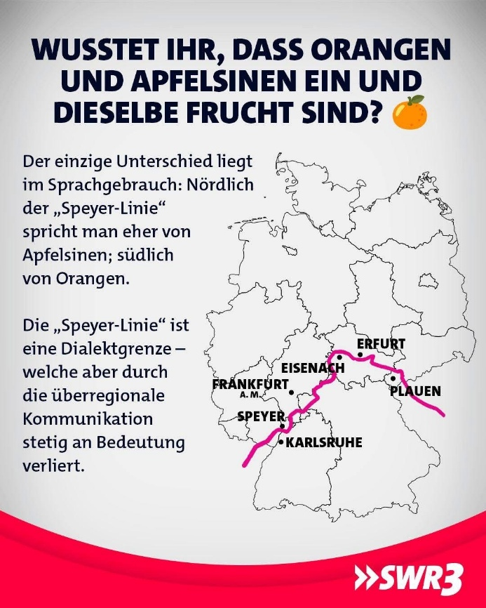
What a difference a capital letter can make!



Love German Idioms!
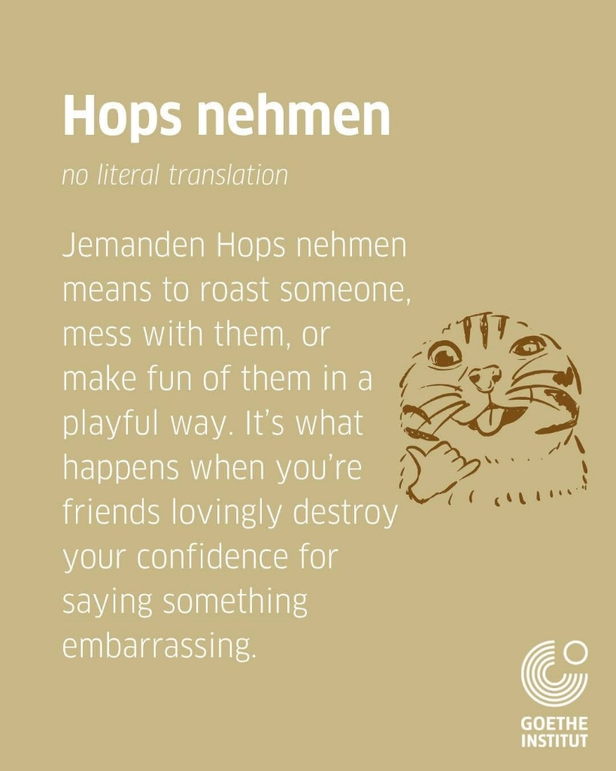
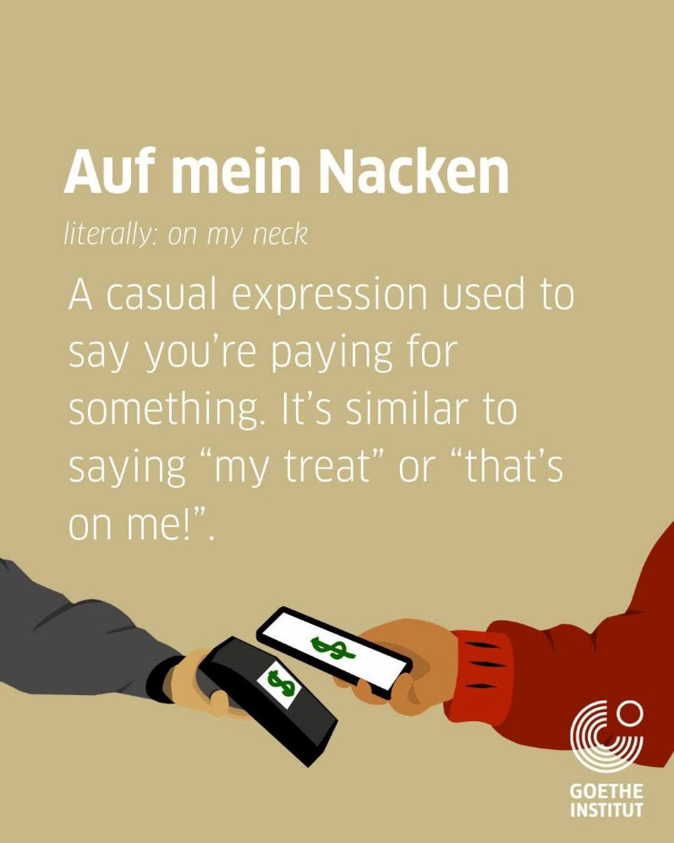

Et en français ……

Agreed?

We can never have too much positivity.

Language to recycle?
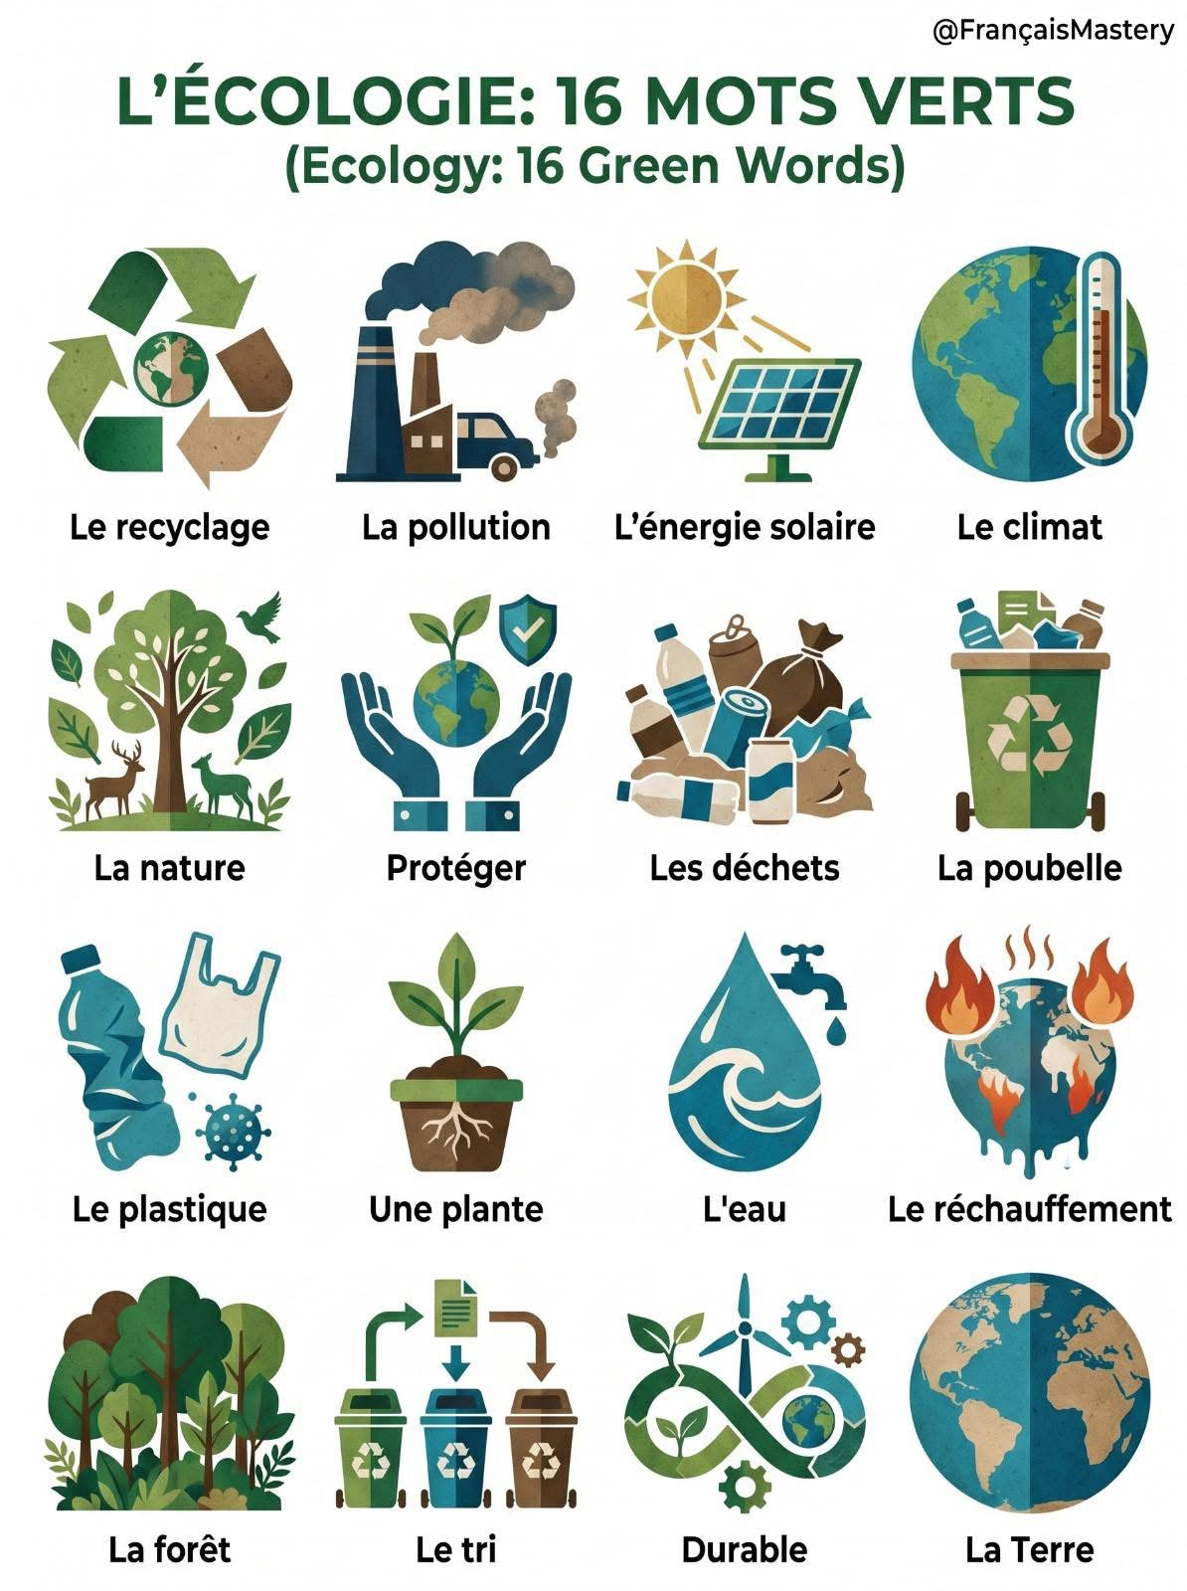

Juste pour rigoler un peu
Le destin

Un bon médecin?
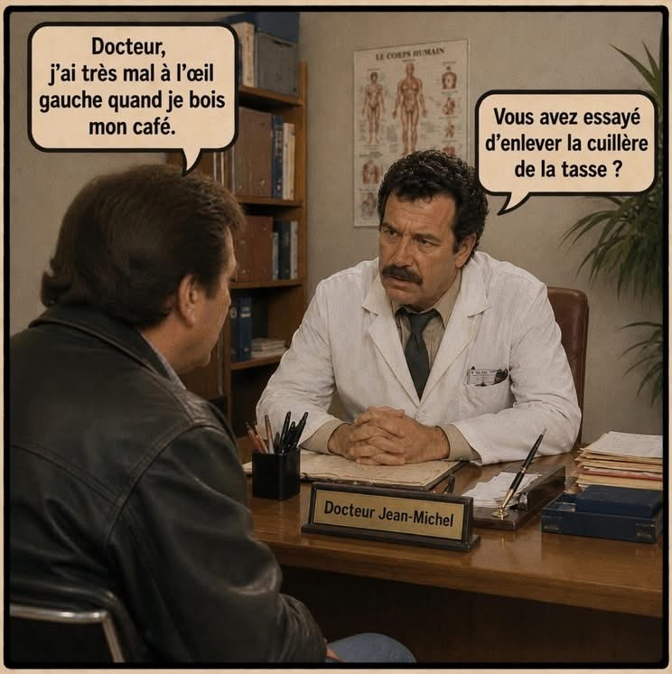



Definitely a ‘cat’ burglar!



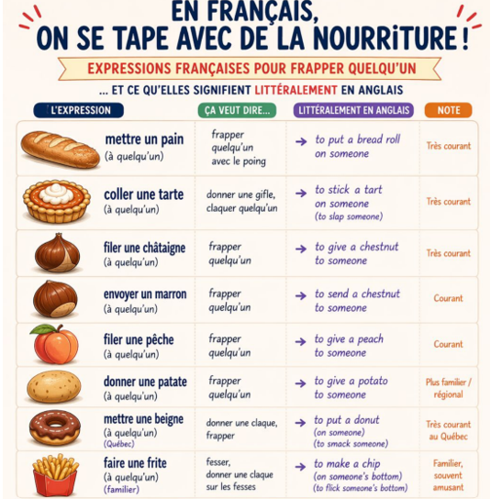
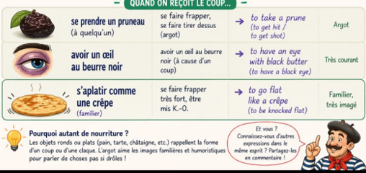
With thanks to Jerome Nogues
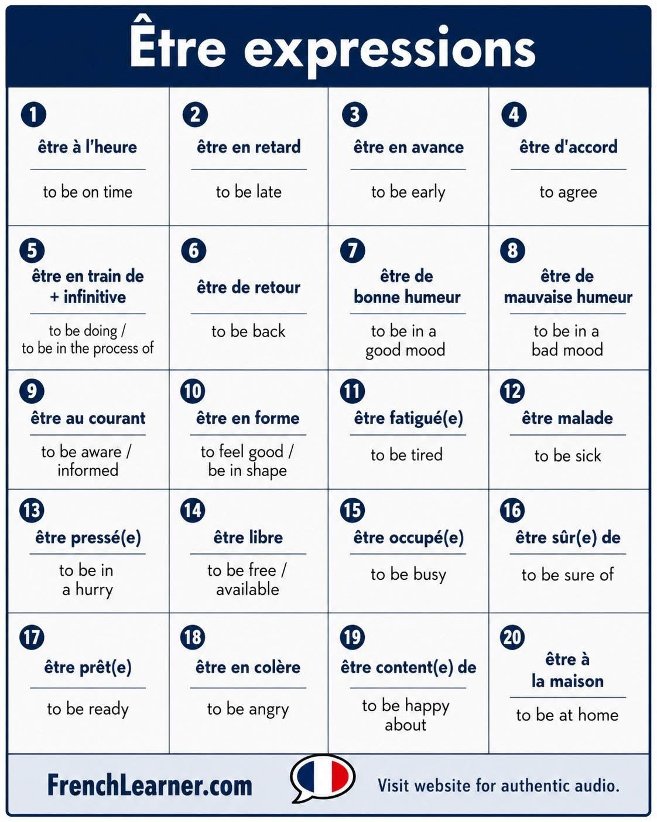

Have fun with verbs – and tenses!
The Association for Language Learning (ALL)
Members are the lifeblood of our professional association – please do think about joining this amazing community of languages champions. You can join here: https://www.all-languages.org.uk/join/becom-a-member/

The Association for Language Learning (ALL) are offering a 10% discount off membership fees, either for current or new members. The code is ALLPortsmouth10 and is valid until 31 July 2026.

Please do think about joining our association which supports languages colleagues and languages education in so many ways.

Together we are stronger!


And to end this update
