Guidance notes for completing 'My Details' page
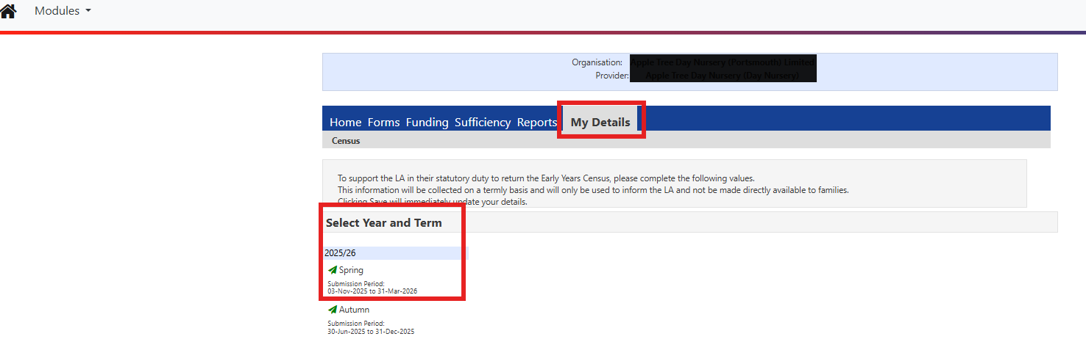
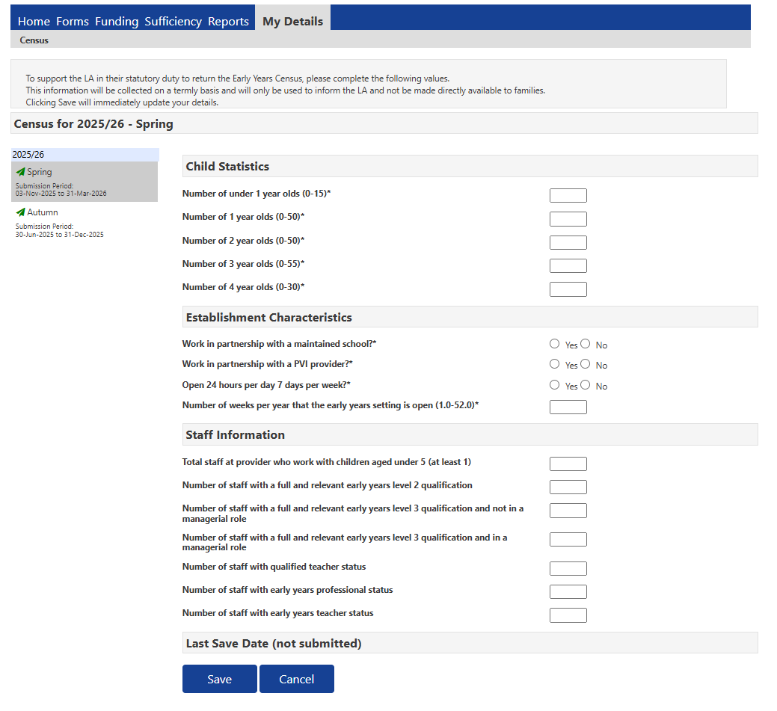
Child Statistics
- In this section you need to check the date of birth of each child to ensure they are counted in the correct group.
- Record the number of children registered to be attending during census week and ensure you include those children who are funded and those who are not funded.
- Enter zero if you have no children in any age range.

Age Groups for This Collection
- Under 1 year old: Born between 01 January 2025 and 31 March 2025
- 1 year old: Born between 01 January 2024 and 31 December 2024
- 2 years old: Born between 01 January 2023 and 31 December 2023
- 3 years old: Born between 01 January 2022 and 31 December 2022
- 4 years old: Born between 01 January 2021 and 31 December 2021

Staffing information
Definitions of ‘full and relevant’ qualifications can be found using the early years qualifications finder Check an early years qualification - GOV.UK
- Record staff who were present during census week.
- If something unusual happened (e.g., the premises were closed), enter your usual staffing levels.
- Enter zero for any items that don’t apply—leave no blanks.
- Only record the highest level of qualification for each staff member, double counting must not occur.

Once all details have been entered click and the following confirmation will appear.

