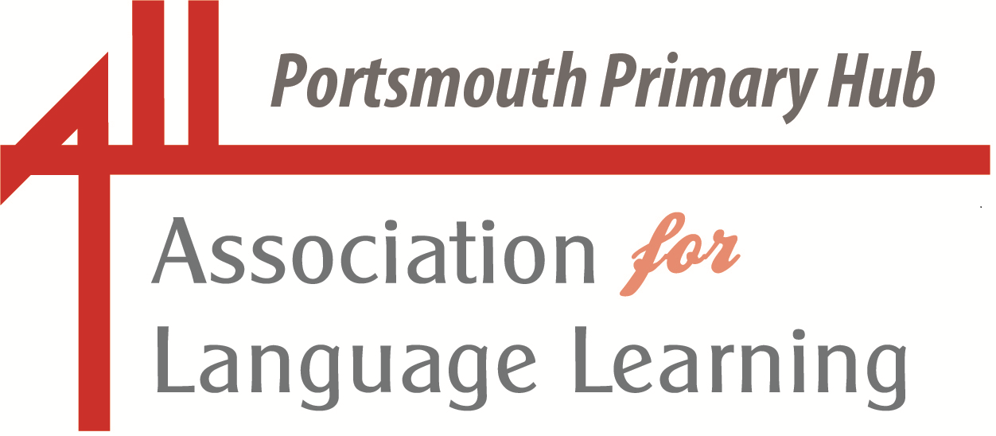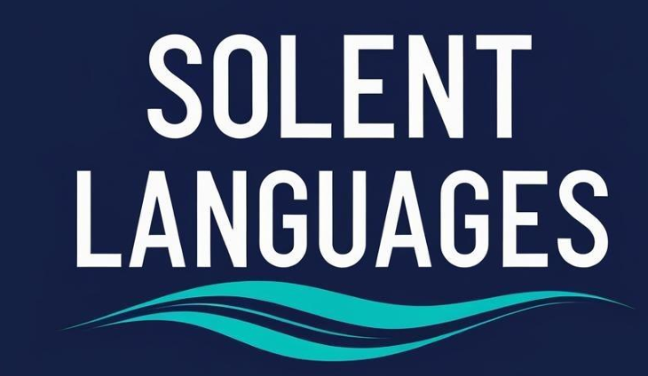
Portsmouth LA Primary Language Leads

Languages in Portsmouth Update
November 2025

Dear Colleagues

Autumn has truly arrived, with its glorious colours and shorter days and longer nights – a time for reflection as the end of another year draws closer and a time for hope as we look ahead to the exciting possibilities of a new year.

I hope you find something of interest in this update, for you and your learners.

with best wishes, Liz. (lizlord0502@gmail.com)

“Der Herbst ist immer unsere beste Zeit.”
Johann Wolfgang von Goethe

“Te recuerdo como eras en el último otoño
Eras la boina gris y el corazón en calma.
En tus ojos peleaban las llamas del crepúsculo
Y las hojas caían en el agua de tu alma.”
Pablo Neruda

“Oh! l’automne! L’automne a fait mourir l’été.”
Guillaume Apollinaire
(and why not listen to Jacques Prévert’s “Les feuilles mortes” sung by Yves Montand? https://www.youtube.com/watch?v=vbMDLfIjbNE)



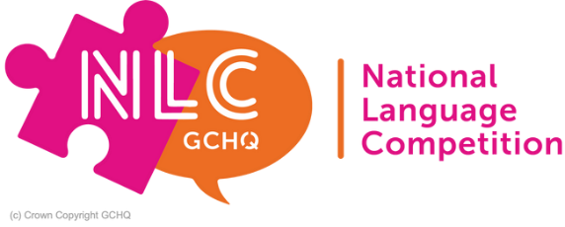
GCHQ’s National Language Competition (NLC)
Learning languages, whether in school or at home, can certainly open the door to exciting career opportunities, and this annually-run competition is intended to give students in Year Nine a flavour of that challenge and excitement.
We very much hope that as many schools as possible in the wider Portsmouth area will encourage their students to take part in this competition organised by the outreach team from GCHQ, the Government Communications Headquarters, an organisation which is known to be a world-leading intelligence, cyber and security agency.
The NLC 2025 will take place from 17-21 November and is aimed at students in Year Nine, competing in teams of up to four. It involves a variety of fun, immersive, language-themed challenges of varying difficulty levels hosted on a virtual platform.

The aim is for students to enjoy using languages to solve the challenges, and to be inspired to continue with their language learning at GCSE. No prior knowledge is required, only a keenness for languages!

For more information visit https://www.gchq.gov.uk/information/national-language-competition and to register, email nlc@gchq.gov.uk.

The National Consortium for Languages Education (NCLE) has announced that their new CPD platform is now live.

Sign up to LEO
You can sign up to Language Educators Online (LEO), NCLE's free online professional learning platform, via the NCLE website. With new modules coming soon, sign up to the NCLE mailing list to be the first to know when these go live!

Connect with your local Language Network
If you're interested in learning more about how NCLE is addressing regional and local needs, you can read more about the National Priority Projects (NPPs) and connect with the NCLE Language Network's leading these projects.

**And, of course, we are very fortunate to have a language network here in Portsmouth, the Solent Language Network, led by Rebecca Britti of Admiral Lord Nelson School and Aamir Kohli of Trafalgar School.

NCLE has an exciting schedule of webinars planned for the year ahead. You can find more information about future webinars including how to register via the NCLE website. Topics include:
- The Curriculum and Assessment Review
- Languages for all - a social justice issue
- Practical ideas for promoting the use of the target language in the classroom

Why not encourage your learners to enter the Institut Français “French Pop Video Competition?”

The French Pop Video Competition is a national competition organised by Francophonie UK for all KS1 to KS5 students of French in the UK. Since 2019, the competition has revealed many talented young singers and encouraged students to engage with French in a creative way. From the writing of a song to its singing (or rapping!) and video shooting, former participants have expressed how empowered the contest has made them feel.

Details of the 2026 competition haven’t been published yet but to find out more, visit https://www.institut-francais.org.uk/app/uploads/2023/11/2024-Competition-Handbook-French-Pop-Video-Competition_compressed.pdf

WolloW: World of Languages, Languages of the World

As we become increasingly aware of how important it is to recognise and celebrate the languages experiences of all our learners and their families, this programme provides excellent opportunities to do so.

Its website states, “WolloW is a fully developed languages curriculum for pupils aged between seven and 15. Created by experienced language teachers and available free to all schools, the project aims to bind together all elements of a pupil’s experience in school and beyond, and to prepare pupils not only for future study but for future life.

Our mission is to bring the study of languages, all languages into the centre of education at a time when our schools have much greater linguistic diversity than ever, and our increasingly diverse society has an urgent need to generate understanding, communication and respect between all people.”

Find out more here: https://theworldoflanguages.co.uk/
Another excellent opportunity to take part in a free learning opportunity, with a message from Doctor Alison Porter and Professor Suzanne Graham:

Dear all,
The Universities of Southampton and Reading are delighted to announce a new launch of our MOOC "Challenge, creativity and empathy: Skills for primary language teaching".

Here's a link to join to join: https://www.futurelearn.com/courses/challenge-creativity-and-empathy-skills-for-primary-language-teaching

To access the free option, you'll need to scroll down the FutureLearn joining page and register for the course on 3rd November or after.

More exciting research is being carried out by colleagues from the University of Reading and UK Research and Innovation.

Visit the Progression in Primary Languages (PiPL) website to learn more and sign up for the project newsletter in which you will find updates and insights from PiPL—a four-year journey into how children learn French, German, and Spanish in primary school.

Together with 17 primary schools across England, the research team has been following pupils from age 7 to 11 to see how their language skills develop over time. Along the way, the team has also been exploring what really helps children thrive in language learning.Follow their journey to hear more about what they are learning.

https://sway.cloud.microsoft/083fjgdqN1KyxPKw?ref=Link

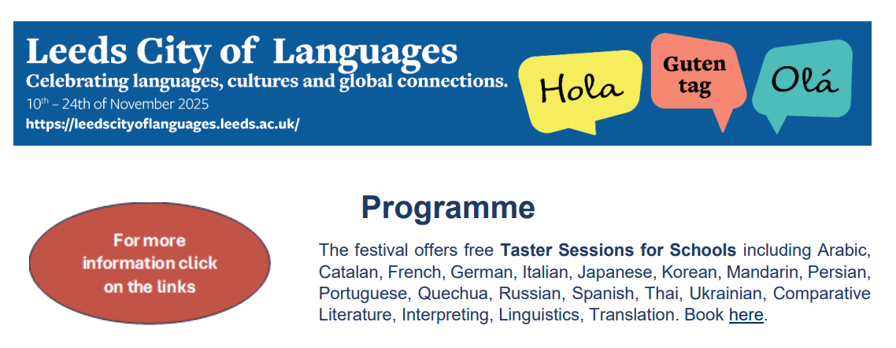

https://leedscityoflanguages.leeds.ac.uk/wp-content/uploads/sites/192/2025/10/AAA_Programme-31.10.25.pdf

Have a look at how Leeds are promoting themselves as a City of Languages – lots of food for thought for our ‘Week of celebrating languages in Portsmouth, 16 - 20 March 2026’?
https://leedscityoflanguages.leeds.ac.uk/

And there’s still time for you, your learners and maybe their families, to sign up to what looks like a great event!

Date Thursday 13 November 2025, 16:00
Location Online
Cost Free. Booking Required
Suitable For Year 7-Year 13 students, families, teachers

How can the study of languages and global cultures help you to stand out in the job market? How can you make a real difference across different countries and continents? Do the media industry, diplomacy, international business and global organisations value these skills?
This talk will reflect on what multi-linguists have achieved in various professions, and on why employers value foreign language skills and inter-cultural awareness.
Register here

The amazing British Council are offering a series of free webinars that aim to support schools with submitting applications for Accreditation/Reaccreditation levels of the International School Award.
All workshops are 45 minutes long, and you will receive help on:
- how to plan your international work for the academic year
- how to design your international activities
- how to find an international partner
- how to disseminate effective international practice
- how to fill in the online action plan form quickly and efficiently
- where to find online supporting documents
Please book in advance of the sessions to ensure your attendance.

Webinar dates
Date | Time (UK time)
Wednesday 5 November  Tuesday 11 November  Friday 21 November  Tuesday 25 November | 08:15  16:30  12:30  12:30
Please contact the ISA team with your preferred date and time, name, and school name in order to book your place.

This is an absolutely fascinating read, with so much food for thought, maybe particularly for us here in the Portsmouth area?

Complexity in secondary languages: how the local context shapes languages education in England
Zhu Hua, Elin Arfon & Ann-Marie Hunter 20 September 2025
UCL Institute of Education, London https://orcid.org/0000-0001-8376-9699
And a quick reminder of some key articles on languages education that have been published this year so far:

How the Francis review can solve England's languages crisis
Languages Today (issue 50)
Think Like a Linguist: It’s time for a national conversation about the value of languages - HEPI

Dates for your diary
Dates have been set for next year’s joint meetings of the ALL Primary Hub, Portsmouth Network Leads and the Solent Language Network. (venues to be confirmed)
Wednesday 4 February 2026
Wednesday 20 May 2026
If there is a particular topic that you would like covered in these meetings, please do get in touch. Additionally, please let me know if you have a preference for face-to-face or online meetings.
We are very keen for these meetings to be a focus and opportunity for everyone interested in languages teaching and learning to attend. Together, we can make a difference!
Celebrating Languages in Portsmouth
After the successful focus on Languages at Work, we are keen to start planning for next year’s ‘Week of Celebrating Languages in Portsmouth’ which will take place during the week beginning 16 March 2026.
We will hold an initial planning meeting online on Tuesday 11 November at 1600. Please do get in touch if you would like to attend.
More details will follow shortly.

And another key date for diaries:
Following the success of our first-ever cross key stage languages conference held at ALNS at the beginning of July, we will run a similar event, again at ALNS, on Wednesday 8 July 2026.
Do let us know if you are aware of speakers you think we should invite – or, indeed, if you would like to deliver a session at our conference!

And signing off, as always, with a smile:

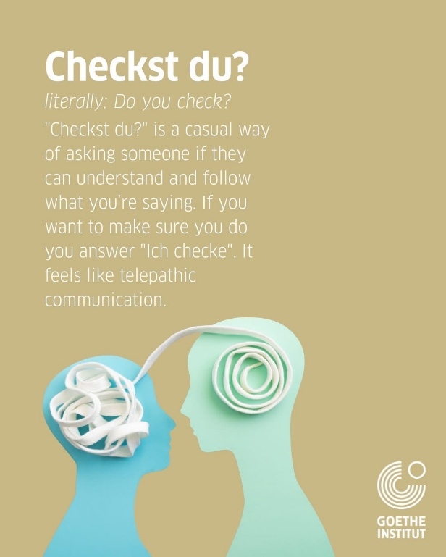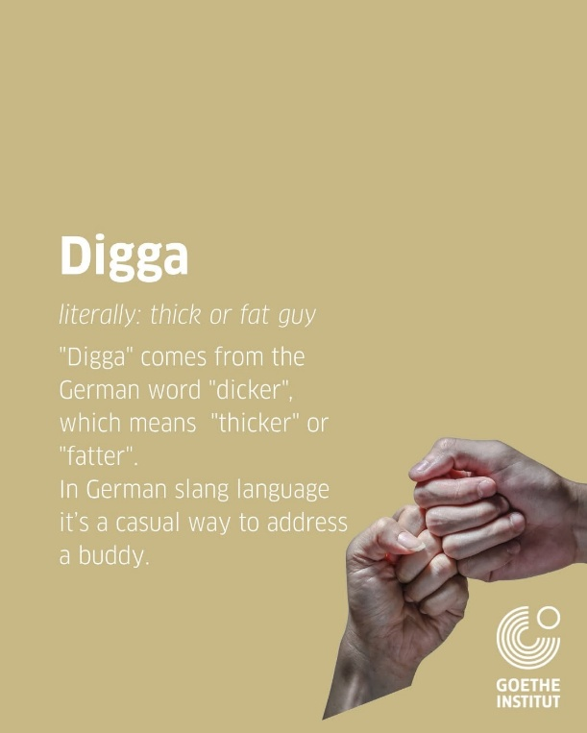

A little late for this year – but still funny

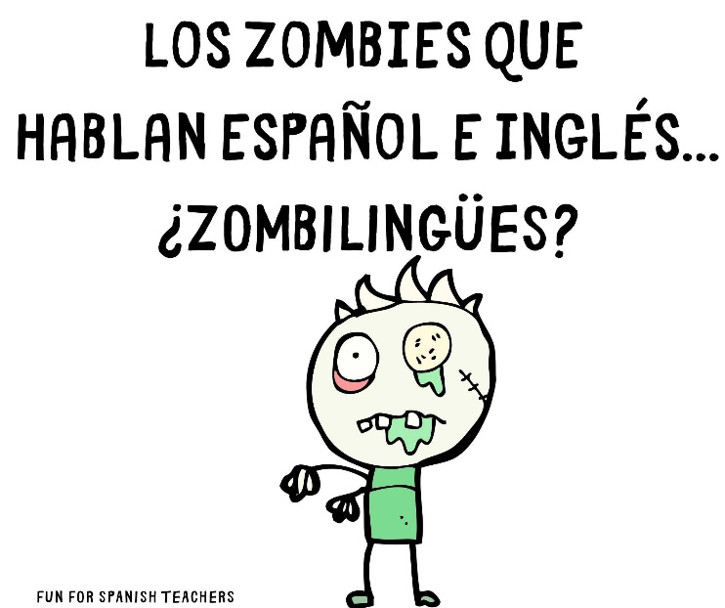
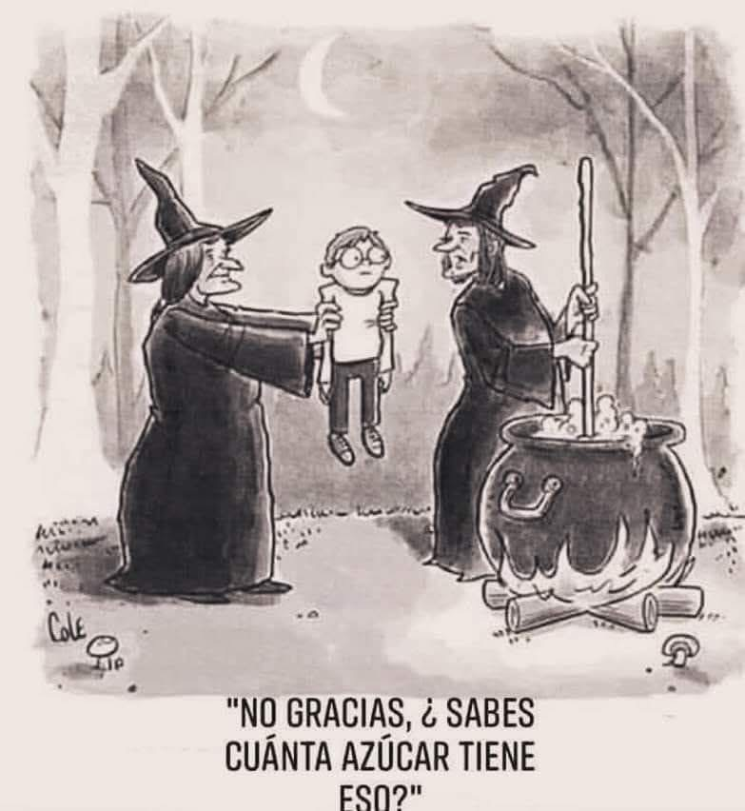

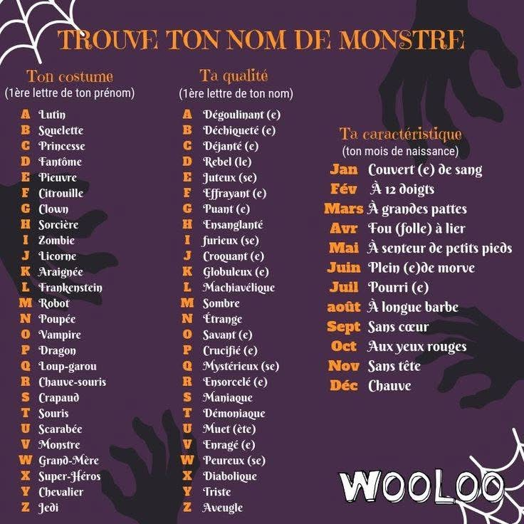

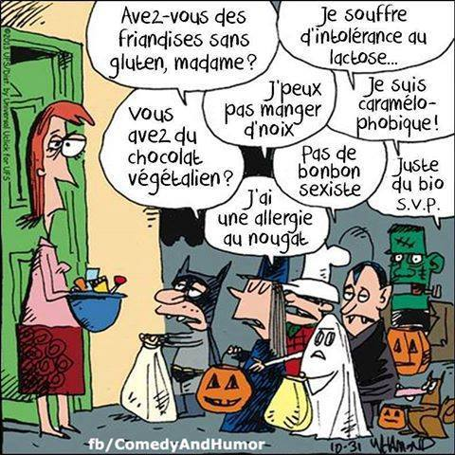
How many days till the Christmas break?


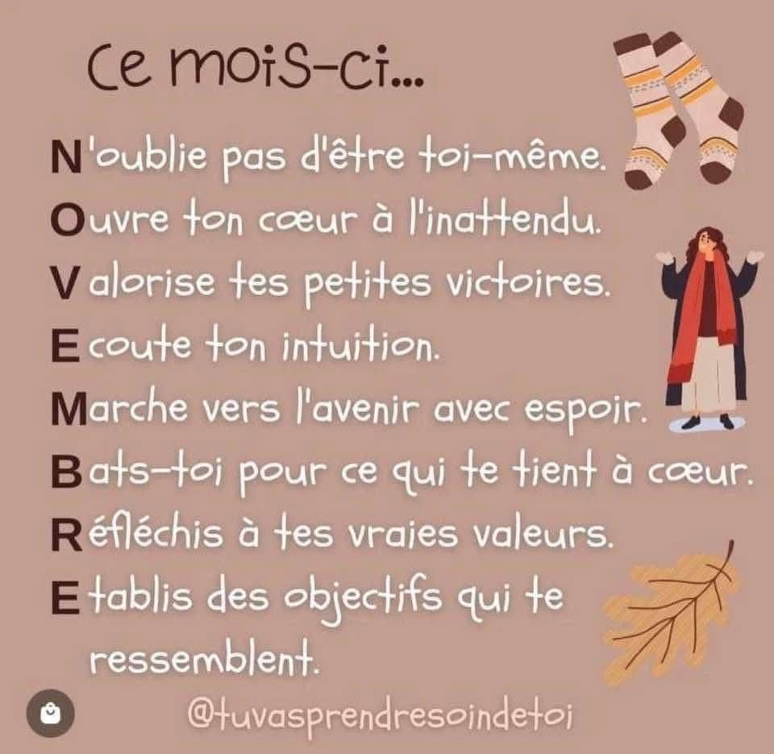
Never forget this – and remind your learners!
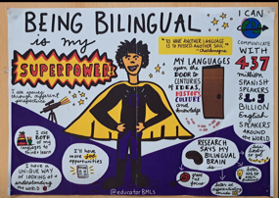
Wishing you, your colleagues and your learners,
the best of weeks to come.
