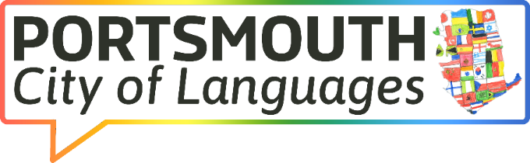
Meeting: CoL Partners' Group
Date: Tuesday 14th October 2025
Time: 3:30 - 4.30

AGENDA
Teams Meeting Link: Join the meeting now
This is a joint initiative launched by the city’s language providers, the Local Authority and other interested groups to showcase good practice in language provision at all levels, signpost to resources and develop networks, as well as celebrating languages in the city.

NO. | ITEM | TIME | LEAD
1. | Welcome and apologies | 1:00 | KT
2. | Notes from the last meeting  Follow up any outstanding items and/or actions | 1:05 | KT
2. | Feedback from the European Day of Languages and Languages at Work Fortnight | 1:10 | LL
3. | Cities of Languages update, including ideas from Newcastle's 'Express Yourself - North East Festival of Languages' | 1:20 | KT/LL
3. | Planning for the next Celebrating Languages Week (March 16th - 20th 2026) | 1:25 | All
4. | Further updates and opportunities for the future (contributions from everyone) | 1:50 | All
5. | AOB  Date and time of next meeting - 24th February 2026, 3:30 - 4:30 | 1:55 | KT

