
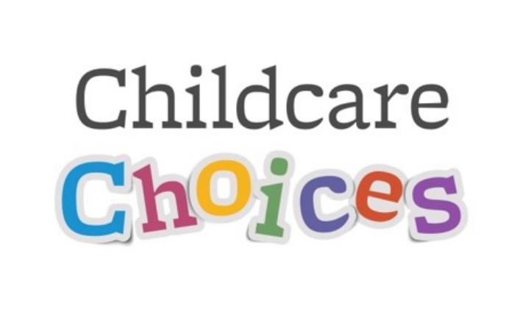
DfE invite senior managers to the early years and childcare provider roadshow for the south-east region.
When: Wednesday 30 April 2025
Venue: Leonardo Royal Hotel Brighton Waterfront (King's Rd, Brighton, England, BN1 2GS)
Times: starts at 10:30 (registration from 10am) and closes at 3:30pm
The event will include an overview and update from the Department for Education, opportunity to share your experiences and views in roundtable discussions, and a best practice session.
Refreshments and lunch will be provided.
Register your place for the roadshow
This event is a great opportunity to help shape this government’s plan for change and hear about the strategy and activity underway to meet the pillar in its Opportunity Mission to give children the Best Start in Life.
You will have a chance to engage with DfE colleagues on the work we’re doing to meet the expanded childcare entitlements from September 2025 and share your ideas, concerns and challenges.
You will also hear how the department is working on the government’s new vision for early years education and childcare.
Throughout the day there will be opportunities to network with external membership organisation and partners who support early years providers.
These roadshows, which started in January 2024, are an important part of shaping early years and childcare policy and delivery.
Further communications will be sent to registered delegates leading up to the event. When registering, please choose from the following roundtables (there will be 3 roundtable sessions).
Being ready to provide expanded childcare places in September 2025
Hear from DfE about the work in train and planned to support the sector to deliver the expanded entitlements for eligible working parents from September 2025, including the availability of regional data. Share your specific challenges, lessons learnt and opportunities that you would like DfE to reflect upon and consider in our planning, support and delivery.
The government-funded childcare entitlements system and future childcare delivery
Hear from the team that manage the government funded childcare entitlements system and the roll out of the new entitlements for working parents, including the delivery of the HMRC, DfE and LA digital systems and the overall policy. You will also have the opportunity to hear about considerations for the future of the entitlement system and feed in your views on how the provider market can support future childcare delivery.
How the early education and childcare funding system works
Hear from the early years and childcare funding team how the early years funding system works and tell us how you are preparing for this coming financial year and your reflections and challenges. You will also have opportunity to hear options being considered for the future of the funding system and to feed in your views.
Providing school aged childcare (Wraparound and Breakfast Clubs)
Encouraging successful partnerships between schools, trusts, PVIs and childminders is at the heart of successful and accessible school-aged childcare. Meet DfE's wraparound and breakfast club team and find out more about the expansion of childcare for primary school-aged children and tell the team how the programme is working for you, your barriers and the opportunities this programme has created. You will also have opportunity to hear options being considered for the future of school aged childcare and to feed in your views.
Early education for children with SEND
Setting up every child up to have the best start in life means delivering access to high-quality early education and childcare, including those with special educational needs and disabilities. During this session you will the DfE’s early years SEND team will share insights on the latest training and guidance available to support practitioners in caring for children with SEND, as well as recent developments in funding reform.
We want to hear your experiences supporting children with SEND in your setting, including what training and development opportunities would benefit you and your staff, your experiences with the early years SEND funding system, and what you feel we can do as a department both now and in the future to ensure that your setting has the support and resources it needs to ensure children with SEND can get the best start in life.
Building the early education and childcare workforce with the right qualifications
During this session you will have the opportunity to find out more about the department's work to support, grow and develop the early education and childcare workforce, including our 'Do something BIG' marketing campaign, Early Years Skills Bootcamps our financial incentives pilot and the Early Years qualifications landscape. We want to hear about the barriers and challenges you face when it comes to staff recruitment, retention and development. You will also have opportunity to hear options being considered for the workforce and to feed in your views.
Supporting quality practice in early education
On the early education and quality practice table we will be introducing you to the free support the department offers to help you deliver excellent education and care in your settings. We will cover training and resources from Early Years Child Development Training, Help for Early Years Providers website through to the networks and evidence-informed practice you can access via your local Early Years Stronger Practice Hub. We also want to hear from you! We’ll be seeking your feedback on the Government's support offer to date, and your input will help shape what we provide in future.
Joining up family services
Find out about the Departments current policy on providing joined up services for families, focusing on the Family Hubs & Start for Life programme. Understand the important role of early years and childcare providers in facilitating that join up and connecting families to local support. In particular, how family hubs and EY settings can work together to improve take up of childcare entitlements and support for disadvantaged families, as well as identifying and connecting families who would benefit from targeted support. This is an opportunity to tell us what the strengths of the current policy are, any identified gaps and how Government can support the EY sector to join up better with family services.

