  - 31/03/2025  child sexual exploitation training  Suitable for all agencies working with children and young people. This training aims to raise awareness of CSE, how to identify and respond effectively to CSE. The training day will involve professionals across various agencies to share insights and develop a unified approach to tackling CSE.  To book onto this training, please email harry.tumber@portsmouthcc.gov.uk. There are limited spaces, your place will be confirmed to ensure enough spaces for all partner agencies. Joining instructions will be shared 2 working days prior to the course.  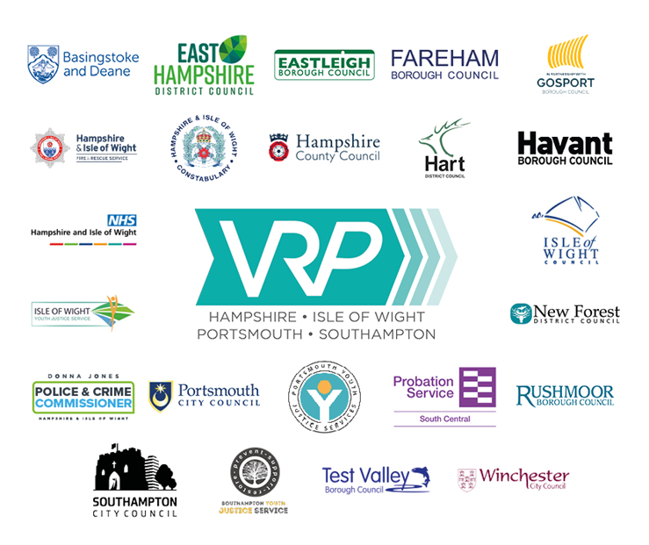
  All Day Event
  ____
  In Person Training
  ____
  Lunch Provided
  ____
  Portsmouth Marriott Hotel
  
  
  Please join us for Child Sexual Exploitation training. delivered by Future Voices and Portsmouth City Council in partnership with VRp.

