Languages in Portsmouth
An Update for the New Year
January 2025
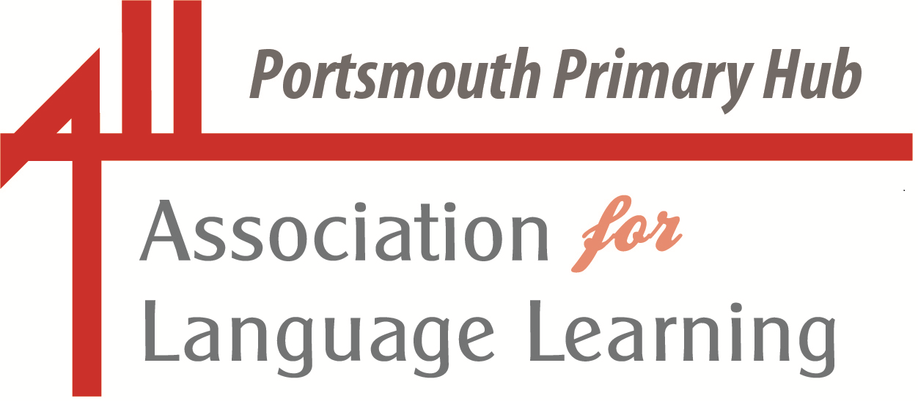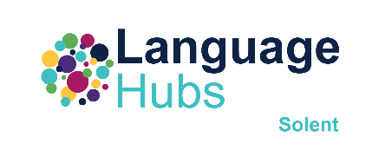
Portsmouth LA Primary Language Leads

Dear Colleagues

Another new year, and another opportunity to start afresh. Wishing you, your colleagues and your learners a safe, healthy and successful spring term.

Liz.

(please do get in touch if you have anything to include in future updates – lizlord0502@gmail.com)

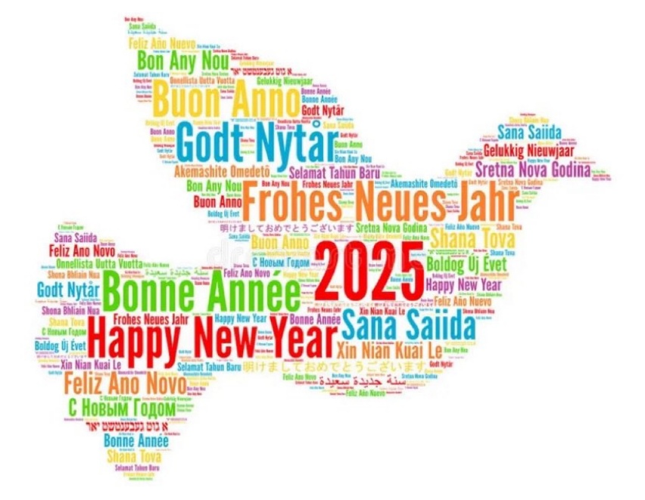

And what a treat in store to start off the New Year …. The ALL Portsmouth Primary Hub and the Portsmouth Network Language Leads proudly present:
Another session for ALL colleagues – and, as always, it’s ALL free!

Everyone – primary and secondary colleagues – will find something of interest in this session on teaching phonics in language lessons, delivered by the Queen of Physical Phonics, Sue Cave (my words, not Sue’s!).

Sue will discuss how best to teach and embed phonics in language lessons, with a focus on the following:

- Why teach phonics
- Which sounds to teach
- Which method to use
- Examples of classroom activities
- How to develop confident and independent speakers
- Decoding IPA symbols

The examples will be mainly in French and English but with some reference to German and Spanish.

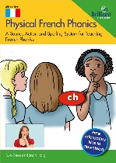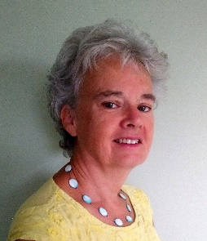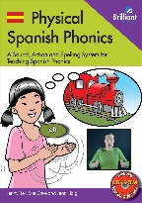

A link to this meeting is included in the update email. Any questions or to register your interest in attending, please contact lizlord0502@gmail.com.



Portsmouth LA Primary Network Language Leads

Sue Cave has more than 35 years’ experience of teaching languages in secondary, adult education, EAL and primary. Currently, she is a consultant and trainer for Cave Languages. Her passion and enthusiasm for the transformative effect of the explicit teaching of phonics is infectious. She is an author of primary languages resource books and co-author of Physical French Phonics and Physical Spanish Phonics.
Note: this session is relevant for both primary and secondary practitioners. Take a quick look at the video in the link below, in which Tracy Williams of the Trent and Tame Language Hub describes how she has used the Physical Phonics Resources in her settings.
https://www.youtube.com/watch?v=3YVHB52epqE&authuser=0
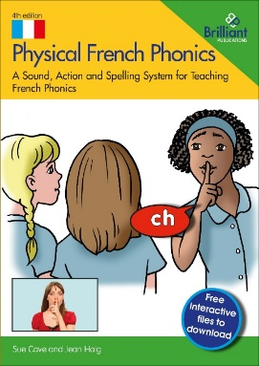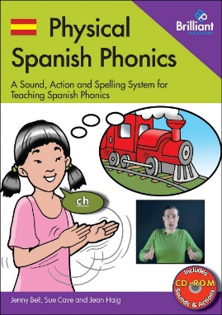

And, because we are fortunate to have one of the national secondary language Hubs in Portsmouth, the Solent Language Hub, an amazing offer from the Institut Français and NCLE - could this be an opportunity for you or one of your colleagues?

Institut Français: Primary French Upskilling Course - Now open to all Hubs' primary colleagues

Call to action: Last chance for Hubs' primary colleagues to claim a free place on the Primary French Upskilling course this term, worth £380.
Take a few seconds to register now!
What is the offer?
The NCLE and the Institut Français have agreed this enhanced offer to the Language Hubs' primary colleagues teaching KS2 French.
The NCLE will pay for places centrally: up to 5 places per Hub i.e. schools do not have to do any paperwork or invoicing - we will take care of it. We are now able to expand this offer to any primary colleagues within Hubs' networks (not just NCLE partner primaries).

Details of the offer:
Free places on the online French Upskilling Course from the Institut Français, France's national cultural institute.
- 12 sessions over 10 weeks, starting Tue 21 January through to the end of term (6pm-8pm).
- Designed for KS2, reinforcing grammar, phonetics and culture.
- Fully funded - value £380, paid by the NCLE
- A wonderful opportunity for primary teachers to refresh and upskill their French skills and knowledge, and meet some new colleagues from across the Hubs network.
How to claim your free places (maximum 5 places per Hub):
Simply register the following details with Philip at NCLE p.harding-esch@ucl.ac.uk
- 1. Name of participant (primary school teacher working at a school with a relationship with an NCLE Language Hub)
- 2. Participant's personal email address. Important to provide own email address (not institutional/school email address), to avoid any technical/access issues.
- 3. Name of the participant's school
- 4. Name of Lead Language Hub school who has referred the participant to the course.
The NCLE will take care of the fee payment on behalf of the Hubs.
The Institut Français will contact the participant directly to enrol them on the online learning platform (accessed via Microsoft Teams) and welcome them to the course.
We ask that participants register with good faith commitment to participate in the course every week.
We're delighted that this offer has been put together specifically for the Language Hubs in partnership with the Institut Français.
We look forward to hearing from you!

Or maybe you would prefer to study independently?
Exercices de tous niveaux pour pratiquer le français - Français Facile - RFI
https://francaisfacile.rfi.fr/fr/exercices/

There are some fun and very topical activities to complete.

************************************************************************

Why not encourage your young learners to create their own calligram for this very motivating competition? Come on Portsmouth schools – let’s show what amazing learners we have!

ALL Primary Calligrams celebration 2025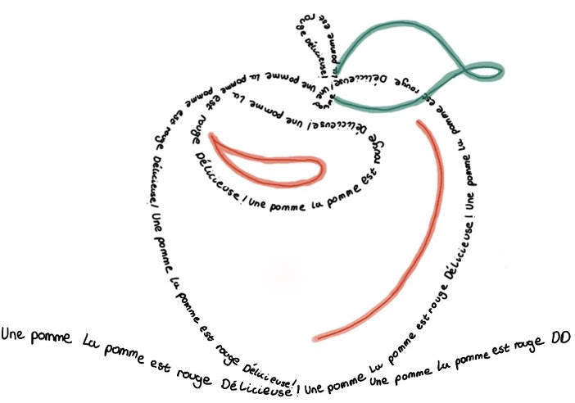
ALL’s Primary Special Interest Group invites you once again to get your Primary class to be creative with the language they are learning!
Each school that enters will receive an ALL certificate, and we are planning to compile a digital collection of some of the most striking calligrams!
We offer 2 categories – 7-9 years old and 9-11 years old, and invite teachers to select a theme that fits in with their schemes.
The celebration is open from January to 24th February and details are available from this page: https://www.all-languages.org.uk/news-events/challenges-and-competitions/ and from the download here.

You may have already seen this call for action from Portsmouth’s Ethnic Minority Achievement Service (EMAS) – please do consider whether you and your learners could be involved.

Understanding the impact of race, ability and language in the educational journey of migrant students |  | 

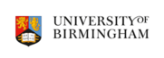
The Ethnic Minority Achievement Service (EMAS) are working with Dr. Valentina Migliarini, Assistant Professor in Education Studies from the University of Birmingham on some British Academy-funded research. This will look at how EMAS try to support EAL pupils and their families who have, or may have, SEND.
EMAS staff are being interviewed as part of this research, due to begin in February, but Valentina is also looking at recruiting six pupils and their families (primary or secondary) to find out their perspective too and says 'I would prefer them to be from a migrant background, racialised as non-white, and at different stages of the SEND referral process, to explore the intersections of language support and SEND support'.
Do you have any families who fit the criteria in mind? Their involvement will just entail an interview, alone or in a small group. Importantly, the pupils/families must have had some EMAS involvement - a BLA and/or an SEN/EAL assessment and then possibly, but not necessarily, an EP assessment, EHCP etc.
Please see the participant information sheet for children, students or parents. Please email Marie Allen at Marie.Allen@portsmouthcc.gov.uk for further information or if you can think of anyone who fits the criteria and would be happy to be contacted.

An absolutely fabulous line-up of speakers at this one-day conference

Making the Case for Languages from Primary
31 January 2025 – Europa School UK
https://europaschooluk.org/making-the-case-for-languages-from-primary/

Europa School UK is proud to announce its inaugural conference focused on “Making the Case for Languages from Primary”. As leaders in immersive language teaching from Reception onwards, Europa School UK has developed an innovative approach over the past 12 years, teaching pupils within an immersive and inclusive setting.

And news from the British Council

Chinese New Year arrives early on 29 January.

Bring the legend of Lady White Snake and more to your classroom with our Year of the Snake education pack. Filled with interactive activities, it’s designed to immerse your pupils in Chinese language and culture.
Download here: https://t.co/2sKsjw5vdv https://x.com/schools_british/status/1876177139281637535?s=51&t=KkNFOoJvATbebgkLG3umBg



Language World 2025

March 14 - March 15
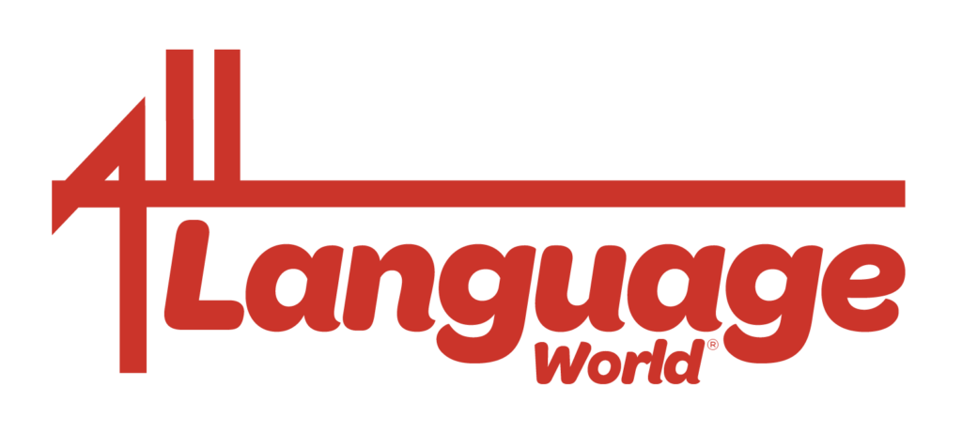

Click here to reach the conference website for more information and registration

Language World is the annual conference and training event of the Association for Language Learning. It is a highlight of the year for teachers of all languages and attracts hundreds of participants each day from across all sectors. Delegates have the opportunity to listen to and be inspired by keynote speakers, attend workshops, reflect and debate as they look together at key areas relevant to their own context.
The theme of Language World for 2025 is
Weaving a rich tapestry: our languages, our world(s)
I’ll be there (I’m going to share some of the things that have been happening in our schools) - would love to see you there too!

We are so privileged in Portsmouth to have learners who bring an amazing and rich cultural and linguistic heritage to our classrooms. Please do get involved!

ages of the A week of celebrating languages in Portsmouth
17 – 21 March 2025

Celebrating Languages in Portsmouth
We are excited to announce Portsmouth's first-ever Celebrating Languages in Portsmouth week and we would love for as many schools as possible in the city to participate. This special week will take place from Monday 17 March to Friday 21 March, aligning with Portsmouth University's Global Week. It will be a fantastic opportunity to celebrate the wealth of languages and cultures that enrich the lives of so many of our learners.
As this is a pioneering event, we encourage schools and all education settings to participate to the extent they are able. To support schools in getting started, a 'menu' of activity ideas is included below.
Whatever your level of involvement, we invite all of our education settings to join us in this celebration and to reflect on how it could grow in the coming years to truly honour the vibrant tapestry of languages and backgrounds we are privileged to have in Portsmouth.
More information will follow shortly over the coming weeks, outlining details of what we hope will be a wonderful opportunity to recognise and celebrate the richly diverse languages heritage of our learners. Please do get in touch if you would like to be more actively involved or you have exciting ideas to share.
(lizlord0502@gmail.com)

Please find below ideas for how you can celebrate our multilingual champions and do share if you have other ideas too!
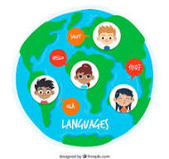
A Week of Celebrating Languages in Portsmouth – Ideas
Daily Theme Ideas:
Monday: Language Welcome Day
- Have older students or multilingual staff greet students at the entrance in different languages.
- Create a “Welcome Wall” with greetings written in the various languages spoken by students.
Tuesday: Cultural Dress Day
- Encourage students to wear traditional clothing representing their cultural heritage.
- Host a fashion show where students explain the significance of their attire.
Wednesday: Global Storytelling
- Invite parents or community members to share traditional stories or folktales in their native languages.
- Organise read-aloud sessions with bilingual books in classrooms.
Thursday: Language Workshops
- Conduct short language lessons where students learn basic phrases from each other's native languages.
- Have students create posters showcasing key phrases or proverbs from different languages.
Friday: International Food Day
- Invite students and their families to bring in dishes from their cultures for a tasting event.
- Ask students to present the recipes and talk about the dishes, including names and main ingredients in their language.

Ongoing Activities:
Language and Culture Showcase Board
- Create a display where students contribute facts, pictures, and stories about their cultural backgrounds.
World Music Breaks
- Play music from different countries during breaks or assemblies throughout the week.
Multilingual Choir or Performance
- Prepare a song or short performance where students sing or speak lines in various languages.
Pen-Pal Exchange
- Pair students within the school to write notes to each other in their first languages, teaching translations to their peers.
Flag and Map Activity
- Display a world map and have students place pins or stickers to represent their country of origin, along with a small flag and fact.
Special Event Ideas:
Cultural Assembly
- Host an assembly where students showcase traditional dances, songs, or other performances.
Language Buddies
- Pair older students with younger ones to teach them simple phrases in a different language.
Art from Around the World
- Have students create artwork inspired by different artists from around the world and hold an exhibition.
International Cinema
- Show short films or clips in different languages (with subtitles) and discuss them.
Daily Language Spotlight
- Each day, highlight a different language with facts, stories, and photos (remember that EMAS have lots of these presentations). We may nominate one of the five most widely spoken languages in Portsmouth for each day of the ‘Celebrating Languages in Portsmouth Week’.

Interactive and Fun Activities:
Recipe Exchange Booklet
- Collect favourite recipes from students’ families to create a school booklet, shared digitally or printed. We are going to do this as a Portsmouth City of Languages project.
Traditional Games Day
- Teach and play games from different cultures, such as Lotería from Mexico or Kabaddi from South Asia.
Language Scavenger Hunt
- Organise a scavenger hunt where students find clues and learn words in different languages.
Cultural Dance Class
- Host a dance workshop introducing steps from popular traditional dances around the world.

And more exciting languages-based events taking place in March, organised by the German Embassy

Shout Out for German 

Put it in your diaries! Next March we're asking you to join us in showing Britain the joys of learning German. Epic school trip to Berlin? First time ordering a beer in Munich? Met a friend for life? Reading a German book?

https://uk.diplo.de/uk-en/germany-and-uk/shout-out-for-geman-2689998

Are you passionate about learning German? In March 2025, the German Embassy in London, together with the Goethe-Institut UKand the German Academic Exchange Service (DAAD), invites you to join our ShoutOutForGerman week-long campaign — a celebration of German language in the United Kingdom.

Whether you’re a student, teacher, or just a fan of the German language, now is your chance to share your enthusiasm: from 17 to 21 March 2025, show us what German means to you by sharing your language-learning highlights.

Tag the German Embassy London and use #ShoutOutForGerman to feature your school activities, favourite German words, travel memories, or even a clip of you dancing to a viral German song.

Whether it’s a quick shout-out to your favourite German teacher, an homage to German traditions or your favourite German TV show – anything goes and will highlight the impact of German in classrooms, on campuses, and beyond.

What: ShoutOutForGerman– A celebration of German language in the UK
When: 17 – 21 March 2025

Visit the link above for more information.
************************************************************************************************
And be inspired by the amazing Festival of Languages in the North East – lots of ideas to take away and events to join in online!

Express Yourself: North East Festival of Languages 2025
is open for registrations

FREE events, activities and resources available from January to March 2025
Back for the 5th year running, our Festival in 2025 is offering even more opportunities to celebrate diverse languages and cultures and the region’s connections to the world.

Inspire children and young people and empower them to discover a world of language, culture and creativity! Designed to spark curiosity and inspire young minds, the Festival is for children and young people (3-18 years) in schools, colleges and community schools and groups across Newcastle, Northumberland, North Tyneside, South Tyneside, Gateshead, Sunderland, and Durham. Schools nationwide can join in with selected events and all webinars. Register now for free activities between January and March and create your own Festival programme.
From January to March, dive into multilingual creative projects and enjoy engaging pre-recorded workshops that can be delivered in schools (with teaching resources provided). In March there is an amazing choice of in person and online live events about world languages and cultures, languages and careers events and resources, on campus experiences for secondary pupils with Newcastle, Northumbria and Durham universities, as well North East and national competitions and language resources.

Participation in any of our registered events automatically qualifies schools for an International School Award (ISA) Foundation Certificate. Festival activities can be used to progress with the ISA and also to support work around Schools of Sanctuary.

There’s something for everyone—all available completely free.
Festival links:
- Click here to see the Festival launch article
- Click here to see the full Festival What’s On programme
- Click here to download the Festival Programme summary
- Click here to see the Festival Programme for KS1-2 (3-11 year-olds)
- Click here to see the Festival Programme for KS3-5 (11-18 year-olds)
- Follow the Festival on social media: instagram | facebook | X
- Sign up on the Festival home page for the newsletter for latest updates
This year we have been supported with funding from the North East Combined Authority. We are also grateful to the many local, regional, national partners and international partners who make the Festival possible, by providing events, activities and resources free of charge. Find out more about our Festival partnership here.

Anthea Bell Prize for Young Translators – 3 Feb to 28 Mar 2025
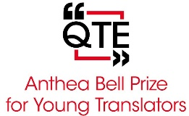

Join in the Anthea Bell Prize for Young Translators and submit entries up to 28th March 2025.
This is a translation competition which aims to promote language learning across UK and inspire creativity in Modern Foreign Languages classroom. It is free to enter and is for students of French, German, Italian, Mandarin, Russian and Spanish in KS3-5. In addition to competition tasks, teachers receive sets of resources for each language on translating poetry, fiction, non-fiction for use in build-up to competition.
Click here to register for the competition and receive resources

We are fortunate to have the Solent Language Hub in Portsmouth, part of the DfE-funded programme, led by the National Consortium for Languages Education.

For secondary colleagues – another super CPD opportunity from NCLE:

Bringing the New GCSE to life: Examples of best practice from NCLE hubs
Date & Time | Jan 15, 2025 04:00 PM London
Webinar ID | 934 9802 1748
Description | Join teachers, German Expert Mentors and curriculum developers from the NCLE hubs programme to explore and enjoy breathing new life into the GCSE. We will be modelling and sharing examples of how to make phonology accessible, how to bring excitement into reading aloud, how to describe pictures and draw on creating while building pupils skills in listening, speaking, reading and writing. We will focus on new areas of content from the specification and will welcome colleagues from the awarding organisations to join a panel of specialist teachers to field your questions.

And more amazing opportunities provided by the Goethe-Institut, one of the partners of NCLE.


Exchange2Change
A Creative Youth Exchange Programme between the UK and Germany
https://www.goethe.de/ins/gb/en/spr/unt/eng/etc.html

“Exchange2Change” is an exchange programme for young people, aged between 14 and 17 during the exchange phase, who live in the UK and Germany. As part of a group, exchangers collaboratively develop a creative project, partly virtual and partly during stays in Berlin and London. Successful applicants will be invited to stay in selected accommodations (usually hotels) during the exchange. The costs of the exchange are fully covered in full by the Friends of the Goethe-Institut United Kingdom and the educational initiative GIMAGINE. Through workshops on project-related topics, the participants gain an insight into artistic professional fields, so that the exchange can also serve as a professional internship.

Students should apply now for Exchange2Change 2025, taking place from 27.04. - 07.05.2025! The application deadline is on 15th January 2025.

Apologies if this update is a little light on Spanish-themed activities and events – will definitely include more in our next update!
And now for more general teaching and languages articles:
Thoughts on Exit Tickets from Harry Fletcher-Wood
An exit ticket is a short task which shows how well all students have understood the lesson’s key ideas. Exit tickets are simple but powerful: designing and using them can help us refine our planning, find out what students have understood and teach more responsively. The first half of this post revisits these critical aspects of exit tickets; the second half shares two new ideas, discussing the exit ticket as an ‘encapsulating task’ for the lesson, and the effect exit tickets can have on student retention.
Exit tickets: encapsulating tasks and retention – Improving Teaching
https://improvingteaching.co.uk/2019/06/16/exit-tickets-responsive-teaching-2019-update-encapsulating-tasks-and-retention/

Another interesting article on the science of language learning:
Bilingual Brains Build Stronger Connections - Neuroscience News
https://neurosciencenews.com/bilingual-brain-connectivity-27833/
Summary: New research demonstrates that learning a second language enhances brain connectivity, particularly when started in childhood. Scientists found that bilingual individuals have more efficient communication between brain regions, notably between the cerebellum and left frontal cortex.

And if there were ever any doubt ….

Why a good night’s sleep is crucial for pupils’ learning
A new study gives schools compelling evidence to present to pupils and parents on the importance of consistent sleep patterns
The impact of sleep on learning: new research for schools | Tes
https://www.tes.com/magazine/analysis/secondary/healthy-sleep-pupils-learning-schools

8 Fascinating Things We Learned about Language in 2024 | Scientific American
https://www.scientificamerican.com/article/8-fascinating-things-we-learned-about-language-in-2024/

Eight, Ocho, Acht Most Fascinating Language Discoveries of 2024
This year scientists found universal language for pain, tracked why some words go extinct, developed mind-reading brain-to-speech technology, and more

The ever-controversial, but also unarguably passionate and dedicated languages champion, Gianfranco Conti posted this recently:

There are ppl with a limited understanding of instructed second language acquisition in secondary schools and of language processing in general who don't grasp the fact that chunking aloud activities such as 'Sentence Stealer', 'Mind reading', 'Lie detector', 'Find your match' and other EPI classics are not merely 'motivational activities'.
They have a clear and manifold pedagogical rationale:
(1) research shows that in order to achieve fluency, students must have developed a willingness to participate in oral activities (Castro, 2019). That's exactly what chunking-aloud games purport to promote;
(2) it also shows phonological short-term memory capacity is an important predictor of vocabulary acquisition patterns in children and adolescents (e.g., Gathercole & Adams, 1993, 1994; Gathercole, Service, Hitch, Adams, & Martin, 1999), and word learning in children and adults (e.g., Gathercole, Hitch, Service, & Martin, 1997). Hence, chunking aloud activities can only be beneficial;
(3) moreover, pronunciation practice can help develop listening comprehension along with word segmentation skills (Darcy, 2018);
(4) phonological encoding and articulation are essential speaking micro-skill (see picture below). Hence, fluency in the execution of the above is key to overal oral fluency;
(5) chunking aloud of highly patterned output, involves repeating specific syntactic structures many times over. These means that word-order mistakes are often prevented when one moves to chunking aloud to oral communicative tasks (e.g. information-gap activities);
(6) based on point (4) above, staging chunking aloud activities before speaking activities obviously decreases the cognitive load;
(7) chunking aloud games are fun, inclusive and totally learner-centred. Inclusiveness is particularly important in mixed-ability settings, where many students feel they are unable to speak and refrain from joining in speaking activities;
(8) last but not least, the new GCSE examination includes a reading-aloud component.

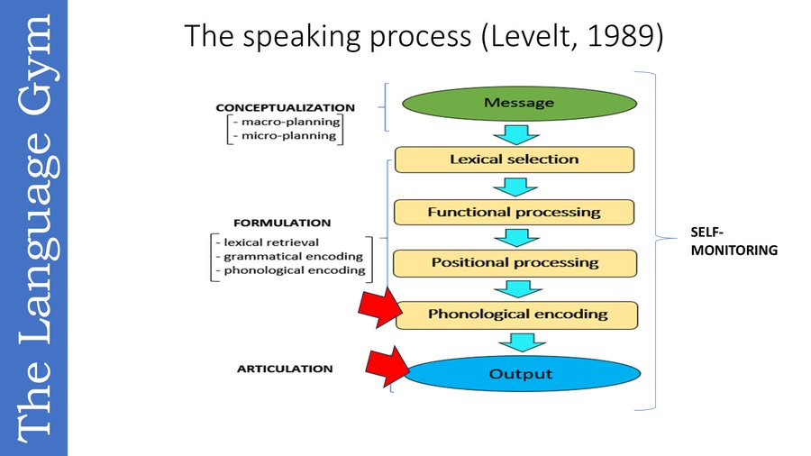

For older language learners

Free resources from the Newcastle University Language Resource Centre
This language learning material is based on task-based learning . There are three links, one for each language for which material is available.
French: https://internationalnewcastle.org.uk/french-teaching-and-language-resources-meet-the-angry-family-conversations-verbs-pronouns
Spanish: https://internationalnewcastle.org.uk/spanish-teaching-and-language-resources-meet-the-angry-family-conversations-verbs-pronouns
German: https://internationalnewcastle.org.uk/german-teaching-and-language-resources-meet-the-angry-family-and-conversations

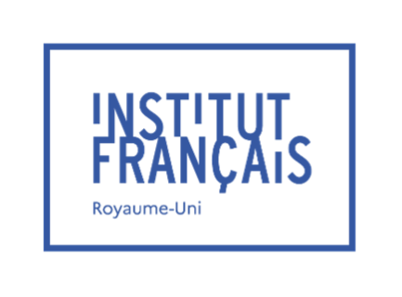
The French Pop Video Competition is looking for its 2025 hit songs!
The Groupe Francophonie UK is pleased to announce the 7th edition of the French Pop Video Competition.
Open to all primary and secondary schools in the UK (England, Scotland, Wales, and Northern Ireland) and the Channel Islands, this competition aims at giving a playful and creative playground for your students (aged 7 to 18) to display their knowledge of French language.
Not only will they be able to improve their writing skills and enrich their vocabulary by creating their own lyrics, but they will also get a chance to practice their speaking skills while shooting the video, and above all create lifelong memories related to their French class... and who knows, maybe they will discover some hidden talents among them!

How can my students participate?
- Register before 16 March 2025 via the online form: https://forms.office.com/e/4ur1EuTjay
- Send us your video before 11 May 2025
- Regional winners will be announced early June, and the grand winners will be announced on 25 June 2025 during an award ceremony at the Institut français du Royaume-Uni in London.
For more information on the competition: https://www.institut-francais.org.uk/french-pop-video-competition/#/
If you have any questions, contact us at: projects-education@institut-francais.org.uk

A fascinating piece of research

The enhancement of creativity through foreign language learning: Do personality traits matter?
Published online by Cambridge University Press: 19 December 2024
https://www.cambridge.org/core/journals/bilingualism-language-and-cognition/article/enhancement-of-creativity-through-foreign-language-learning-do-personality-traits-matter/D86F1DBDB403A389FA9DA7DDBE0855E4

And another one …

Bilingual education enhances creative fluency and flexibility over the first year of primary school
Published online by Cambridge University Press: 13 December 2024
https://www.cambridge.org/core/journals/bilingualism-language-and-cognition/article/bilingual-education-enhances-creative-fluency-and-flexibility-over-the-first-year-of-primary-school/3413FB1EF6E81867A72FF16730AA703B

++++++++++++++++++++++++++++++++++++++++++++++++++++++++++++++++

I loved this little snippet I found recently on Bluesky

 Merriam-Webster @merriam-webster.com‬

Something interesting you might not have realized: a number of words in English are nouns when you stress the first syllable but verbs when you stress the second. "Your CONduct is better when you conDUCT yourself appropriately.”

And from the inimitable Brian Bilston
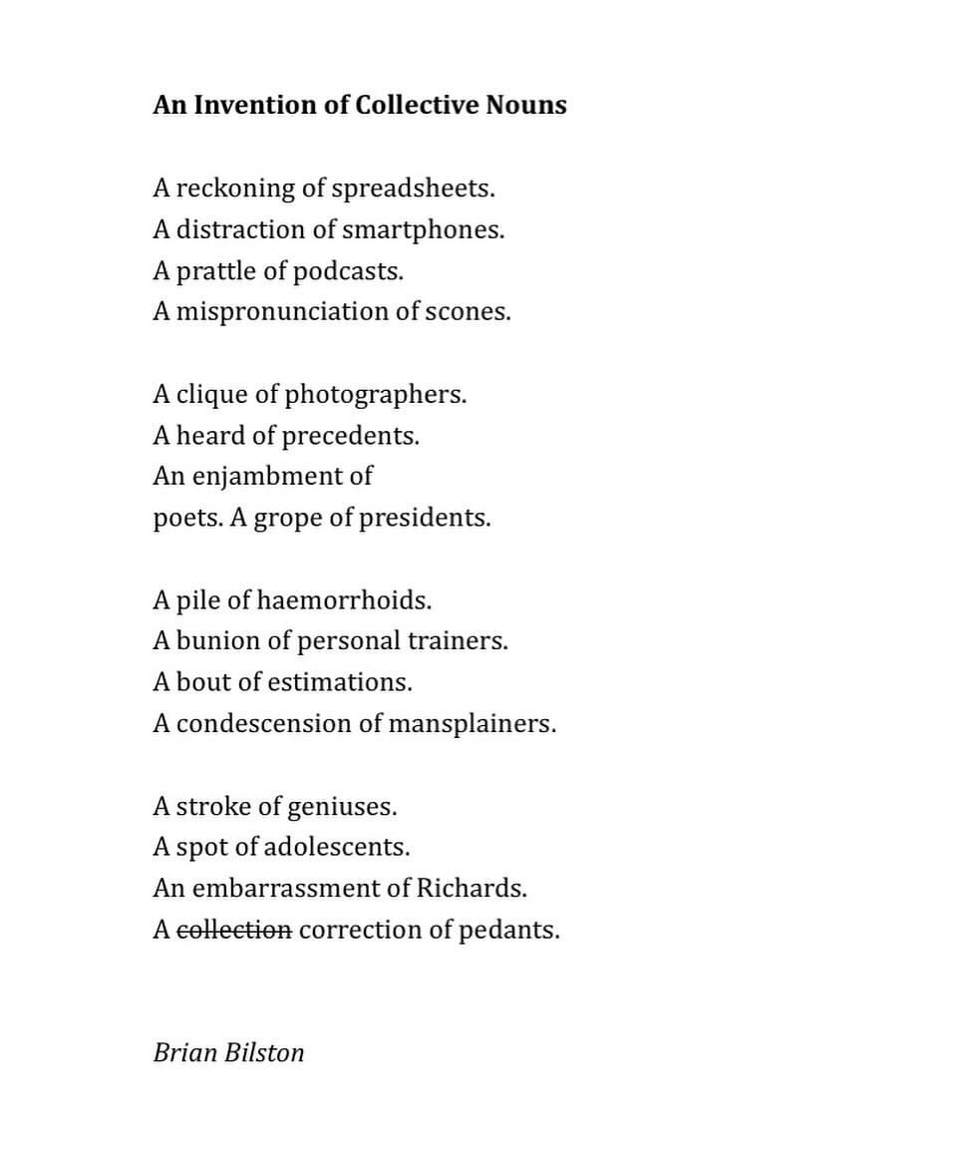
And more fun with language:
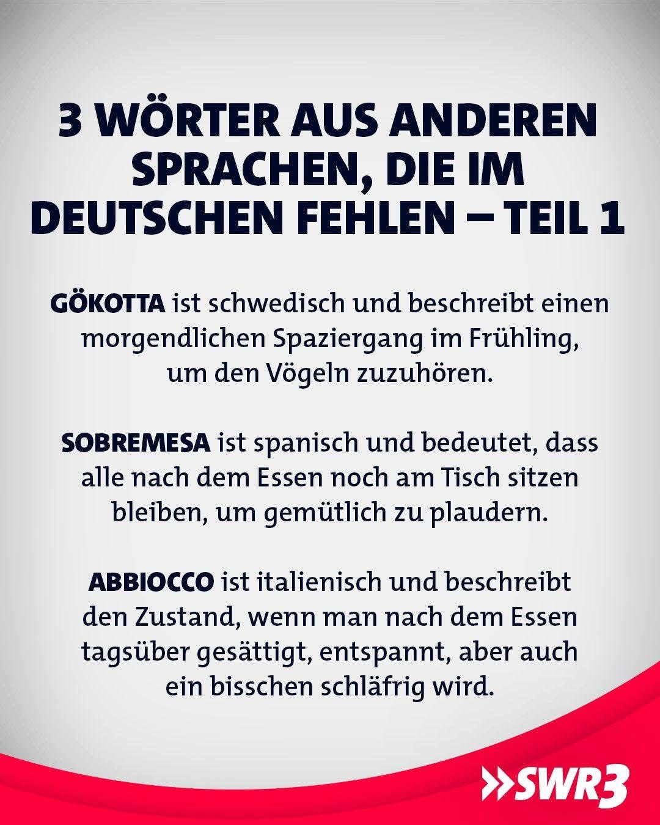
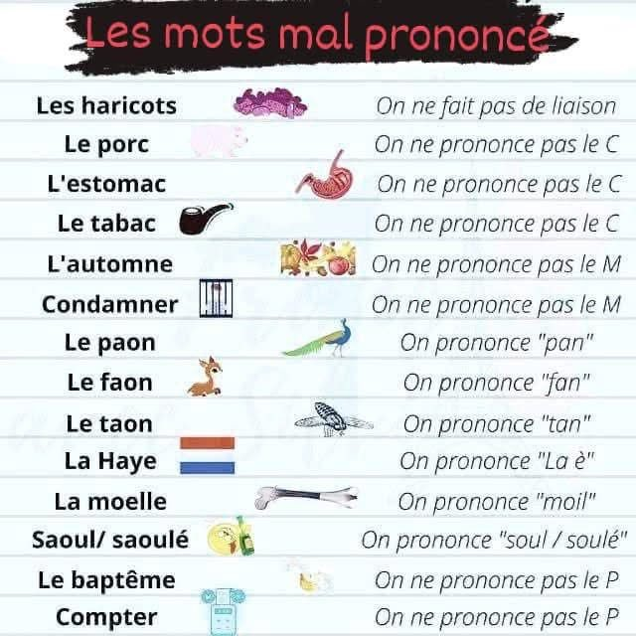



And I totally relate to this !



And some final thoughts as we embark on the adventure
of a New Year ….
