Languages in Portsmouth Winter Update
December 2024
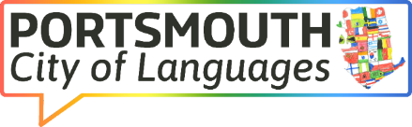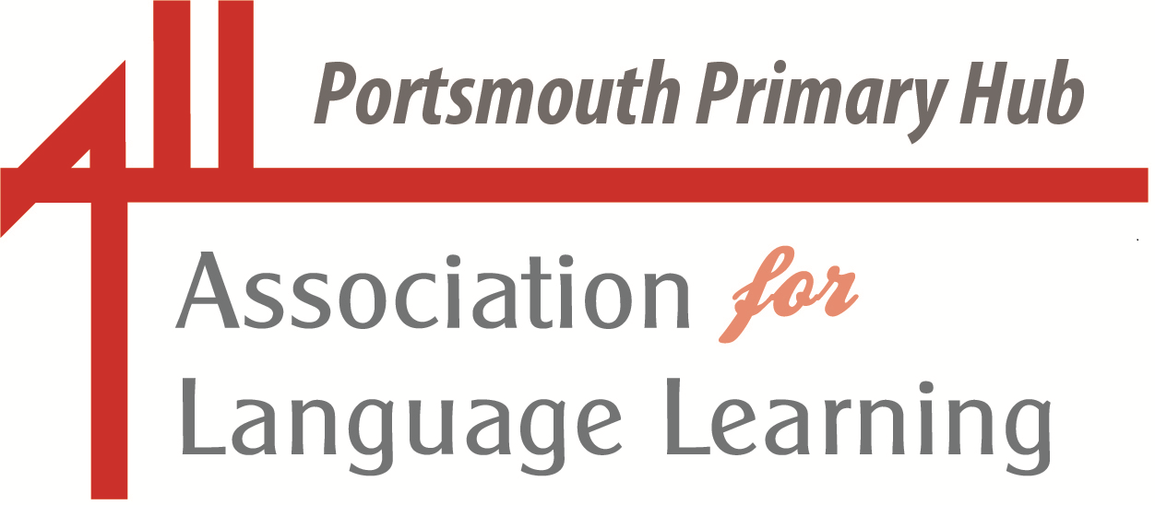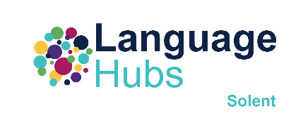
Portsmouth LA Primary Language Leads

Dear Colleagues

Enjoy skimming through the sparkling gems of information and ideas included in this update,

With warmest wishes,

Liz.
(please do get in touch if you have anything to include in future updates – lizlord0502@gmail.com)

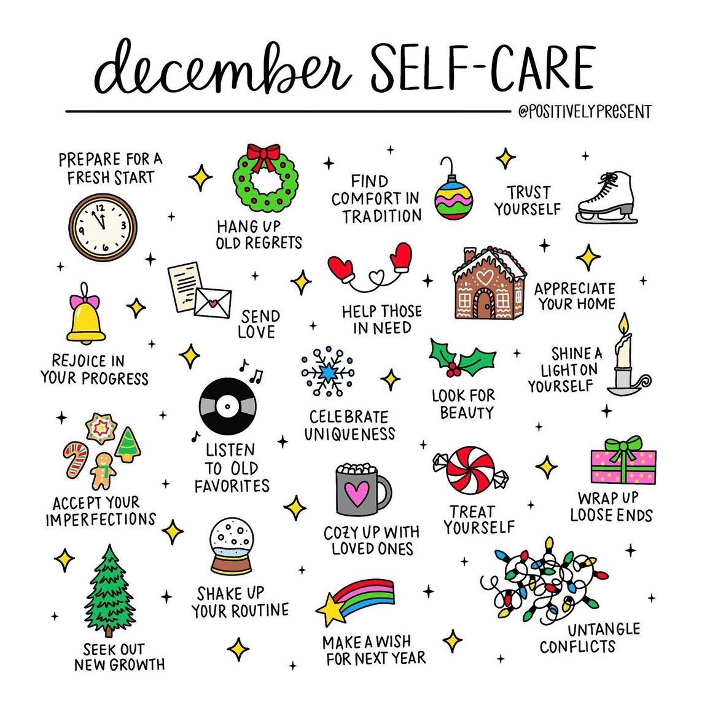
The Big Christmas Language Quiz
Quiz the season to be jolly with the BIG Christmas Language Quiz by Discover the World Education. The quiz is created by former MFL teachers and incorporates topics from the MFL curriculum so that you can tailor the experience to your student's language skills and focus areas. The quiz is perfect for KS3+ and is packed with rounds that include around the world in 10 traditions, films in translation, festive headlines, deck the halls with songs all over and much more.
Access the quiz here.

And what a treat in store to start off the New Year …. The ALL Portsmouth Primary Hub and the Portsmouth Network Language Leads proudly present:
La
Another session for ALL colleagues
– and, as always, it’s ALL free!

Everyone – primary and secondary colleagues – will find something of interest in this session on teaching phonics in language lessons, delivered by the Queen of Physical Phonics,
Sue Cave (my words, not Sue’s!).

Sue will discuss how best to teach and embed phonics in language lessons, with a focus on the following:

- Why teach phonics
- Which sounds to teach
- Which method to use
- Examples of classroom activities
- How to develop confident and independent speakers
- Decoding IPA symbols

The examples will be mainly in French and English but with some reference to German and Spanish.

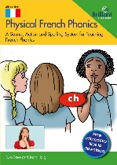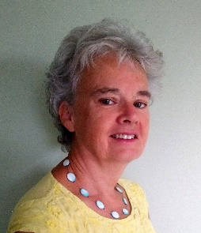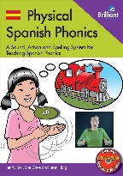

A link to this meeting will be sent out closer to the date. If you would like to register your interest, please contact lizlord0502@gmail.com.



Portsmouth LA Primary Network Language Leads

Sue Cave has more than 35 years’ experience of teaching languages in secondary, adult education, EAL and primary. Currently, she is a consultant and trainer for Cave Languages. Her passion and enthusiasm for the transformative effect of the explicit teaching of phonics is infectious. She is an author of primary languages resource books and co-author of Physical French Phonics and Physical Spanish Phonics.
Note: this session is relevant for both primary and secondary practitioners. Take a quick look at the video in the link below, in which Tracy Williams of the Trent and Tame Language Hub describes how she has used the Physical Phonics Resources in her settings.
https://www.youtube.com/watch?v=3YVHB52epqE&authuser=0
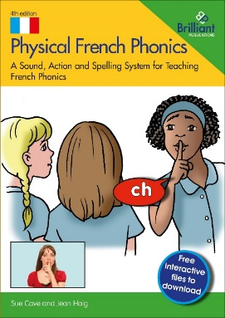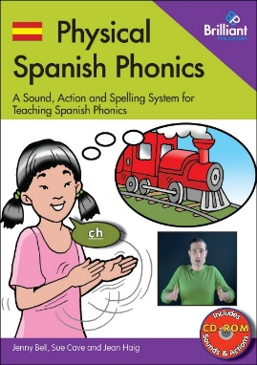
We are so privileged in Portsmouth to have learners who bring an amazing and rich cultural and linguistic heritage to our classrooms. Please do get involved!

ages of the A week of celebrating languages in Portsmouth
17 – 21 March 2025

Celebrating Languages in Portsmouth
We are excited to announce Portsmouth's first-ever Celebrating Languages in Portsmouth week and we would love for as many schools as possible in the city to participate. This special week will take place from Monday 17 March to Friday 21 March, aligning with Portsmouth University's Global Week. It will be a fantastic opportunity to celebrate the wealth of languages and cultures that enrich the lives of so many of our learners.
As this is a pioneering event, we encourage schools and all education settings to participate to the extent they are able. To support schools in getting started, we will distribute a 'menu' of activity ideas in the New Year. Additionally, we plan to establish a shared Google Drive where colleagues can upload and exchange ideas, creating a directory of activities that can be used both this year and in future celebrations.
To spark initial ideas, consider having older students greet pupils in their first language at the start of the day, or try incorporating recipes from around the world with students explaining their significance, names, and ingredients in their own language. For those who wish to take it further, why not host a dedicated celebration day or plan rotating activities throughout the week?
Whatever your level of involvement, we invite all of our education settings to join us in this celebration and to reflect on how it could grow in the coming years to truly honour the vibrant tapestry of languages and backgrounds we are privileged to have in Portsmouth.
More information will follow shortly, outlining details of what we hope will be a wonderful opportunity to recognise and celebrate the richly diverse languages heritage of our learners. Please do get in touch if you would like to be more actively involved or you have exciting ideas to share.
(lizlord0502@gmail.com)

Please find below ideas for how you can celebrate our multilingual champions and do share if you have other ideas too!
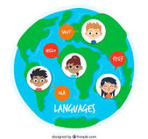
A Week of Celebrating Languages in Portsmouth – Ideas
Daily Theme Ideas:
Monday: Language Welcome Day
- Have older students or multilingual staff greet students at the entrance in different languages.
- Create a “Welcome Wall” with greetings written in the various languages spoken by students.
Tuesday: Cultural Dress Day
- Encourage students to wear traditional clothing representing their cultural heritage.
- Host a fashion show where students explain the significance of their attire.
Wednesday: Global Storytelling
- Invite parents or community members to share traditional stories or folktales in their native languages.
- Organise read-aloud sessions with bilingual books in classrooms.
Thursday: Language Workshops
- Conduct short language lessons where students learn basic phrases from each other's native languages.
- Have students create posters showcasing key phrases or proverbs from different languages.
Friday: International Food Day
- Invite students and their families to bring in dishes from their cultures for a tasting event.
- Ask students to present the recipes and talk about the dishes, including names and main ingredients in their language.

Ongoing Activities:
Language and Culture Showcase Board
- Create a display where students contribute facts, pictures, and stories about their cultural backgrounds.
World Music Breaks
- Play music from different countries during breaks or assemblies throughout the week.
Multilingual Choir or Performance
- Prepare a song or short performance where students sing or speak lines in various languages.

Pen-Pal Exchange
- Pair students within the school to write notes to each other in their first languages, teaching translations to their peers.
Flag and Map Activity
- Display a world map and have students place pins or stickers to represent their country of origin, along with a small flag and fact.

Special Event Ideas:
Cultural Assembly
- Host an assembly where students showcase traditional dances, songs, or other performances.
Language Buddies
- Pair older students with younger ones to teach them simple phrases in a different language.
Art from Around the World
- Have students create artwork inspired by different artists from around the world and hold an exhibition.
International Cinema
- Show short films or clips in different languages (with subtitles) and discuss them.
Daily Language Spotlight
- Each day, highlight a different language with facts, stories, and photos (remember that EMAS have lots of these presentations). We may nominate one of the five most widely spoken languages in Portsmouth for each day of the ‘Celebrating Languages in Portsmouth Week’.

Interactive and Fun Activities:
Recipe Exchange Booklet
- Collect favourite recipes from students’ families to create a school booklet, shared digitally or printed. We are going to do this as a Portsmouth City of Languages project.
Traditional Games Day
- Teach and play games from different cultures, such as Lotería from Mexico or Kabaddi from South Asia.
Language Scavenger Hunt
- Organise a scavenger hunt where students find clues and learn words in different languages.
Cultural Dance Class
- Host a dance workshop introducing steps from popular traditional dances around the world.

And have a look at the amazing Festival of Languages in the North East – lots of ideas to take away and events to join in online!

Express Yourself: North East Festival of Languages 2025 is open for registrations

FREE events, activities and resources available from January to March 2025
Back for the 5th year running, our Festival in 2025 is offering even more opportunities to celebrate diverse languages and cultures and the region’s connections to the world.

Inspire children and young people and empower them to discover a world of language, culture and creativity! Designed to spark curiosity and inspire young minds, the Festival is for children and young people (3-18 years) in schools, colleges and community schools and groups across Newcastle, Northumberland, North Tyneside, South Tyneside, Gateshead, Sunderland, and Durham. Schools nationwide can join in with selected events and all webinars. Register now for free activities between January and March and create your own Festival programme.
From January to March, dive into multilingual creative projects and enjoy engaging pre-recorded workshops that can be delivered in schools (with teaching resources provided). In March there is an amazing choice of in person and online live events about world languages and cultures, languages and careers events and resources, on campus experiences for secondary pupils with Newcastle, Northumbria and Durham universities, as well North East and national competitions and language resources.

Participation in any of our registered events automatically qualifies schools for an International School Award (ISA) Foundation Certificate. Festival activities can be used to progress with the ISA and also to support work around Schools of Sanctuary.

There’s something for everyone—all available completely free.
Festival links:
- Click here to see the Festival launch article
- Click here to see the full Festival What’s On programme
- Click here to download the Festival Programme summary
- Click here to see the Festival Programme for KS1-2 (3-11 year-olds)
- Click here to see the Festival Programme for KS3-5 (11-18 year-olds)
- Follow the Festival on social media: instagram | facebook | X
- Sign up on the Festival home page for the newsletter for latest updates
This year we have been supported with funding from the North East Combined Authority. We are also grateful to the many local, regional, national partners and international partners who make the Festival possible, by providing events, activities and resources free of charge. Find out more about our Festival partnership here.

And to support further our efforts to enthuse our learners and get them to ‘fall in love with languages:

WoLLoW is a fully developed languages curriculum for pupils in pupils aged between 7 and 15. Created by experienced language teachers, and available free to all schools, the project aims to bind together all elements of a pupils’ experience in school and beyond and to prepare pupils not only for future study, but future life.
Our mission is to bring the study of languages, all languages, into the centre of education at a time when our schools have much greater linguistic diversity than ever, and our increasingly diverse society has an urgent need to generate understanding, communication and respect between all people.
https://theworldoflanguages.co.uk/

We are fortunate also to have the Solent Language Hub in Portsmouth, part of the DfE-funded programme, led by the National Consortium for Languages Education. Lots to explore here too:
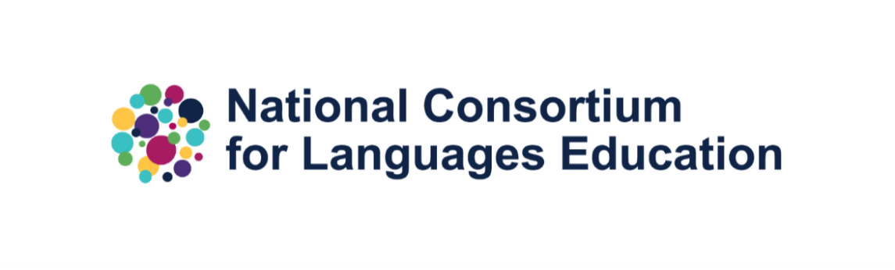
NCLE Language Hubs Conference: Autumn 2024
Earlier this term, NCLE hosted a conference for our Lead Language Hub Schools. It was an opportunity to reflect on the good practice taking place in classrooms across the country, the challenges teachers and leaders face, and to look to the future of languages education. Key themes explored during the conference were:
- Using AI in the languages classroom
- Transition from primary to secondary languages learning
- Strategic leadership
- The new GCSE
We were joined by graphic facilitator, Dr Pen Mendonça who created the beautiful graphic below inspired by the second day of conference activities.
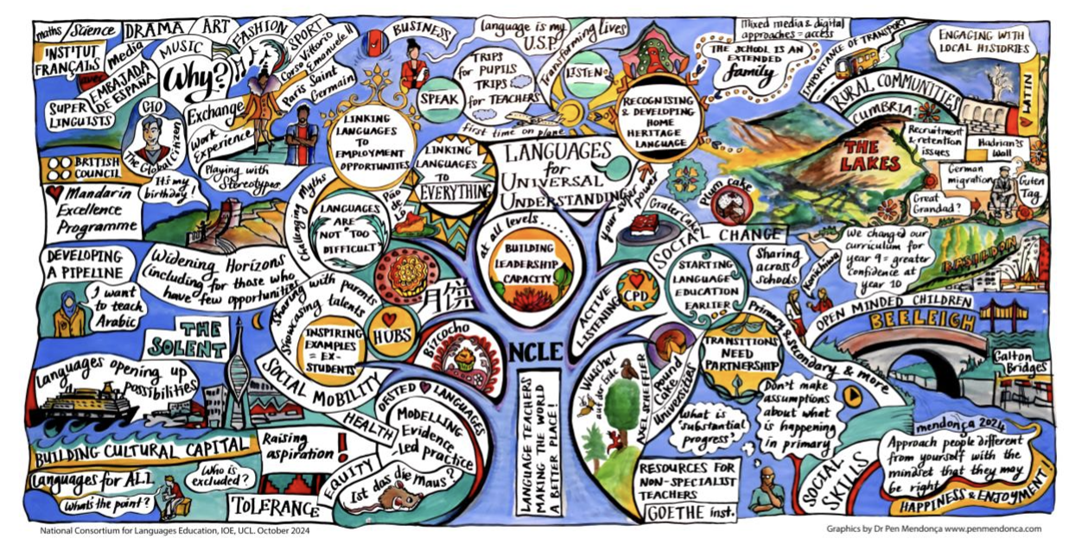

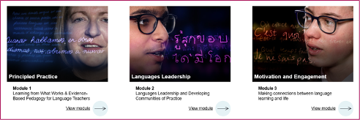

NCLE CPD E-Learning Platform Coming Soon!
This academic year, NCLE are proud to be launching the NCLE CPD E-Learning Platform which will host a range of FREE online CPD modules and resources across 10 different topics. NCLE CPD will include topics such as Principled Practice, Transition and Transfer, Languages Leadership, AI and Technology, and many more.
Take a sneak peek here at all of the themes and ideas you'll have a chance to explore.
Be the first to know when the platform is live through signing up to the NCLE newsletter, as well as on NCLE’s X page.

An inspiring languages teacher who is so generous about sharing ideas and resources, Esmaralda Salgado has written this blog recently:

- MFL Craft @BotonesSalgado
- This Blog is about sharing good practice and my own Teaching and Learning reflections. If you or your school would like personalised CPD, get in touch, via Twitter or The Contact Form in this Blog.
- Teaching & Learning Resources at KS3 based on the NEW 2024 GCSE

mflcraft.blogspot.com/p/new-teaching-learning-resources-at-ks3.html

And more amazing opportunities provided by the Goethe-Institut, one of the partners of NCLE.


Exchange2Change
A Creative Youth Exchange Programme between the UK and Germany
https://www.goethe.de/ins/gb/en/spr/unt/eng/etc.html

“Exchange2Change” is an exchange programme for young people, aged between 14 and 17 during the exchange phase, who live in the UK and Germany. As part of a group, exchangers collaboratively develop a creative project, partly virtual and partly during stays in Berlin and London. Successful applicants will be invited to stay in selected accommodations (usually hotels) during the exchange. The costs of the exchange are fully covered in full by the Friends of the Goethe-Institut United Kingdom and the educational initiative GIMAGINE. Through workshops on project-related topics, the participants gain an insight into artistic professional fields, so that the exchange can also serve as a professional internship.

Students should apply now for Exchange2Change 2025, taking place from 27.04. - 07.05.2025! The application deadline is on 15th January 2025.

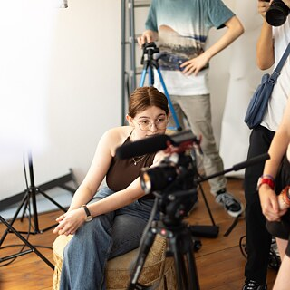

The Conversation - JUST FASCINATING !

“You live a new life for every language you speak. If you know only one language, you live only once.”

― Czech proverb

Your personality changes when you speak another language, but that’s not always a bad thing
Published: December 3, 2024 12.18pm GMT

Authors
- Mari Mar Boillos Pereira
Profesora contratada doctora de la Facultad de Educación de Bilbao, Universidad del País Vasco / Euskal Herriko Unibertsitatea
- Ana Blanco Canales
Profesora Titular de Lengua Española, Universidad de Alcalá

Disclosure statement
Mari Mar Boillos Pereira receives funding from the Spanish Ministry of Science, Innovation and Universities.
Ana Blanco Canales receives funding from the Spanish Ministry of Science, Innovation and Universities.

Languages

Republish our articles for free, online or in print, under Creative Commons licence.
Have you ever wondered whether the language you speak influences the way you see the world? Well, according to a number of studies in psycholinguistics, cognitive psychology and linguistic anthropology, it does. Languages don’t just allow us to communicate – they also shape our perception of what surrounds us, and ourselves.
Over half of the world’s population uses two or more languages in their day to day lives. Whether this is because of education, immigration or family, being bilingual or multilingual is increasingly common in our globalised society.
So how does knowing two or more languages affect the way we process emotion? Recent research suggests that each language can make its speakers perceive reality in a different way, and people can even notice a change in themselves as they switch from one language to another.
Other studies have shown that bilingual people may behave differently depending on the language they use. The people talking to them also perceive them differently depending on which language they are speaking.
Read more: How can a baby learn two languages at the same time?

Emotions in different languages
If you speak multiple languages, you process words that define or describe emotion differently depending on whether you use your mother tongue (which you learn in childhood and predominates your thought and speech) and your second language (which has been learned, either formally or organically).
The mother tongue tends to have an emotional edge over the second language – bilingual or multilingual people feel greater emotional intensity when speaking theirs, especially when recalling experiences they had in this language.
Some studies have shown that people describe childhood memories more vividly if they speak in their mother tongue, since this is the language in which they label and remember these experiences. The second language, in contrast, offers a degree of emotional distance, allowing the speaker to feel less anxiety or shame when talking in complex situations, like when they need to express anger or apologise.
In other words, the mother tongue is perceived as a more emotionally rich language, while the second language is less expressive, but more practical. This means that emotional expression in the mother tongue is felt more intensely, regardless of whether the emotion is positive or negative.
Read more: Our emotions and identity can affect how we use grammar

Different language, different personality?
The choice of language in which bilingual people communicate affects not only emotional intensity, but also the way they perceive themselves and others. Using one language or another can influence the construction of discourse, and reveal cultural and social aspects that are specific to the language communities to which they belong.
In one study on bilingual Chinese and English speakers in the US, participants stated that they felt more comfortable expressing their emotions in English (their second language) because it had fewer social restrictions, but they experienced greater emotional intensity in Mandarin (their mother tongue).
The second language may therefore offer some advantages when speakers want to keep an emotional distance, both for personal and socio-cultural reasons. By expressing emotions in a less emotionally connected language, people can reduce feelings of embarrassment, anxiety or personal involvement. This is especially true if a person’s mother tongue belongs to a culture that places greater value on the collective, meaning people are less prone to sharing feelings.

Language proficiency and environment
The level of proficiency in a second language also plays a huge role. Parents prefer their mother tongue for expressing emotions when talking to their children – for example, for telling them off – if this is the language they know best. However, if they are proficient in a second language, they may also use it to express emotions.
The environment where the second language was learned can also be important. In cases where a language was learned in a formal or academic context, as opposed to a more organic one, speakers report more anxiety when communicating in public, even if they are technically proficient.

Emotion, identity and language learning
Our life experiences, age of language acquisition and context of use influence how we process and express our emotions in different languages. Understanding these dynamics not only enriches our knowledge of language and the human mind, but also helps us to improve intercultural communication and emotional understanding in an increasingly diverse and connected world.
The implications for second language teaching are also significant. Making sure that learners feel happy and satisfied with their perception of themselves in the language they are learning – i.e. with the identity constructed in that language – is key to helping them feel comfortable when speaking. Teachers can play a role in helping learners feel less alien in the language they are learning.
A learner’s attitude towards the language being learned is decisive. It influences how we evaluate our experiences with the language, which in turn impacts how we face challenges, how we perceive ourselves, and how we think others see us. The better this attitude, the greater the satisfaction in the process, and the better the emotional connection to the language. The result will be a stronger identity in the new language, which translates into deeper and more effective learning.

And to continue the theme (think I may have shared this before):
Business communication (Harvard Business School)

How to Get Better at Reading People from Different Cultures
Body language varies from culture to culture, but micro-expressions—very brief flashes of emotion across the face—are universal. So the ability to read them can be an effective took for navigating cross-cultural situations. If you study the common ones, look for them in your counterparts, and effectively interpret them, you have a better chance of avoiding misunderstandings and building bridges with people from different parts of the world.
https://hbr.org/2018/09/how-to-get-better-at-reading-people-from-different-cultures

And a bit of languages fun!

How Do Animals Sound In Different Languages?

After Norwegian comedy singer duo Ylvis ignited the world’s interest in sounds that animals make with “What Does The Fox Say?,” other artists have begun exploring these questions more in-depth. English artist James Chapman has created a series of comics comparing how different languages around the world write down the sounds animals make.
The panels are a delight to see, with bright colours and cute animals. The comparisons between languages are also interesting, no matter what your native language is. Depending on what language you speak, some of these can seem pretty wacky. As an English speaker, the Dutch horse sounds pretty funny to me (Vrinsk?), but I also admit that, with a lame showing like “oink,” we can use some work on our verbs for animal sounds. Mice, cats, and bees, however, seem to have inspired international consensus on the sounds they make.
Chapman is a PhD physics student and illustrator from Manchester who runs a great Tumblr featuring more of his illustrations, as well as one just for animal sounds.
Scroll down to see what farm animals sound like in different languages below!
Source: chapmangamo.tumblr.com

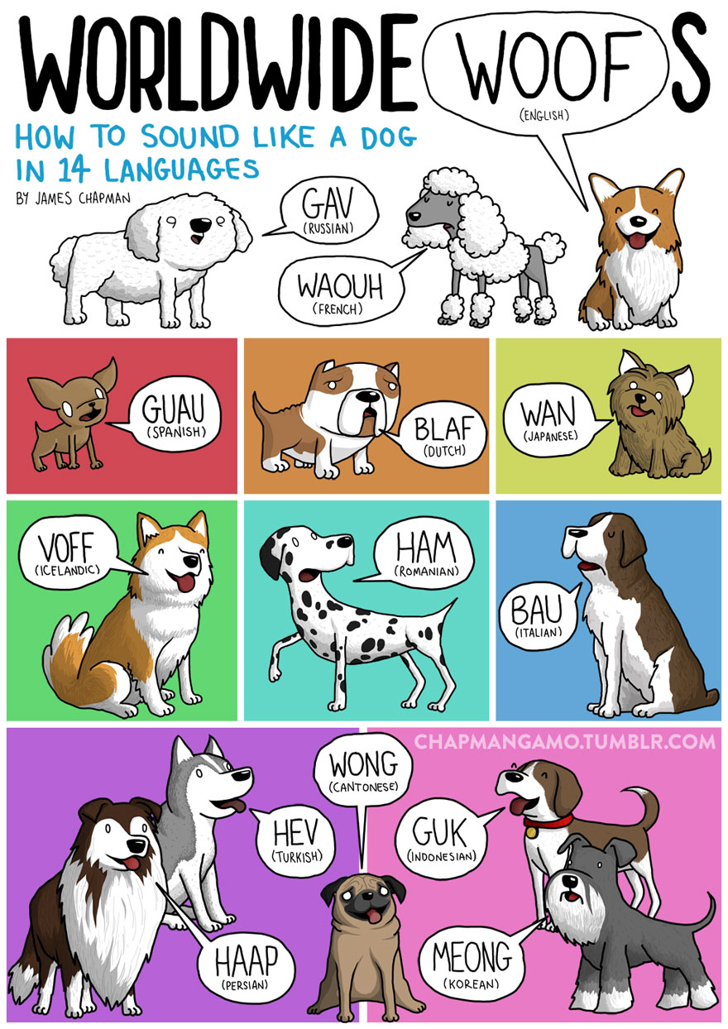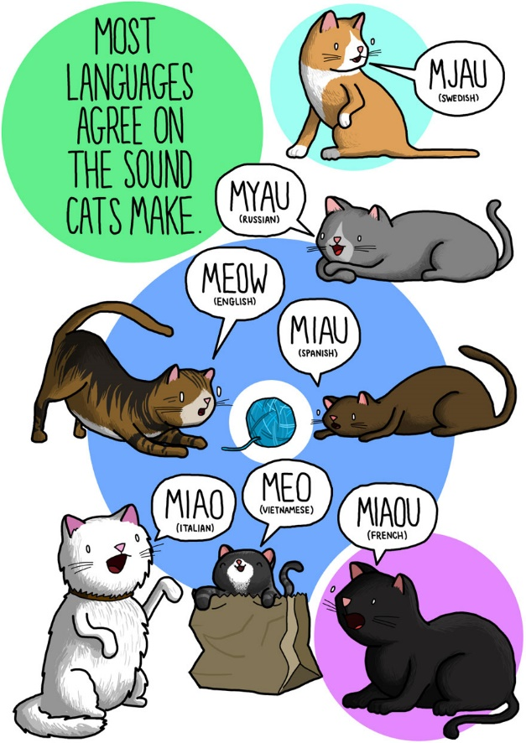

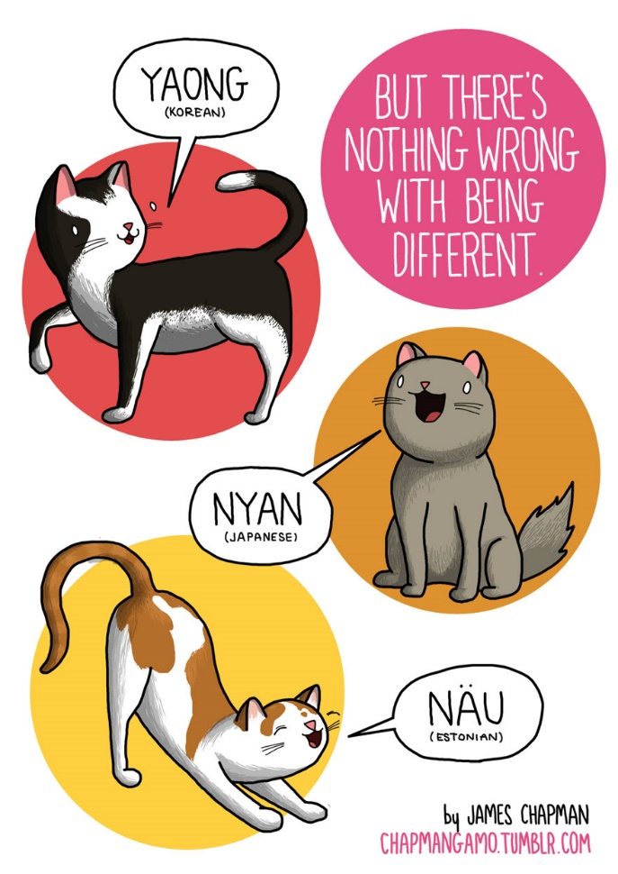

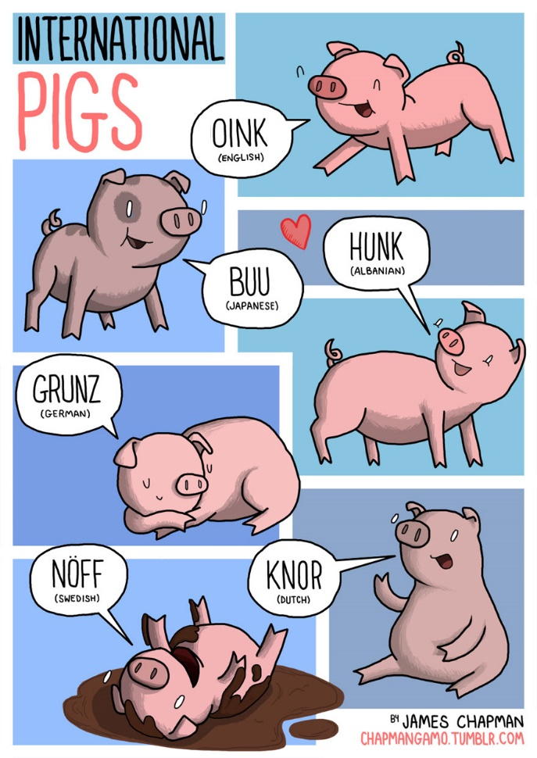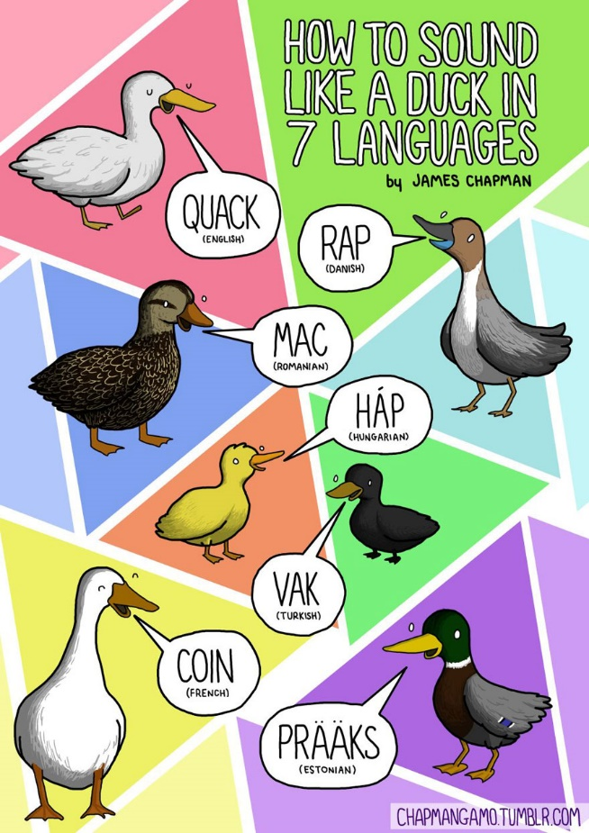
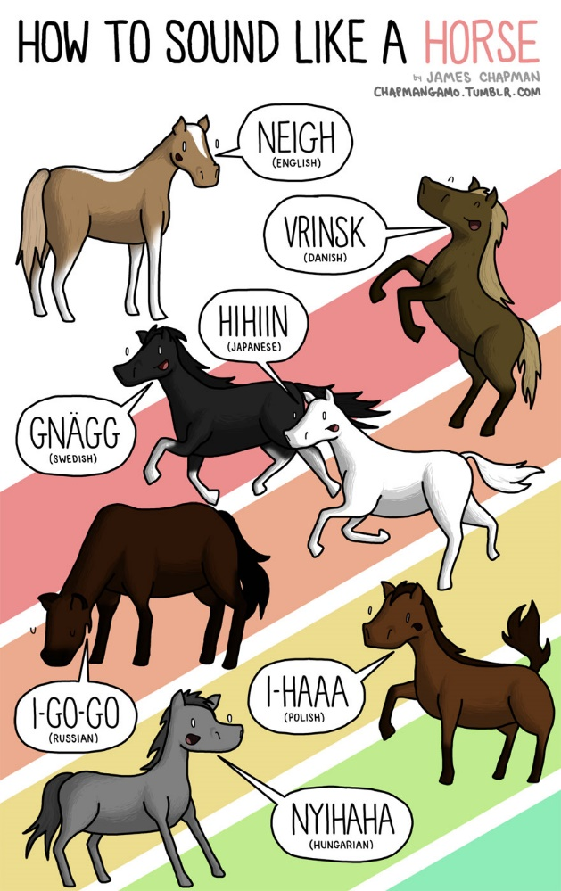

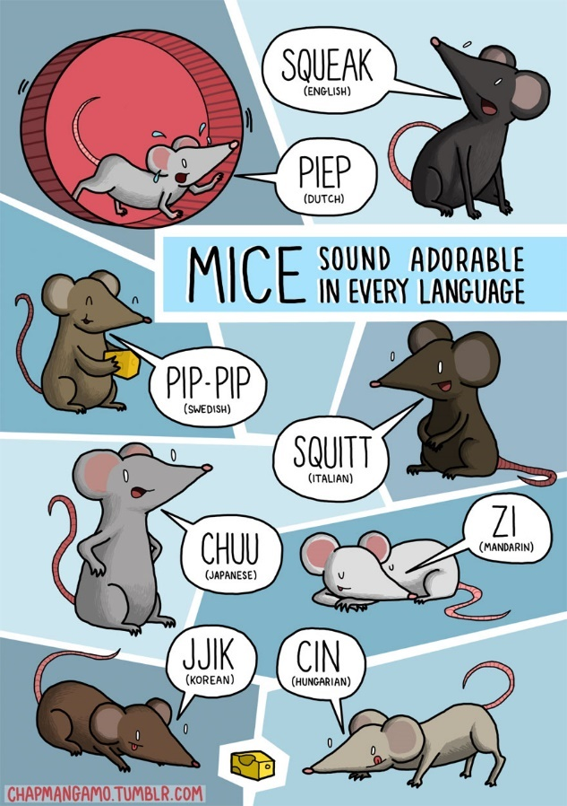
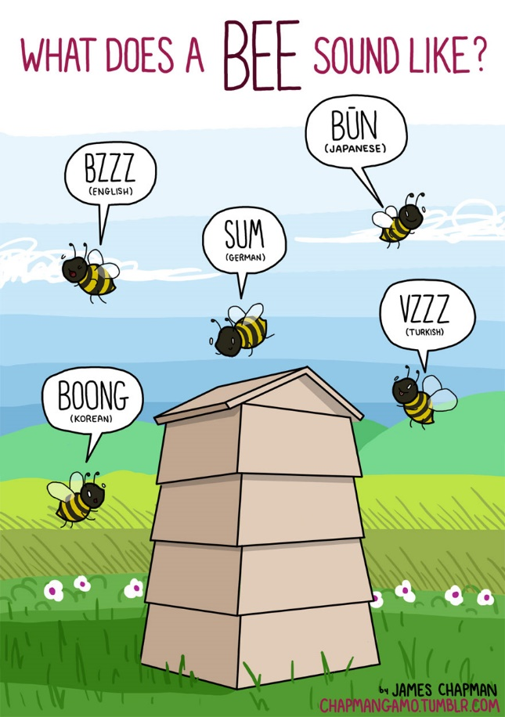
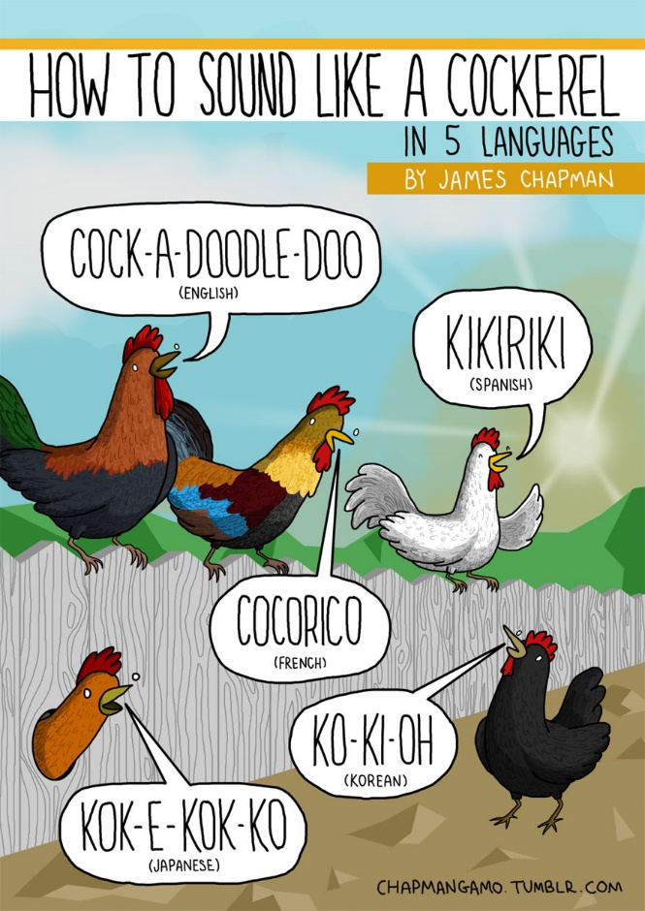
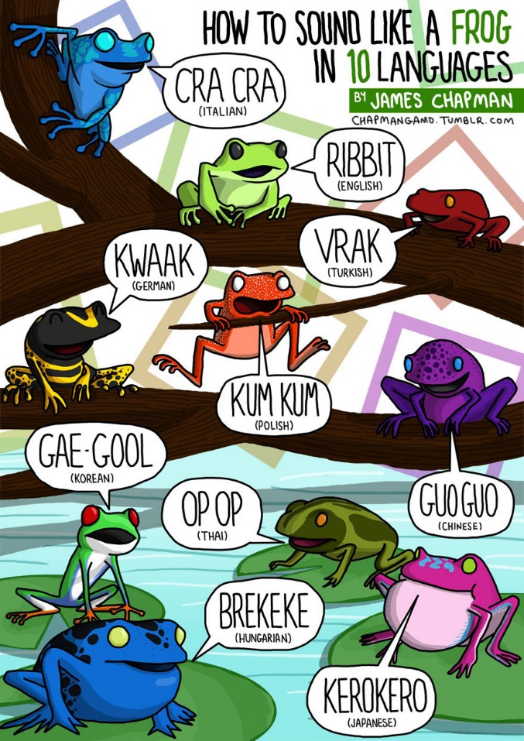
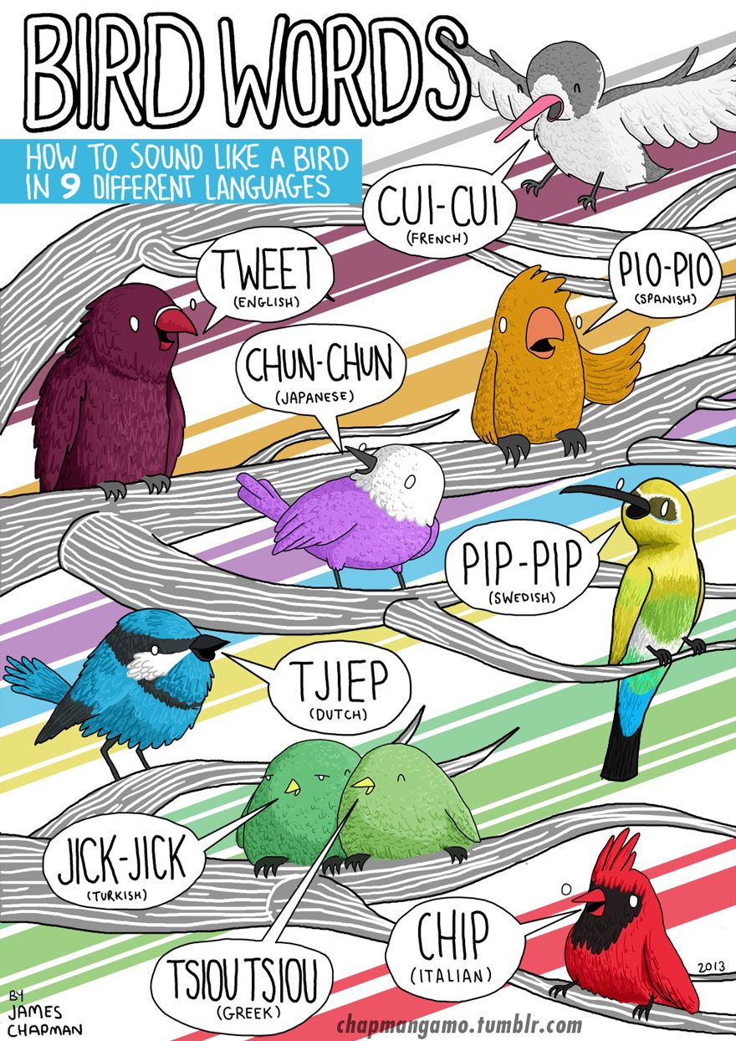

The Power of Music and Song

I have often shared how much I have enjoyed using song and music in language lessons, with different foci, eg:

- to help embed vocabulary in long-term memory;
- to improve pronunciation and strengthen the phoneme -grapheme link;
- to introduce a cultural link;
- to motivate and engage learners;
- to create an ‘Ohrwurm’ (ear worm - isn’t German wonderful?)

Here are some links that I am going to investigate over the holidays:

11 Songs to help you Learn French | How to use Music to Improve Fluency
https://www.youtube.com/watch?v=R7yxrfGyw0M

Learn French with songs Indila - Dernière Danse [French Pronunciation Guide]
https://www.youtube.com/watch?v=g10V76ZoSYQ

Stromae- Papaoutai (French & English Lyrics)
https://www.youtube.com/watch?v=LhddrZJ98SI&list=PLWC3jTo5VQfCXN81Xr-J38E_wiupPzwCt&index=18

Learn Spanish with Songs Lyrics (10 Great Songs to Improve Spanish)
https://www.youtube.com/watch?v=zUcdCnQ8Tjs

Learn Basic Spanish: 10 Easy Spanish Songs With Lyrics || English | Spanish
https://www.youtube.com/watch?v=1qG5VU-vl_c

Kevin, Karla y la Banda

Perfect (spanish version) - Kevin & Karla
https://www.youtube.com/watch?v=jb0K64SGsfc

Learn Basic German: 10 Easy German Songs With Lyrics || English | German
https://www.youtube.com/watch?v=Z2R1qMFKBgI

Disney's Frozen - Let it go (German S&T)

https://www.youtube.com/watch?v=cvZB5cNvQlk&list=PL-I_8mv1Xbz9TqFDyWhV_PUYNzCMYElOo

https://www.youtube.com/watch?v=dEnpjaR5V0c&list=PL0GDt0M9xnmLWNENsApSTwVr3vdDi_qwn

You've Got A Friend in Me (German) - Subs and Translation

https://www.youtube.com/watch?v=R0cRANzCkII&list=PL0GDt0M9xnmLWNENsApSTwVr3vdDi_qwn&index=2

And literally an ‘Ohrwurm’ from the German group ‘The Wise Guys’:



https://www.youtube.com/watch?v=V9sDoZu8VWg

Lyricstraining.com
Lyricstraining.com is a website that tries to help you learn a language through music. It’s free to sign up and you can sign up with your Facebook account if you have one. Once you’re signed up you can learn several languages through the website, not just English. Most of the language are European languages though you can also learn Japanese.

LyricsTraining | Learning languages with music
https://www.youtube.com/watch?v=BjsG7LeAXVU

Finally, for this update, the re-opening ceremony of Notre Dame Cathedral in Paris was just amazing.
And the highlight for me was Vianney translating and singing a song by my favourite artist of all time, Leonard Cohen.
Vianney sings a "Hallelujah" specially translated into French for the reopening of #NotreDameDeParis!

Réouverture de Notre-Dame de Paris : Vianney chante un magnifique "Hallelujah" tout en français

https://www.youtube.com/watch?v=FltFV-vdPK0

And the message projected on to the famous cathedral is for you too - A huge. huge thank you for all you do
to keep languages alive and thriving

Merci, Vielen Dank y Gracias,
