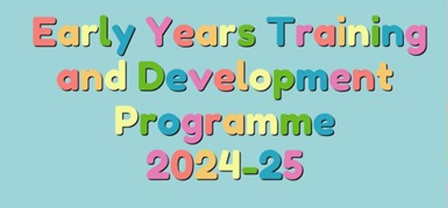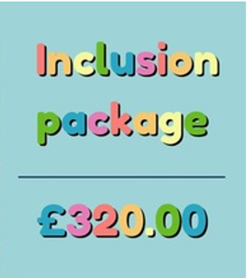
A tailored package with more onsite support and a focus on inclusion for your setting. When purchasing this package you will have access to:
One of our introduction to SEND 2 hour virtual workshops in Spring or Summer 2025.
3 x Practical SEN strategies workshops delivered face-to-face with the Portage team at Civic Offices (sensory needs parts 1 and 2, attention and interaction skills and visual support systems).
Plus...
A SEN staff meeting in your setting - please contact us by email at eyworkforce@portsmouthcc.gov.uk to book your meeting, including any dates and times that you have in mind.
For full details please visit the Portsmouth Traded Services website Portsmouth Traded Services for Schools or email us:
EY Package and training queries: eyworkforce@portsmouthcc.gov.uk
EY Inclusion queries: eyinclusion@portsmouthcc.gov.uk

