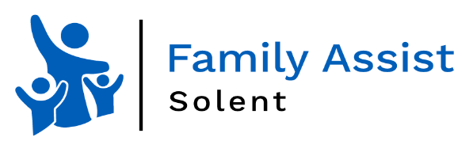

Portsmouth Neurodiversity Team advice clinics

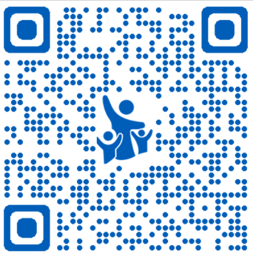

**The Neurodiversity Team have regular advice clinics at your local Family Hub.**

**Buckland Family Hub**

1st Monday of every month 1.00pm-3.00pm

**Northern Parade Family Hub**

1st Tuesday of every month 1.00pm-3.00pm

**Milton Park Family Hub**

1st Tuesday of every month 1.30pm-3.30pm

**Scan the QR Code to access the Family Assist Portsmouth Neurodiversity Page.**

**https://bit.ly/3uzMprL**

**Please contact the team on 02392 606051 or email** [**Neurodiversity0-19Enquiries@portsmouthcc.gov.uk**](mailto:Neurodiversity0-19Enquiries@portsmouthcc.gov.uk) **to book an appointment**

**We look forward to seeing you.**

*The Neurodiversity Team.*