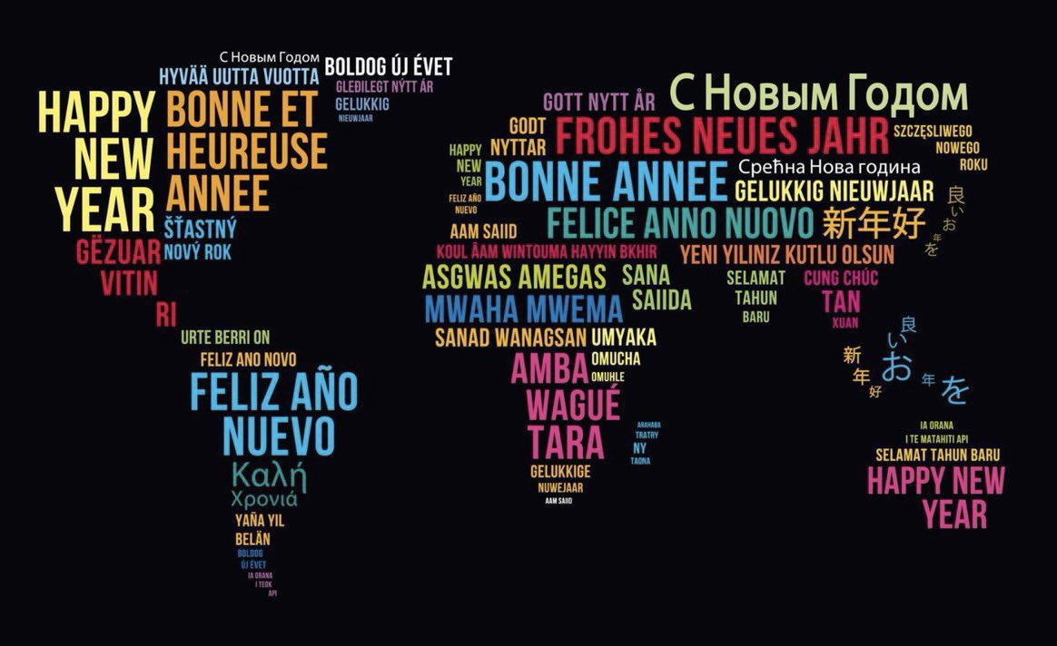

An Update for Portsmouth Primary Languages
January 2024

Dear colleagues
I hope this update finds you rested and ready to enjoy a happy, healthy and successful year ahead.

This update is a bit of pic’n’mix, with news about upcoming events and references to interesting languages articles. And as always, please do get in touch if you have some teaching resources or language learning gems that you would be happy to share with our network of lovely colleagues.

With warmest wishes in a wintry and chilly January, Liz.

ALL Primary Hub Meetings in 2024
Our first Hub meeting of 2024 will take place at Cottage Grove Primary School, Southsea, on Thursday 7 March 2024 at 1600. Once again we will welcome Tanya Riordan, MFL PGCE course leader at the University of Portsmouth.

Tanya will deliver a session on CLIL (Content Language Integrated Learning), in which she will share with us how art can be taught through the medium of another language, in this case French.

This should be of interest to all colleagues, whether teachers of French or Spanish (or German). Please do put this date in your diary and be prepared to work on creating mini-masterpieces!

A summer meeting of the Hub has yet to be scheduled, and the theme of the meeting yet to be decided. If you have any preferences, or ideas, about dates and topics, please do get in touch.

And I know that the Christmas decorations have been put away for another year, but I did enjoy asking friends and family for their choice of ‘artistic’ Christmas tree!

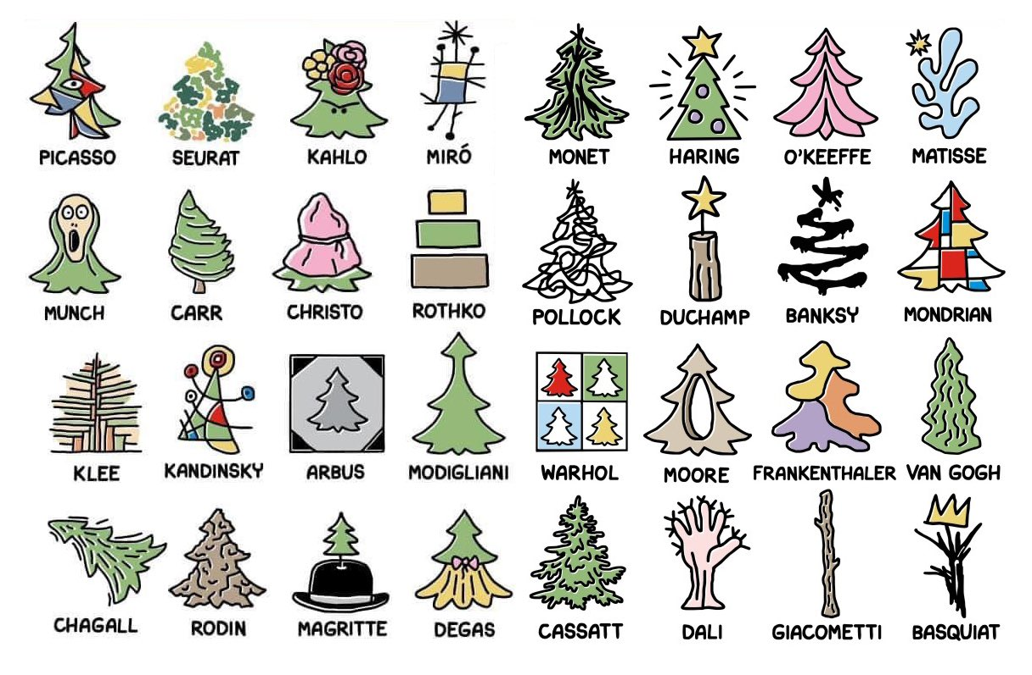

ALL Primary Calligram celebration – in early 2024

The ALL Primary Special Interest Group (SIG) invites you to get your class to be creative with the language they are learning!

Each school that enters will receive an ALL certificate, and there are plans to compile a digital collection of some of the most striking calligrams!

Just over a hundred years ago, at the end of the First World War, the French poet Guillaume Appollinaire published a set of poems called Calligrammes in which he used ink and fonts to draw recognisable shapes with connected words. You can locate examples by searching for ‘Calligrammes’ online.

ALL are now inviting Primary children to make their own calligrams, using words and/or phrases they have learnt in any language other than English. The words might draw the outline of the image, or fill in the silhouette of the image. The key things are that they should be related to the image, they should be easy to read (neat and not over-elaborate), and they should be spelled correctly. They can be created by hand or with a computer.

To submit an entry form, please click here. Forms are to be returned as attachment to caligram24@gmail.com, with max. 3 entries in each age category per school.
To learn more, have a look at the separate attachment.

Language World 2024
ALL’s flagship annual conference will take place on Friday 8 and Saturday 9 March at the Chesford Grange Hotel in Kenilworth.
Do put this event in your diary. It’s always packed with inspirational presentations and speakers from across the languages sector, primary and secondary and beyond. And it’s a great way to get together and learn with language teachers from around the UK, and around the world.
Please click here to visit the Language World 2024 website.

The theme for this year’s conference is Languages – a unique ingredient of learning. Many aspects of education today in multilingual Britain will be considered:
- What is unique about our subject?
- In what ways does the learning of a language support learners today beyond the classroom?
- What are the ingredients of a healthy language learning experience?

Lots of food for thought, indeed.

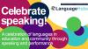

Celebrate Speaking with NCLE, the British Council and ALL

Why not consider giving your language learners an opportunity to show off their prowess in speaking another language by taking part in the Celebrate Speaking event?

https://www.britishcouncil.org/school-resources/languages/celebrate-speaking

There’s a great skill to speaking a modern foreign language confidently and coherently. It’s an important part of the MFL curriculum across the United Kingdom and a significant part of linguistic and cultural development for all learners of languages.
It’s also great fun to get your tongue around those different words like Kühlschrank, chatouillement or felicidad!
Join in during February for this festival of language when students can show off their language skills. This can be a language they are learning at school or one they speak in their community. It’s about sharing a love of language and celebrating the diversity of people in the UK who speak a language other than English.
The festival is managed by the British Council on behalf of the National Consortium for Languages Education (NCLE) and is open to all schools.
How do you join the festival?
Practise and celebrate a language your students are learning or use in their community, and take part in a virtual festival of speaking!
It’s easy to take part, simply:
- Ask your student(s) to prepare a short poem, presentation, sketch or dialogue in their favourite language. This can be a solo or joint performance but should be no longer than 90 seconds in total.
- Record them delivering the performance. It is suggested that under-16s use PowerPoint slides, Bitmoji, images or video, rather than showing their faces.
- Upload the performance to your own or your school’s Twitter (or X) account with the hashtags #CelebrateSpeaking and the language chosen (e.g. #Polish).
Remember to use the hashtag so that the performances can be found!
Get inspiration from some entries from last year by watching the short introduction video or watch a recording of the full event from 2022 and 2023.
Live celebration event
Language partners (including Association of Language Learning (ALL), Goethe Institut, Alliance Française, Confucius Institute and the Spanish Education Department), will select a favourite performance who will be invited to attend a live virtual celebration event in late March 2024, hosted by the British Council with a VIP guest. It would be great to have the selected students perform live at this event but you may choose to do a recording of their performance to be played to the attendees.
Get inspiration from some entries from last year by watching our short introduction video or watch a recording of the full event from 2022 and 2023.

A reminder about the Language Trends Survey
Language Trends is an annual survey of primary and secondary schools in England, designed to gather information about the situation for language teaching and learning. Its aims are: (i) to assess the impact of policy measures in relation to languages; and (ii) to analyse strengths and weaknesses based both on quantitative evidence and on views expressed by teachers. Previous reports can be found on the British Council website. The Language Trends series shows general shifts in data and seeks to provide a springboard for teachers, school leaders, academics, inspectors, policy makers, school pupils and the public to consider aspects of language learning more deeply.
Calls to complete this year’s survey should be arriving shortly in schools (usually to Headteachers).

Why not bring the language into the classroom and welcome a Language Assistant?
Have you thought about having a British Council Language Assistant working alongside you in the classroom? Maybe you could share with another school and cut the cost? Find out more by visiting the website below:
https://www.britishcouncil.org/school-resources/employ-language-assistant
Applications for the 2024-25 academic year open on 29 February 2024 and close on 30 April 2024.

Primary French Teachers Training Day
There’s still time to register for the next Primary French Teachers’ Training Day.
Recording & showcasing progression in KS2 French
Saturday 20 January 2024 / 9h00 - 13h00
Using the free French teaching materials from the Institut français, the session will focus on offering support and advice to Language Coordinators or other practitioners who teach, or would like to start teaching French in key stage 2.
Participants will be offered to explore how to demonstrate progress in French in KS2. The focus will be put on how to make the learning explicit to children and class teachers. Participants will learn methods for the teaching of vocabulary and grammar, the development of listening, speaking, reading, and writing skills, and the use of speaking and writing frames.
The Primary French Project
The Primary French Project materials offer a complete set of teaching resources for use in key stage 2; they contain easy-to-follow lesson plans, printable materials and PowerPoint presentations with all necessary visuals and integrated sound recordings by native speakers. The resources are especially supportive of teachers who speak little or no French, as they aim to develop the subject knowledge of the teacher as the subject is being taught to the children.
Saturday 20th January 2024
9h00 - 13h00
Institut français du Royaume-Uni
17 Queensberry Place, SW7 2DT, London

To register or learn more, visit https://t.co/ztg9aOqrQf

And grants are available for colleagues hoping to brush up their Spanish in the summer at the University of Salamanca.

Verano 2024: formación para profesores de español
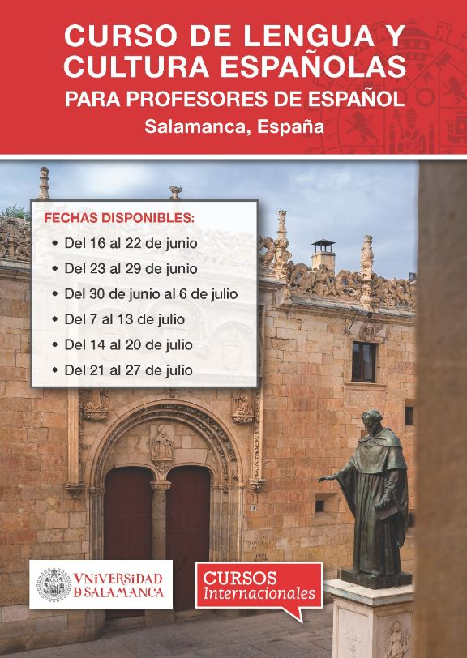Enlace externo, se abre en ventana nueva
La Universidad de Salamanca, sus Cursos Internacionales y la Junta de Castilla y León ofrecen becas para profesores de español en activo fuera de España para realizar un curso de lengua y cultura españolas y de actualización didáctica de una semana de duración en Salamanca.

Fechas ofertadas:
- Del 16 al 22 de junio
- Del 23 al 29 de junio
- Del 30 de junio al 6 de julio
- ​Del 7 a 13 de julio
- Del 14 al 20 de julio
- Del 21 al 27 de julio
La matriculación estará abierta hasta agotar el número de becas disponibles.
For more information, write to / Para más información, escribir a profesoresele@usal.es

Some interesting language-related articles that have appeared recently:

Do subtitled films really help you learn languages?
Published: December 20, 2023 10.11am GMT

https://theconversation.com/do-subtitled-films-really-help-you-learn-languages-216610?utm_source=twitter&utm_medium=bylinetwitterbutton

English still rules the world, but that’s not necessarily OK. Is it time to curb its power?
Michele Gazzola

https://www.theguardian.com/commentisfree/2023/dec/27/english-world-power-language-linguistic-justice

Majority of adults support compulsory language learning in schools
The YouGov poll of more than 2,000 UK adults suggests most agree that studying a modern language should be compulsory in primary school (64%) and in secondary school (71%).
https://www.independent.co.uk/news/uk/people-languages-british-yougov-geoff-barton-b2431453.html

And enjoy this selection of language-themed pics I have found on Twitter (X) and the Facebook Languages groups.

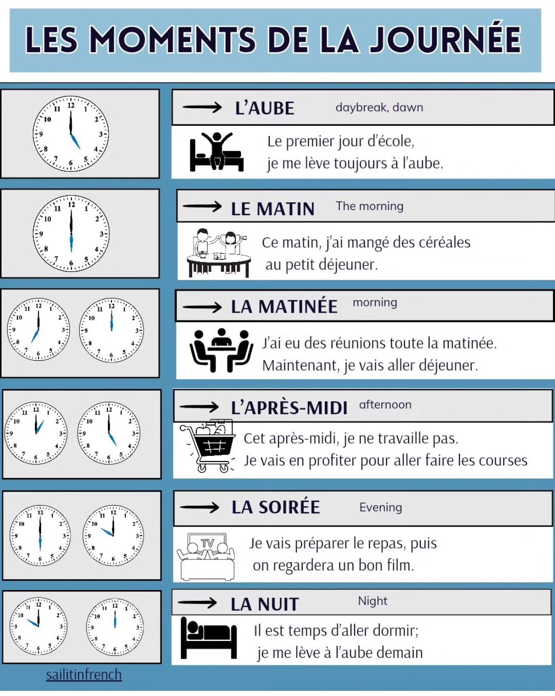

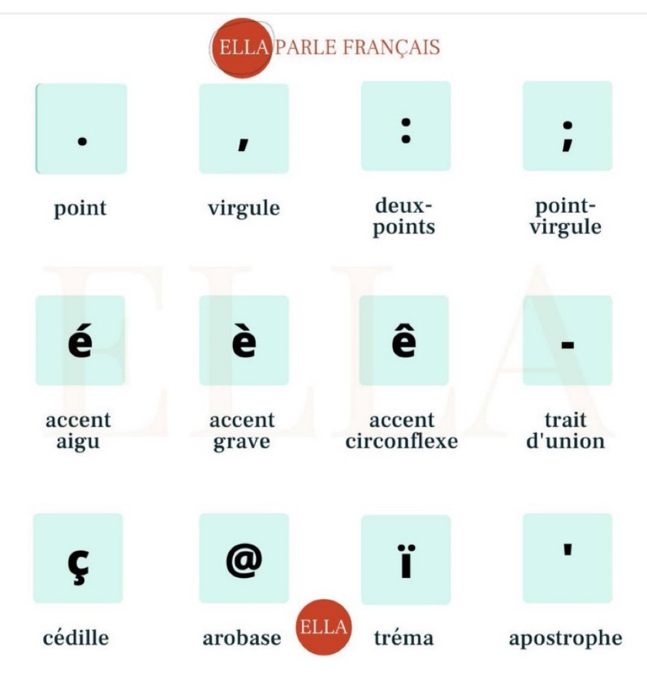

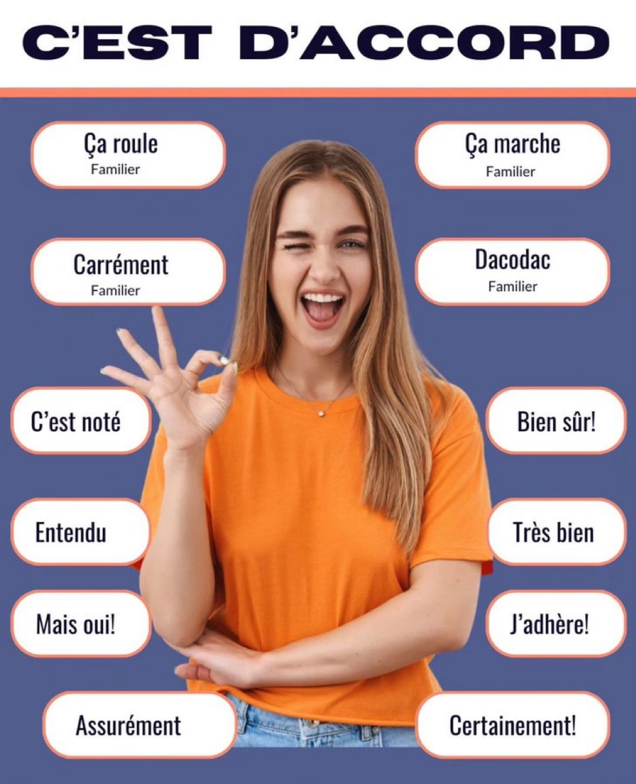
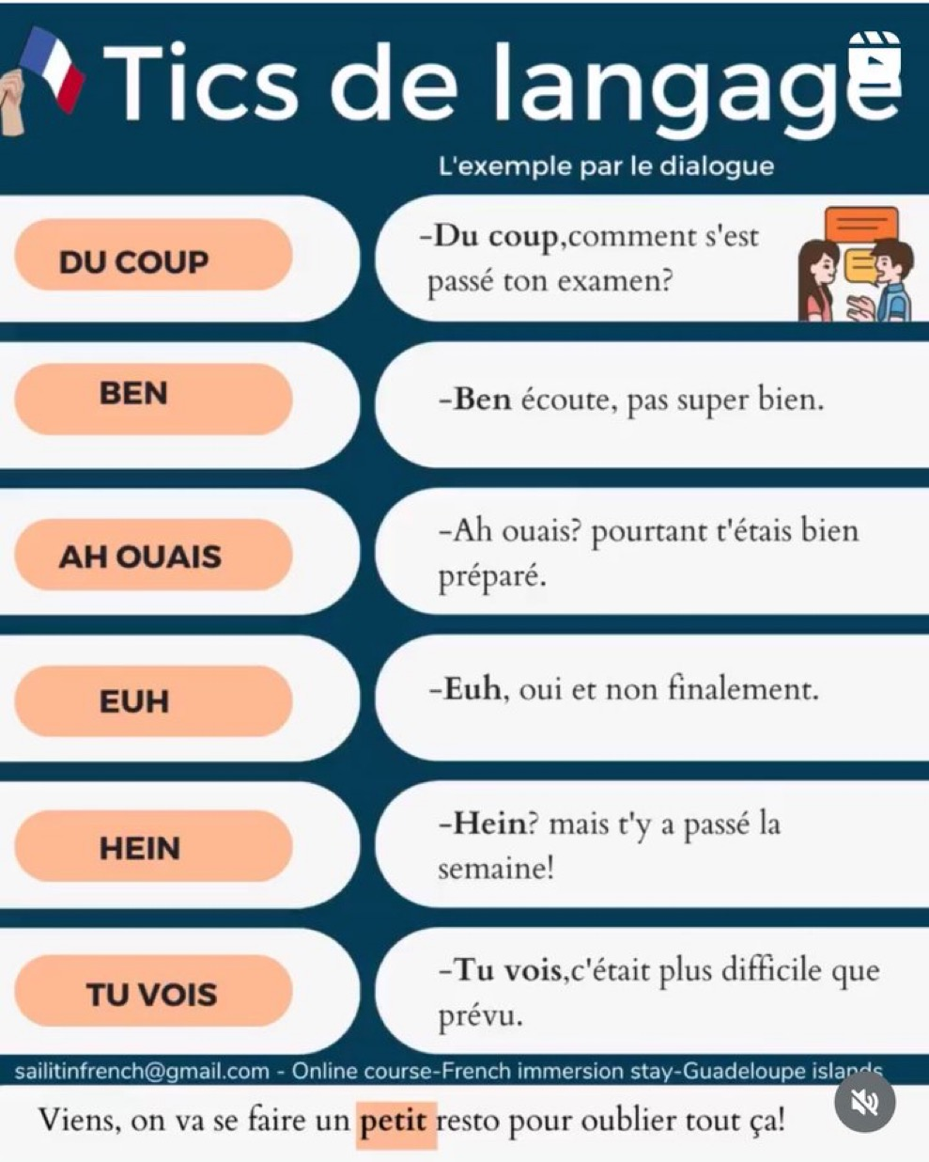
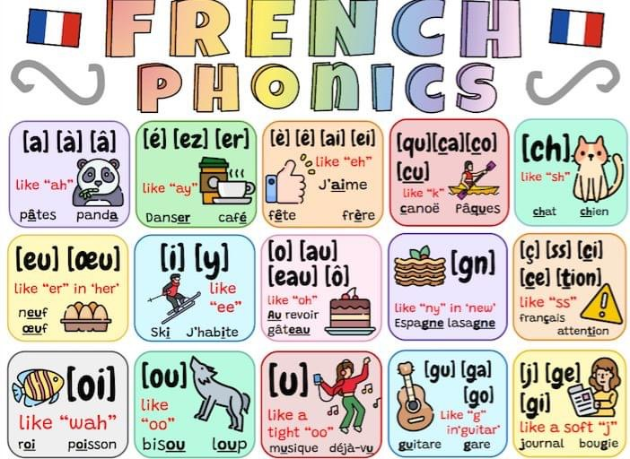

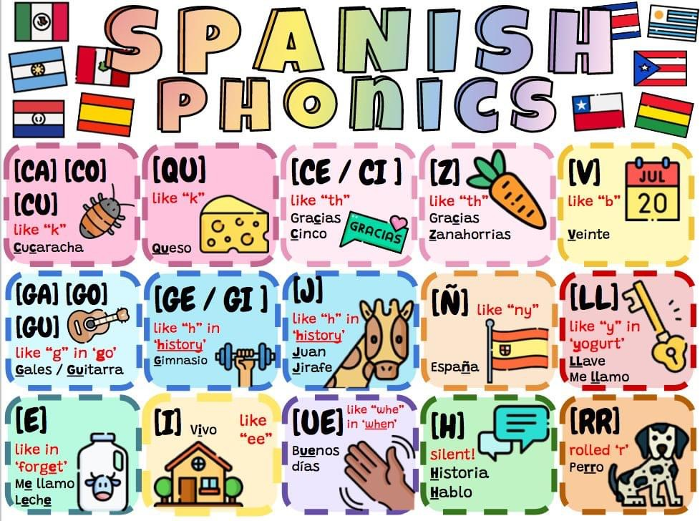

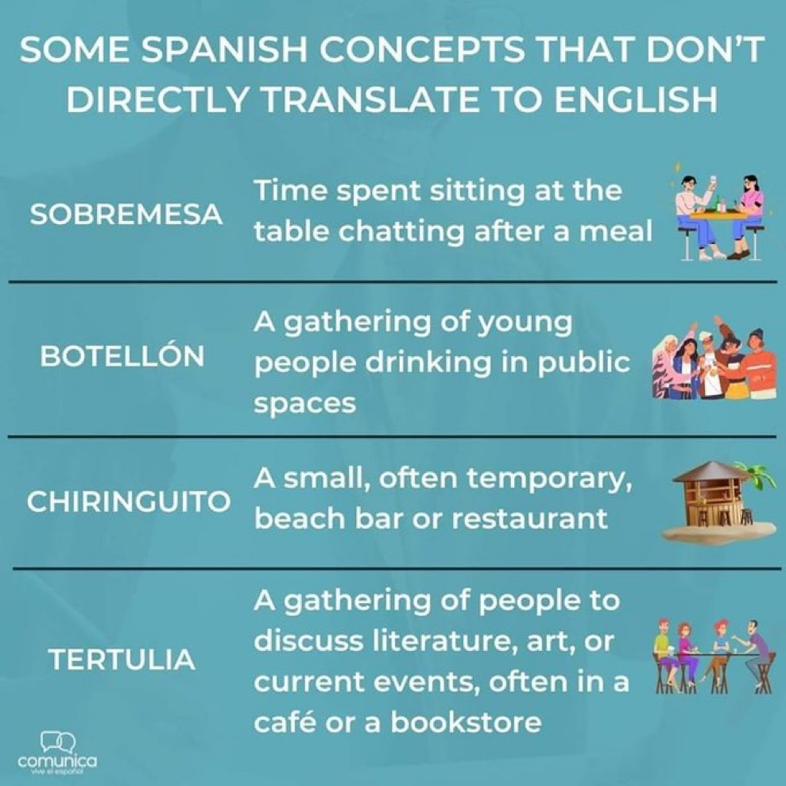
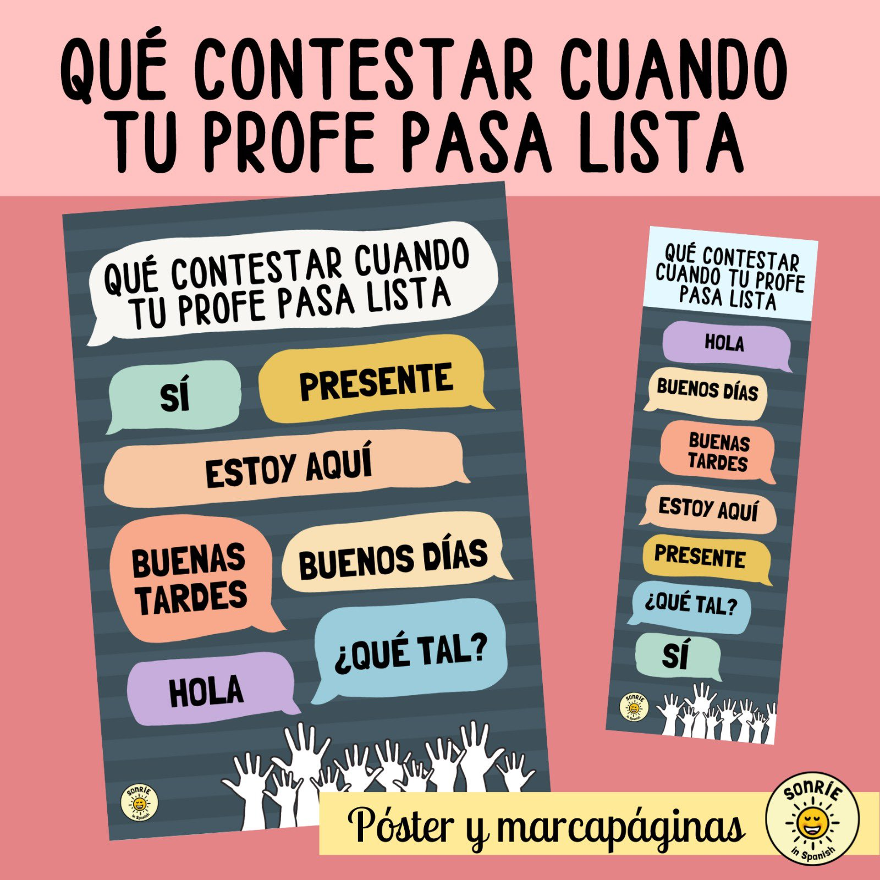

And posting once again this useful chart from Catherine Cantin
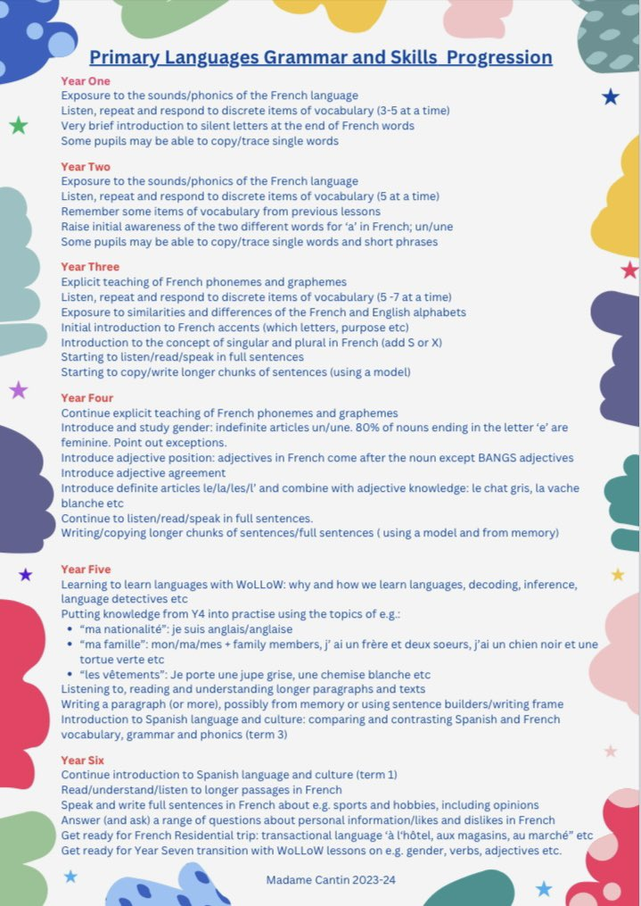
And not languages related, just a wonderful reminder from the late Sir Tim Brighouse:
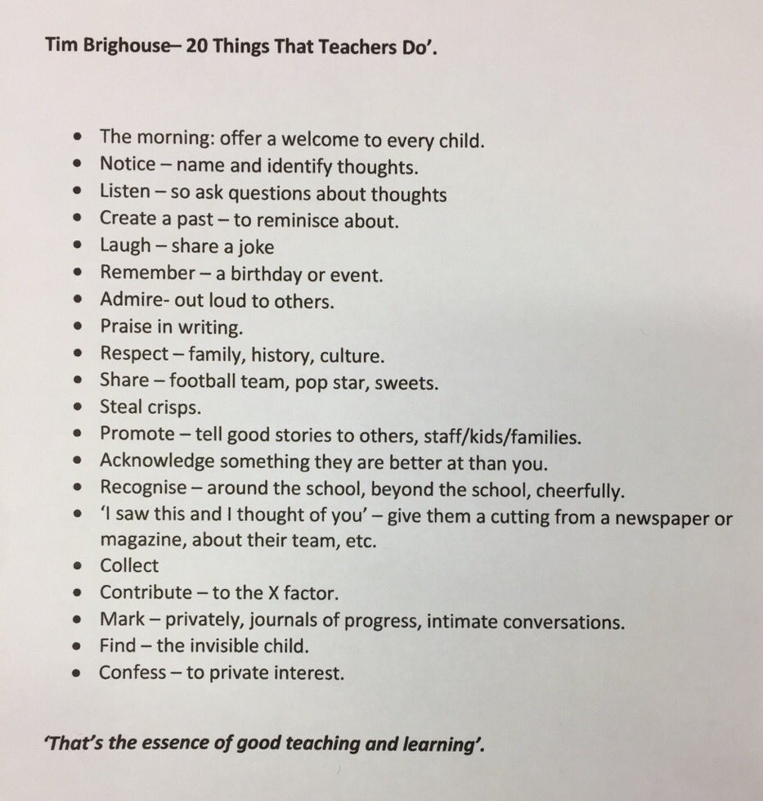

Enjoy all the adventures that 2024 may bring you!

