How to set up an account to access Best Start Speech and Language training on the NHS Health Education England
e-learning website.
https://www.e-lfh.org.uk/
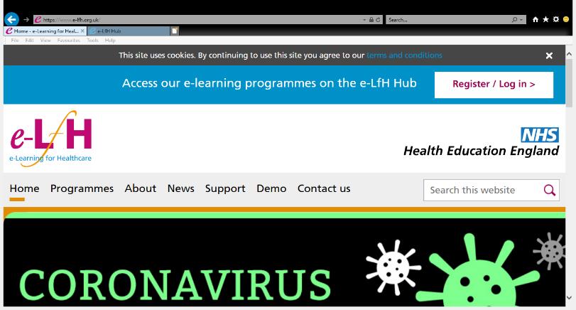
- Click on link above or type into search bar.
- Click on ‘Register’ to set up an account.
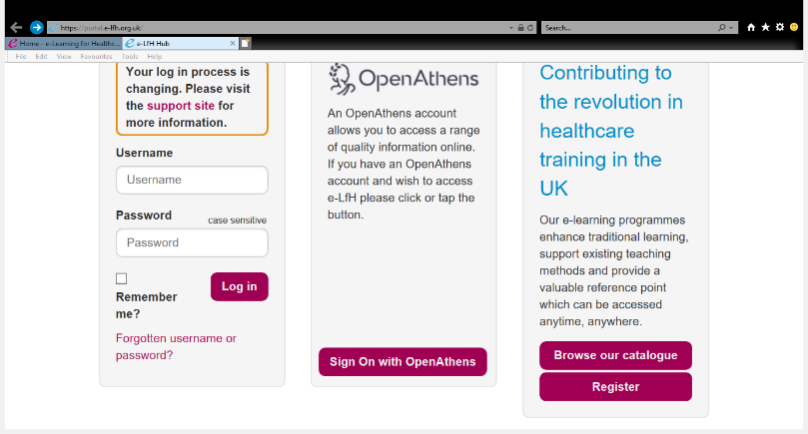
- Click on ‘Register’ on the bottom right hand corner as shown.

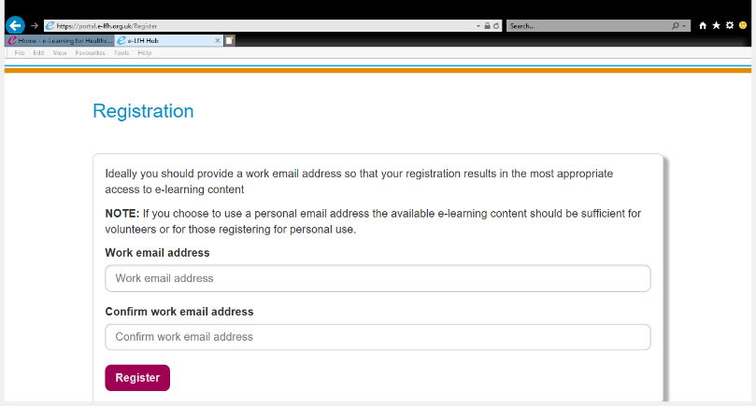
- Type in email address twice, then click ‘Register’
- This will then take you to a screen to add your detail.
- Await confirmation email to activate account.
You can then access the Best Start training from the ‘Course Catalogue’.
https://forms.office.com/Pages/ResponsePage.aspx?Host=Teams&lang=%7Blocale%7D&groupId=%7BgroupId%7D&tid=%7Btid%7D&teamsTheme=%7Btheme%7D&upn=%7Bupn%7D&id=wRwyQbnsfEaw1YVGRNlOOzoQMg6oNrJJhUQpjNuq1DxUODBCVlNIRFkxWFg0UjZEM1lFNUVJM0xBNyQlQCN0PWcu
PLEASE ASK AS MANY STAFF TO COMPLETE THIS PRE TRAINING QUESTIONNAIRE BEOFRE DOING THE TRAINING.
THANK YOU!

